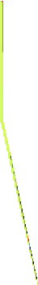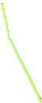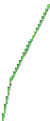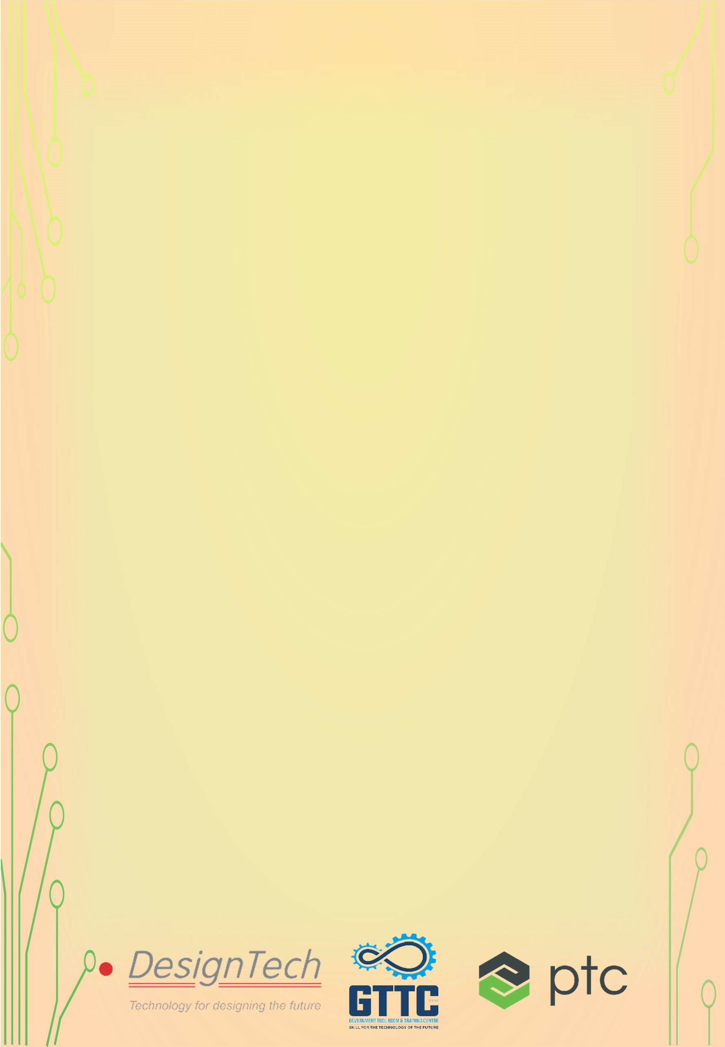

PRODUCT DESIGN

& DEVELOPMENT LAB

CREO FOR DESIGN

STUDENT MANUAL

**PRODUCT DESIGN AND DEVELOPMENT LABORATORY**

This lab allows you to visualize your imagination in a virtual environment and which can be further developed and optimized. PTC Creo software package is used to achieve this and which helps you to save time, money and effort to develop new concepts and bring them into reality. In any design cycle, product design and development is the critical stage to bring life to any conceptual model.

T

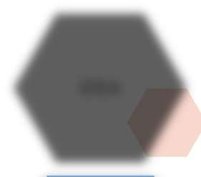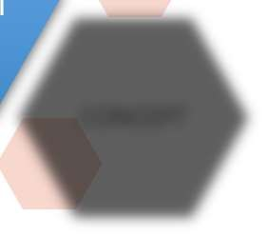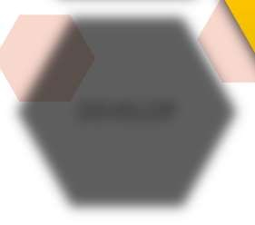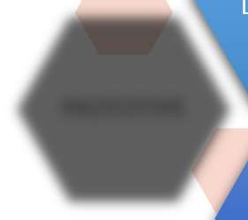

IDEA

TESTING

DEFINE

DESIGN &

DEVELOPMEN

PROTOTYPE

CONCEPT

DEVELOP

In this lab you will be learning basic modeling of parts (solids, sheet metals and Class – A surfaces), Assembly, Drafting, creating of different tools and dies for manufacturing special parts and also MathCAD to create report of your mathematical calculations related to your design.

The list of courses offered,

|  |  |  |
| --- | --- | --- |
| **S. No** | **Name of the Course** | **Duration** |
| 1 | Creo for Design | 108 Hours |
| 2 | Creo for Industrial Engineers | 72 Hours |
| 3 | Specialization program for Tool and Die design | 40 Hours |
| 4 | MathCAD | 40 Hours |

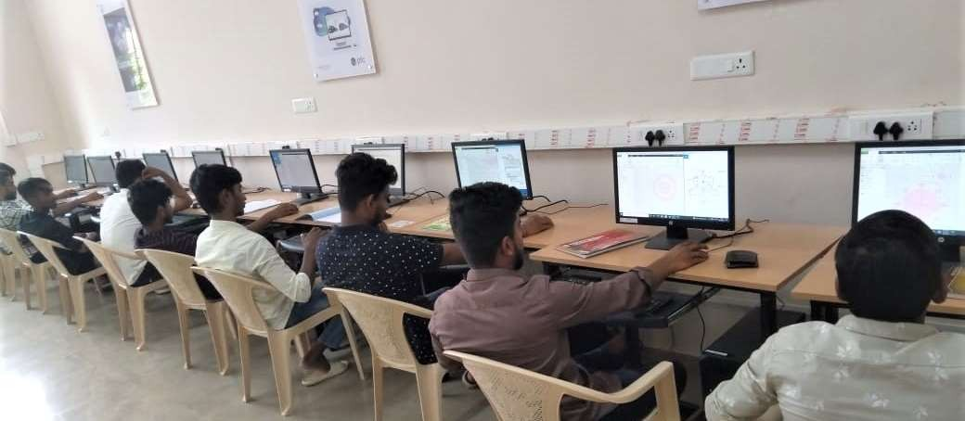

**CREO FOR DESIGN**

Creo for design is the basic course offered in Product Design and Development laboratory. In Creo for design, you will be learning all the basics of modelling which are essential for anyone in the field of design or who are passionate towards design field. You will be learning 4 modules - Sketch, Part (Solid and Sheet metal), Assembly and Drafting.

Students will have an opportunity to learn best way to model an idea in virtual environment so that it can be modified easily when required, which is essential in design industry point of view.

**LABWISE HOURLY DISTRIBUTION:**

|  |  |  |
| --- | --- | --- |
| **S. No** | **Name of the Course** | **Duration** |
| 1 | Creo for Design | 108 Hours |

**HARDWARE / SOFTWARE PACKAGES:**

Creo parametric 6.0.3.0

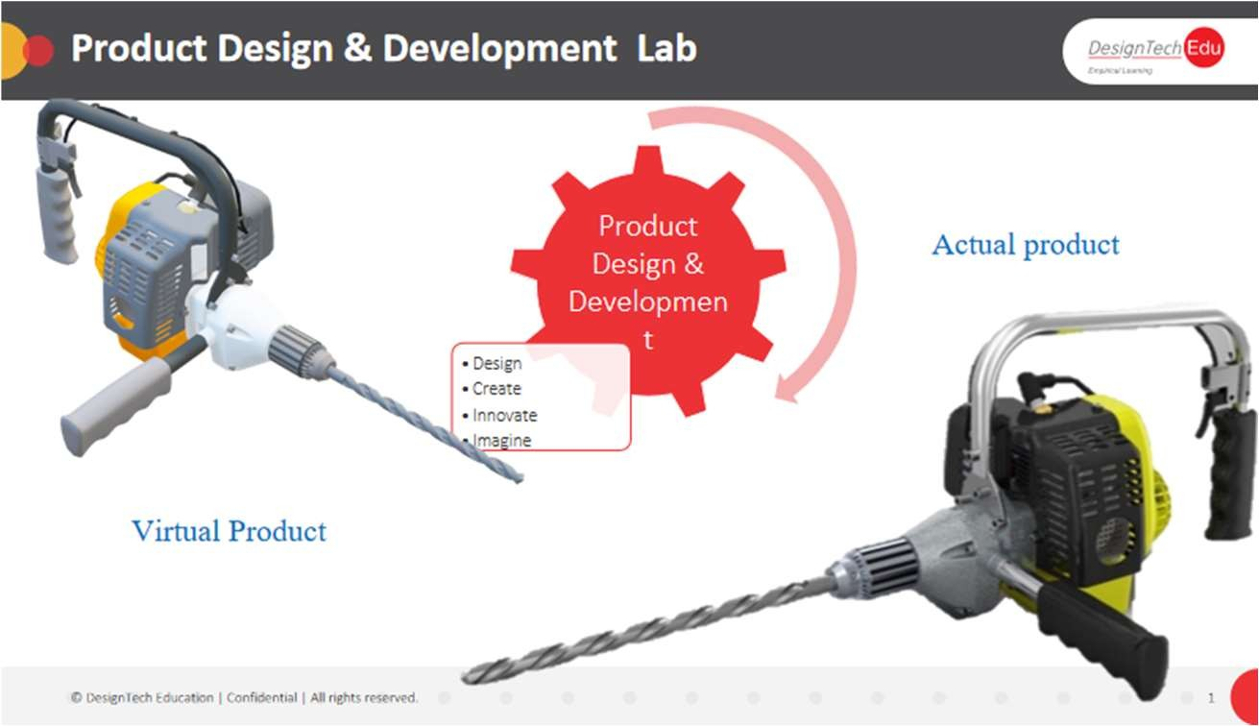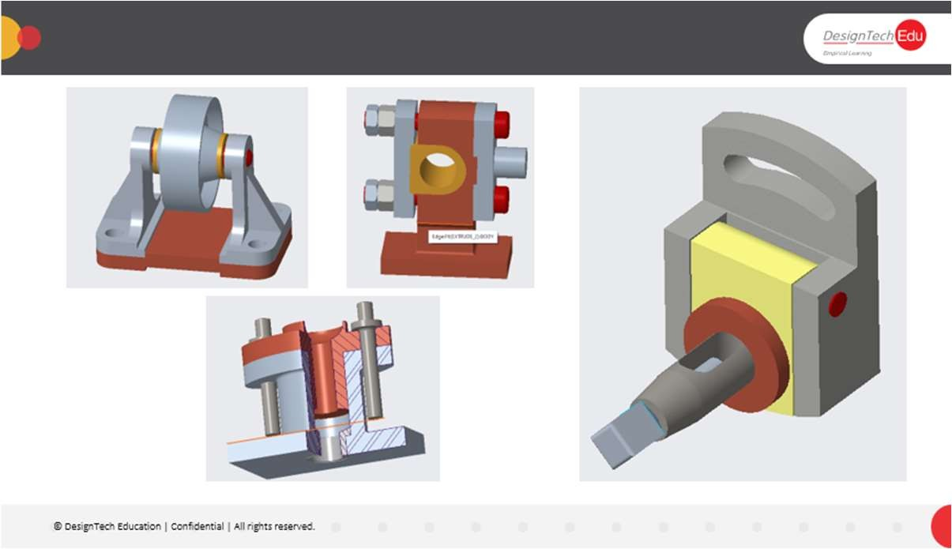

**CONTENTS**

|  |  |  |
| --- | --- | --- |
| CHAPTER – I | Introduction to CAD & PTC Creo | 05 |
| CHAPTER – II | Design for user interface | 11 |
| CHAPTER – III | Part modelling | 32 |
| CHAPTER – IV | Datum planes | 40 |
| CHAPTER – V | Engineering features | 44 |
| CHAPTER – VI | Pattern feature | 68 |
| CHAPTER – VII | Assembly sectioning | 85 |
| CHAPTER – VIII | Drafting | 89 |
| CHAPTER – IX | Views | 96 |
| CHAPTER – X | Sheet metal | 122 |
| CHAPTER – XI | Flexible modelling | 135 |

# CHAPTER 1 – Introduction to CAD, PTC_Creo

* Introduction to Creo
* Outline
* Design Cycle
* Importance of 3D Modelling
* Creo Parametric Concept
* Solid Modelling Concept
* Feature based Modelling
* Parametric Modelling
* Associative concept
* Model Centric Concept
* Introduction to PTC

# CHAPTER 2 – Design for User Interface

* Launching Creo
* User Interface after launching creo
* User Interface of sketcher
* User interface of Part Modeling
* User interface of assembly
* User interface of drafting
* User interface of Sheet Metal
* Understanding Interface of Creo Parametric
* Graphic User interface
* Navigator
* Status Bar
* Mouse Controls
* Initial Settings
* Setting Up Work Directory
* Creo Parametric File Version
* Deleting Files
* Sketching Tools
* Constraints
* Dimensional and Geometric Constraints
* Dimension Concepts
* Inspection Tools

# CHAPTER 3 – Part Modelling

* Part Modelling
* Basic Modelling Guidelines
* Part Modelling - Solid
* Types of Sketches
* Shape Feature
  + Extrude
  + Revolve
  + Sweep
  + Helical
  + Blend

# CHAPTER 4 – Datum Plane

* Datum Planes
  + To Select Datum Plane in Creo
  + To create an Offset Datum Plane
  + To Create a Datum Plane with an Angular Offset
  + To create a Datum Plane Mid Plane Between Two References
  + About Creating a Datum Plane Tangent to a Surface

# CHAPTER 5 – Engineering Features

* Round
* Chamfer
* Hole
* Auto Round
* Draft
* Profile Rib
* Trajectory Rib
* Shell
* Corner Chamfer

# CHAPTER 6 – Pattern Features

* Pattern Features
  + Dimension
  + Direction
  + Axis
  + Curve
  + Point
  + Fill
  + Reference
  + Table
  + Mirror

# CHAPTER 7 – Assembly Sectioning

* Planar Section
* Offset Section

# CHAPTER 8 – Drafting

* Placing Views
* Drawing Views
* General Views
* Lock View Movement
* Annotation

# CHAPTER 9 – Views

* Placing the First Views (Base View)
* View Type Option
* Visible Area Option
* Half View
* Partial View
* Broken View
* View States Option
* View Visible Option
* Projected View
* Detailed View
* Auxiliary View
* Revolved View
* Annotation
* Ordinate Dimension
* Generating Balloons
* Creating Table

# CHAPTER 10 – Sheet Metal

* Planar
* Flange Walls
* Flat
* Bend
* Unbend
* Convert Solid to Sheet Metal

# CHAPTER 11 – Flexible Modelling

* Flexible Modelling
* Flexible Modelling U1
* Flexible Modelling Process
* Selection using Selection Filter
* Selection using Shape Selection Workflow
* Flexible Move
* Move using Dagger
* Move by Dimensions
* Move by Constraints

# Chapter:1 Introduction to Creo:

Creo is a family or suite of Computer-aided design (CAD) apps supporting product design for discrete manufacturers and is developed by PTC. The suite consists of apps, each delivering a distinct set of capabilities for a user role within product development. The parametric version of Creo deals with creating and modifying 3D models, while the model check version is for comprehensive and collaborative analysis tool for users to check their models. Creo sketch is used to turn ideas into 2D sketches and Creo Element is used to combine 2D and 3D parts in a lightweight easy to learn software.

# Learning Objectives:

After completing this chapter, you will be able to:

* Understand the advantages of using PTC Creo Parametric.
* Know the system requirements of PTC Creo Parametric.
* Get familiar with important terms and definitions in PTC Creo Parametric.
* Understand important options in the File menu.
* Understand the importance of Model Tree.
* Understand the functions of mouse buttons.
* Use the options of default toolbars.
* Customize the Ribbon.
* Understand the functions of browser.
* Understand the use of Appearance Gallery.
* Render stages in PTC Creo Parametric.
* Change the color scheme of the background in PTC Creo Parametric.

# Outline

Creo runs on Microsoft Windows and provides apps for 3D CAD parametric feature solid modeling, 3D direct modeling, 2D orthographic views, Finite Element Analysis and simulation, schematic design, technical illustrations, and viewing and visualization. Creo can also be paired with Mastercam (Machining based software) to machine any designed model in a minimal timeframe, creo has increased the rate of rapid prototyping in the industry tremendously.

Creo Elements and Creo Parametric compete directly with CATIA, Siemens NX/Solid Edge, and SolidWorks. The Creo suite of apps replace and supersede PTC’s products formerly known as Pro/ENGINEER, Create, and Product View. Creo has many different software package solutions and features. Creo Illustrate is a good example. Creo Parametric allows users create 3D models with many features such as sweeps, revolves and extrusions. This makes it one of the leading cad softwares that is in use for many engineering and technical based careers.

# Design Cycle

The product realization process can be roughly divided into two phases; design and manufacturing. The design process starts with identification of new customer needs and design variables to be improved, which are identified by the marketing personnel after getting feedback from the customers. Once the relevant design information is gathered, design specifications are formulated. A feasibility study is conducted with relevant design information and detailed design and analyses are performed. The detailed design includes design conceptualization, prospective product drawings, sketches and geometric modeling. Analysis includes stress analysis, interference checking, kinematics analysis, mass property calculations and tolerance analysis, and design optimization. The quality of the results obtained from these activities is directly related to the quality of the analysis and the tools used for conducting the analysis.

The manufacturing process starts with the shop-floor activities beginning from production planning, which uses the design process drawings and ends with the actual product. Process planning includes activities like production planning, material procurement, and machine selection. There are varied tasks like procurement of new tools, NC programming and quality checks at various stages during the production process. Process planning includes planning for all the processes used in manufacturing of the product. Parts that pass the quality control inspections are assembled functionally tested, packaged, labelled, and shipped to customers.

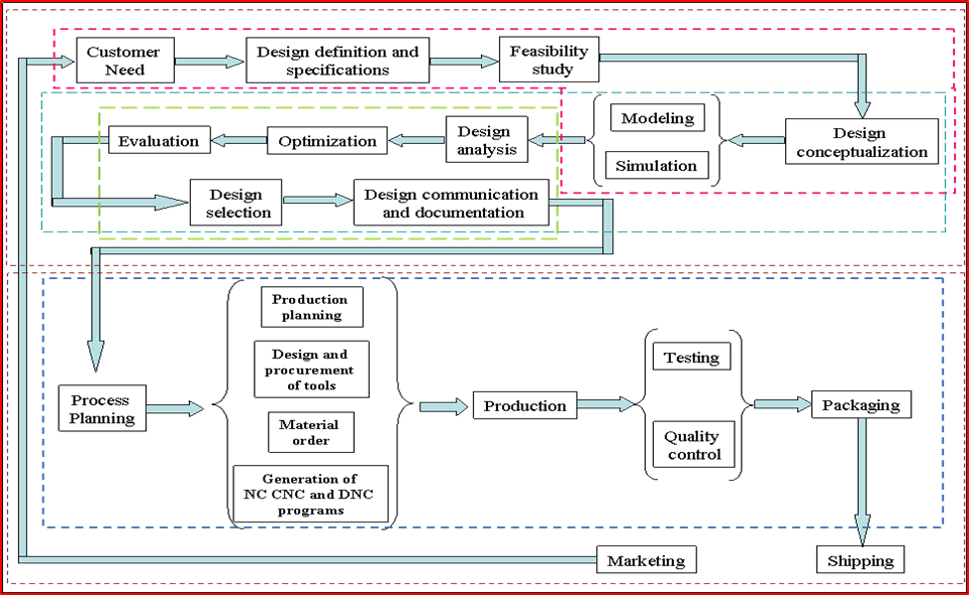

# Importance of 3D Modelling

CAD is technology concerned with using computer systems to assist in the creation, modification, analysis, and optimization of a design. Any computer program that embodies computer graphics and an application program facilitating engineering functions in design process can be classified as CAD software.

The most basic role of CAD is to define the geometry of design – a mechanical part, a product assembly, an architectural structure, an electronic circuit, a building layout, etc. The greatest benefits of CAD systems are that they can save considerable time and reduce errors caused by otherwise having to redefine the geometry of the design from scratch every time it is needed.

The present day CAD development focuses on efficient and fast integration and automation of various elements of design and manufacturing along with the development of new algorithms. There are many commercial CAD packages available for direct usages that are user-friendly and very proficient.

# Creo Parametric Concept

Parametric modeling is a modeling process with the ability to change the shape of model geometry as soon as the dimension value is modified. Parametric modeling is implemented through the design computer programming code such as a script to define the dimension and the shape of the model. The model can be visualized in 3D drafting programs to resemble the attributes of the real behavior of the original project. It is quite common that a parametric model uses feature-based, modeling tools to manipulate the attributes of the model.

The key advantage of parametric modeling is, when setting up a 3D geometric model, the shape of model geometry can be changed as soon as the parameters such as the dimensions or curvatures are modified; therefore, there is no need to redraw the model whenever it needs a change. This greatly saves time for engineers, especially in the scheme design stage. Before the advent of parametric modeling, the scheme design was not an easy task for designers, as the model is prone to be changed frequently. Therefore, changing the shape of a construction model was very difficult. Particularly, parametric modeling allows the designer to modify the entire shapes of the model, not just individual members. For example, to modify a roof structure, conventionally, the designer had to change the length, the breadth, and the height. However, with parametric modeling, the designers need to only alter one parameter; the other two parameters get adjusted automatically.

Creo is the 3D CAD solution that helps you accelerate product innovation so you can build better products faster. Easy-to-learn Creo seamlessly takes you from the earliest phases of product design to manufacturing and beyond. You can combine powerful, proven functionality with new technologies such as generative design, augmented reality, real-time simulation,

additive manufacturing and the IoT to iterate faster, reduce costs, and improve product quality. The world of product development moves quickly, and only Creo delivers the transformative tools you need to build competitive advantage and gain market share.

# Solid Modelling Concept

Solid modeling (or modelling) is a consistent set of principles for mathematical and computer modeling of three-dimensional solids. Solid modeling is distinguished from related areas of geometric modeling and computer graphics, such as 3D modeling, by its emphasis on physical fidelity. Together, the principles of geometric and solid modeling form the foundation of 3D-computer-aided design and in general support the creation, exchange, visualization, animation, interrogation, and annotation of digital models of physical objects.

The use of solid modeling techniques allows for the automation of several difficult engineering calculations that are carried out as a part of the design process. Simulation, planning, and verification of processes such as machining and assembly were one of the main catalysts for the development of solid modeling. More recently, the range of supported manufacturing applications has been greatly expanded to include sheet metal manufacturing, injection molding, welding, pipe routing, etc. Beyond traditional manufacturing, solid modeling techniques serve as the foundation for rapid prototyping, digital data archival and reverse engineering by reconstructing solids from sampled points on physical objects, mechanical analysis using finite elements, motion planning and NC path verification, kinematic and dynamic analysis of mechanisms, and so on. A central problem in all these applications is the ability to effectively represent and manipulate three-dimensional geometry in a fashion that is consistent with the physical behavior of real artifacts. Solid modeling research and development has effectively addressed many of these issues, and continues to be a central focus of computer- aided engineering.

# Feature based Modelling

Feature-based modeling refers to the construction of geometries as a combination of form features. The designer specifies features in engineering terms such as holes, slots, or bosses rather than geometric terms such as circles or boxes.

Features can also store nongraphic information as well. This information can be used in activities such as drafting, NC, finite-element analysis, and kinematic analysis. Furthermore, feature-based packages frequently record the geometric construction and modification sequences used in building the model.

# Parametric Modelling

Feature-based modeling refers to the construction of geometries as a combination of form features. The designer specifies features in engineering terms such as holes, slots, or bosses rather than geometric terms such as circles or boxes.

Features can also store nongraphic information as well. This information can be used in activities such as drafting, NC, finite-element analysis, and kinematic analysis. Furthermore, feature-based packages frequently record the geometric construction and modification sequences used in building the model.

The approach of creating two-dimensional sketches of the three-dimensional features is an effective way to construct solid models. Many designs are in fact the same shape in one direction. Computer input and output devices we use today are largely two dimensional in nature, which makes this modeling technique quite practical. This method also conforms to the design process that helps the designer with conceptual design along with the capability to capture the design intent. Most engineers and designers can relate to the experience of making rough sketches on restaurant napkins to convey conceptual design ideas. Creo provides many powerful modeling and design-tools, and there are many different approaches to accomplishing modeling tasks. The basic principle of parametric modeling is to build models by adding simple features one at a time. In this chapter, the general parametric part modeling procedure is illustrated; a very simple solid model with extruded features is used to introduce the Creo user interface.

# Associative concept

A link between two different functions in a CAD system that assures that a change made in one area is reflected in all other areas. For example, a change to a solid model will be reflected in its drawing.

In Creo, when you update some feature inside the 3D model, 2D drawing generated from the corresponding model also gets modified accordingly after regenerating the drawing. This aspect helps you to maintain a clear correlation between the model and the drawing.

# Model Centric Concept

Model-based (or -centric) design is an approach that puts 3D models at the center of design. It uses a set of standards and processes created specifically to employ 3D models as the design authority and the source for all design data. The 3D model is the central source of design data, it becomes accessible by all team members and the flow of information is released as soon as the design cycle begins. In essence, Model-Based Design opens a larger pipeline, allowing the

team to receive, understand, and evaluate designs faster than the traditional step-by-step approach.

Model-Based Design does not eliminate drawings, but rather forces the use of mathematically accurate, 3D CAD models as the source for all design data. If drawings are required as a form of communication, they can be generated from the data already warehoused in the 3D CAD models. The advantage is that we design, document and control a 3D object, which is what the hardware becomes, instead of designing, documenting and controlling on a flat piece of paper.

# Introduction to PTC

PTC Inc. (formerly Parametric Technology Corporation) is an American computer software and services company founded in 1985 and headquartered in Boston, Massachusetts. The global technology company has over 6,000 employees across 80 offices in 30 countries, 1,150 technology partners. The company began developing parametric, associative feature- based, solid computer-aided design (CAD) modeling software in 1988, including an Internet- based product for product lifecycle management (PLM) in 1998. PTC products and services include Internet of things (IoT), augmented reality (AR), and collaboration software.

The PTC CAD product provides computer aided design capabilities. PTC CAD is a suite of 2D and 3D product design software used to create, analyze and view product designs. PTC Creo software was released in June 2011 to replace and supersede PTC's products formerly known as Pro/ENGINEER, CoCreate, and ProductView.

**CHAPTER 2**

# Launching Creo:

Launch Creo by LMB double-clicking on the shortcut Creo Parametric icon in the PC desktop. Another way to launch the software is to press on the Windows Start icon, and then to activate Creo Parametric from the PTC applications list.

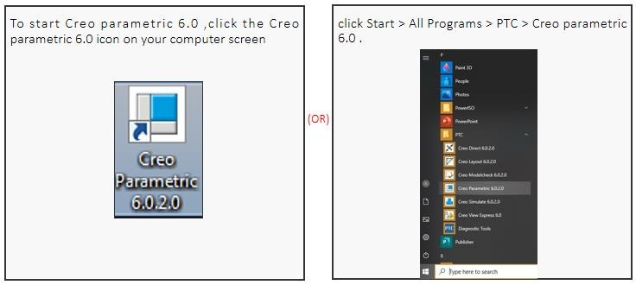

# User Interface after launching creo:

The initial screen after starting the software is shown in Figure. It consists of File and Home ribbon menu options, Folder Browser tab, and Favorites tab to run a Web browser.

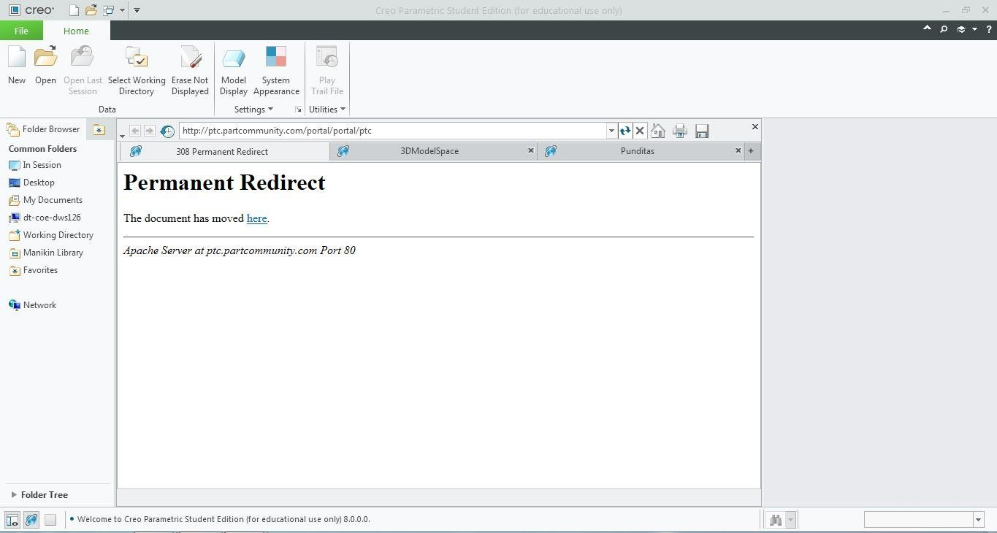

The main areas and functions of this interface are as follows:

* The Folder Browser tab located on the left of the screen next to the Model Tree tab, lists the folders on the computer or network. Browse the folders and view their contents in the Folder Browser.
* The Favorites tab is a multi-functional Web browser embedded in Creo. It displays models and tutorials from PTC.com and other websites.
* A preview window appears in the Centre of the screen after the launch.
* The Folder Browser icons are located at the bottom left corner of the main window. Click (LMB) on the icons to either show or hide the current folder and Web browsers.

# User Interface of sketcher

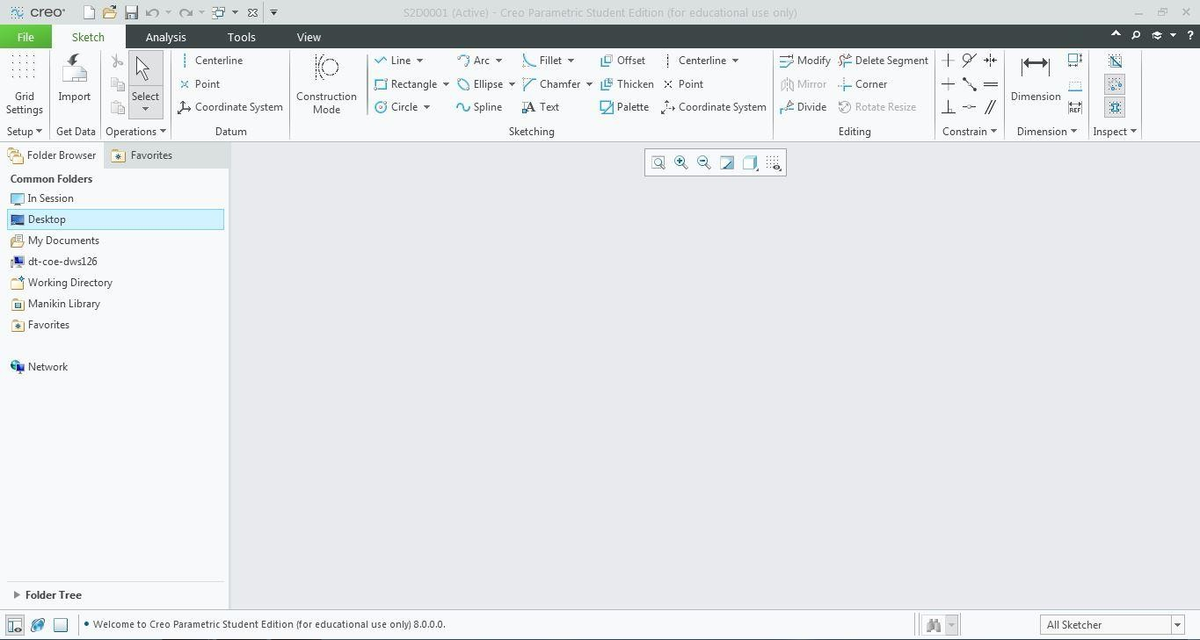

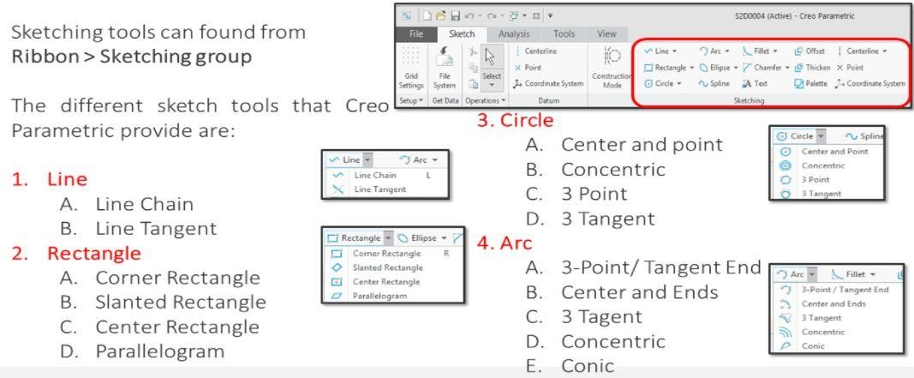

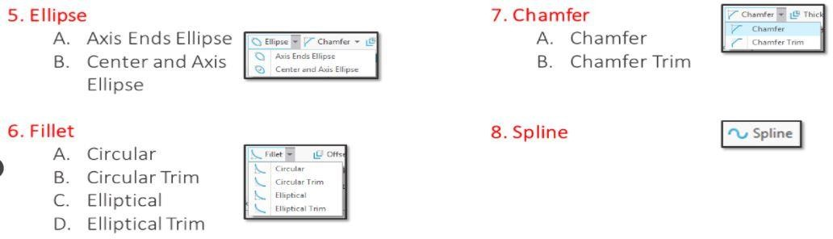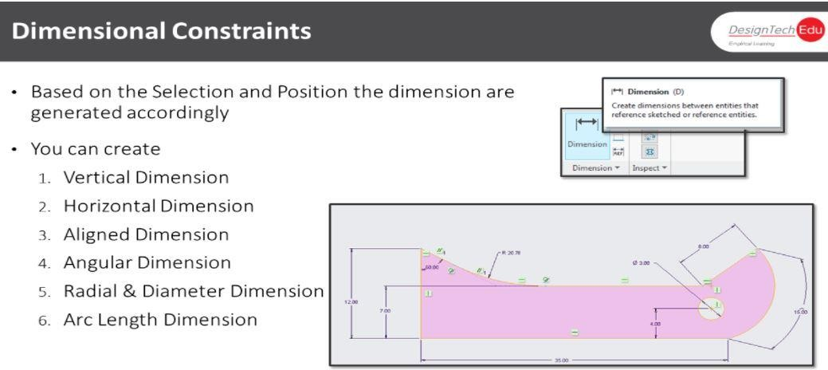

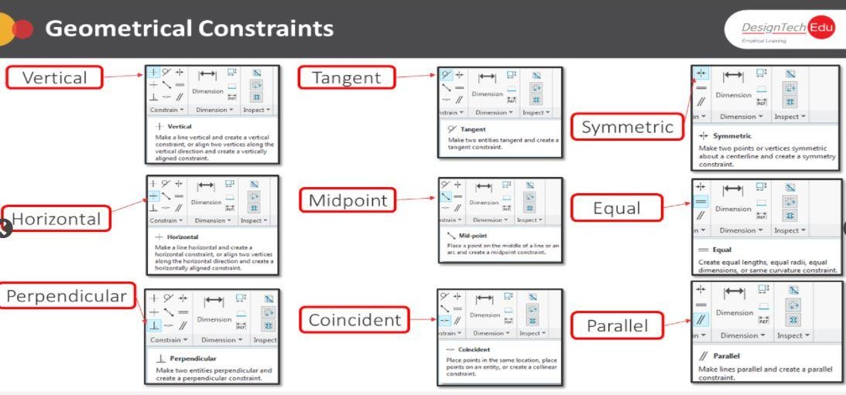

**User interface of Part Modeling**

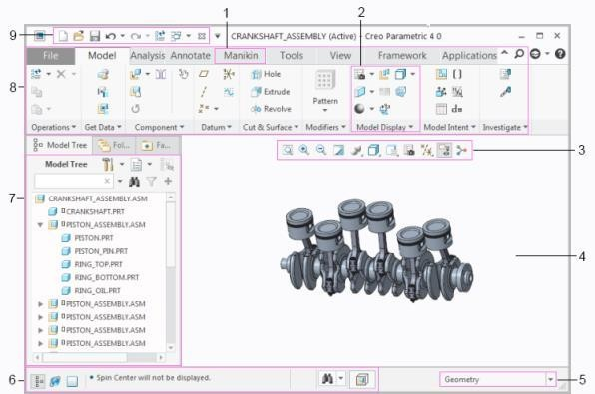

The ribbon contains command buttons organized within a set of tabs. On each tab, the related buttons are grouped.

The Quick Access toolbar is located at the top of the Creo Parametric window. It provides quick access to frequently used buttons, such as buttons for opening and saving files, undo, redo, regenerate, close windows, switch windows, and so on.

The navigator includes the  Model Tree, Layer Tree, Detail Tree,  Folder browser, and  Favourites.

The model is displayed in the graphics window to the right of the navigator. The in- graphics toolbar is embedded at the top of the graphics window. The buttons on the toolbar

control the display of graphics. A status bar located at the bottom of the Creo Parametric window provides options to control the display of the navigator and browser. It also displays information on the status of the operation.

1. Tab
2. Group
3. In-graphics toolbar
4. Graphics window
5. Selection filter
6. Status Bar
7. Model Tree
8. Ribbon
9. Quick Access Toolbar

# User interface of assembly

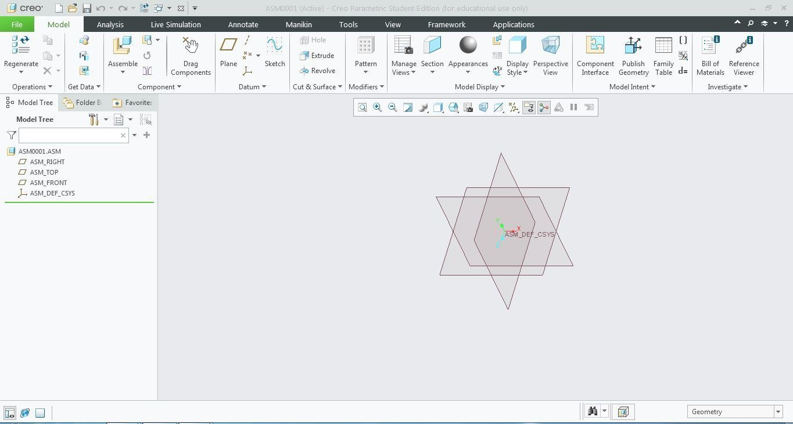

**Ribbon bar with assembly commands:**

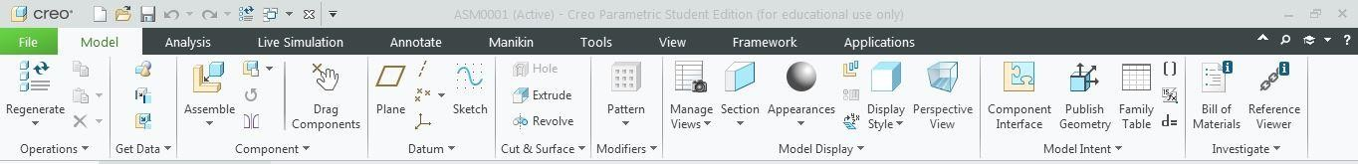

# User interface of drafting

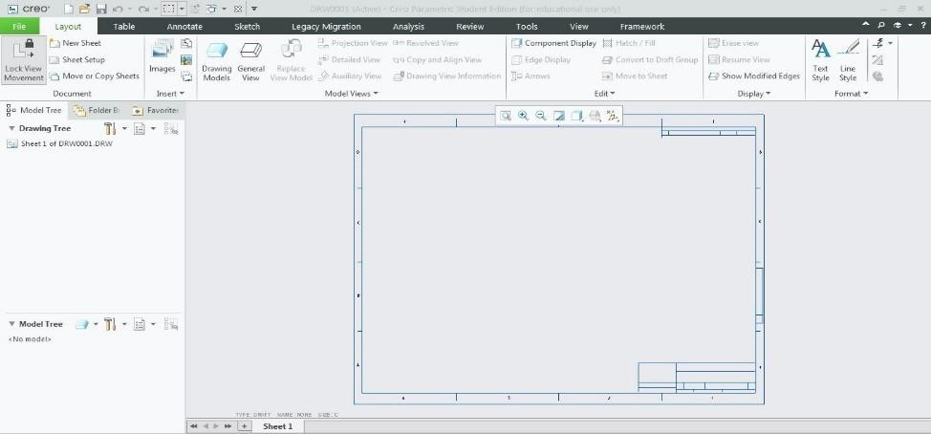

**Ribbon bar with drafting commands:**

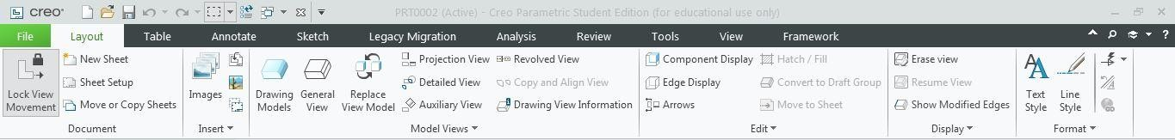

# User interface of Sheet Metal

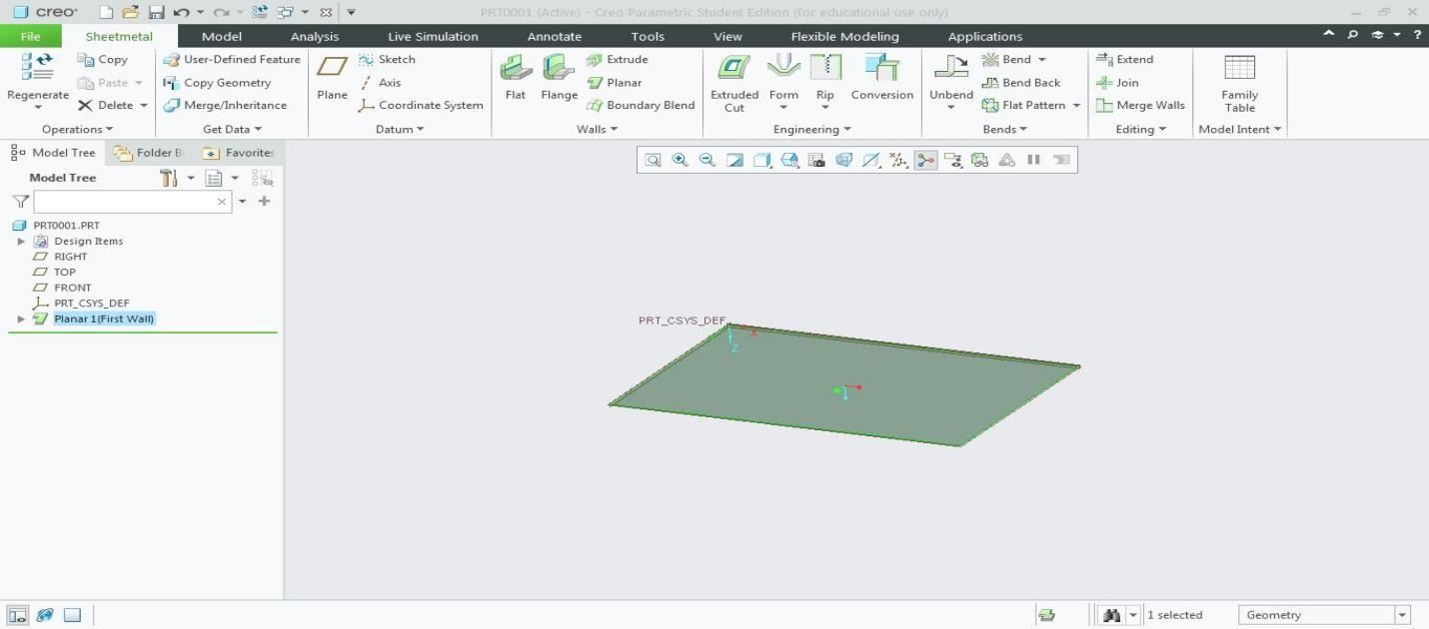

**Ribbon bar with sheet metal commands:**

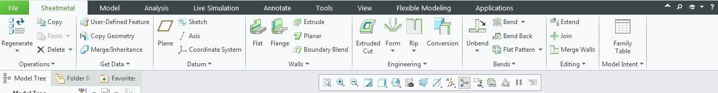

# Understanding Interface of Creo Parametric

The Creo Parametric window consists of the following elements:

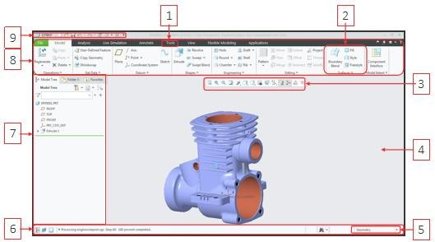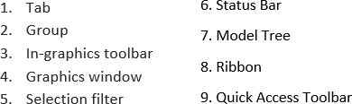

# Ribbon Interface

Ribbon is located at the top of the window. It has various tabs

# Sketch Tab

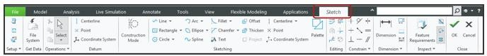

**Model Tab**

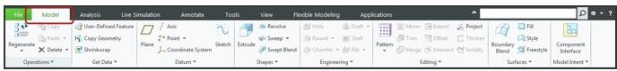

# Command Search:

The command search tool enables you to find commands faster and preview the location of the command on the user interface.

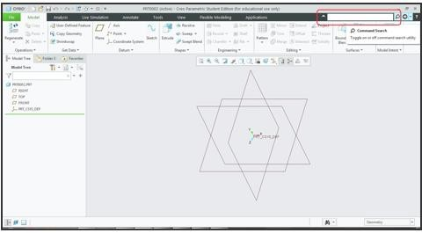

# Navigator: Folder Browser

The Folder Browser is an expandable tree that lets you browse the file systems and other locations accessible from your computer.

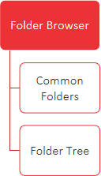

# Common Folders

* This section consists of top-level nodes for accessing file systems.
* You can access the commonly-used locations

# Folder Tree

* This section consists of a hierarchical structure of the local file system

# Mouse Controls

|  |  |
| --- | --- |
| **Mouse Button Types** | **Description** |
| Left Button | Most commonly used for **selecting** objects on the screen or sketching |
| Right Button | Used for activating pop-up menu items, typically used when **editing** |
| Middle Button | Used for model rotation, dimension, zoom when holding Ctrl key, and pan when holding Shift key. It also cancels commands and line chains |
| Middle Scroll Wheel | only it activates Zoom feature when scrolling wheel. |

**Zoom**

Middle Scroll Wheel or Ctrl+ hold Middle Scroll Wheel up and down

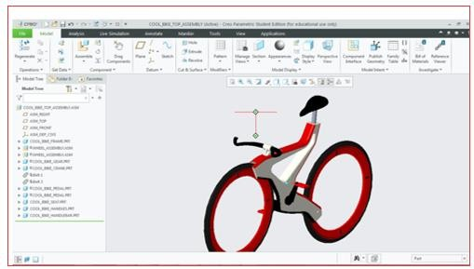

# Pan

Shift + hold Middle Scroll + Drag

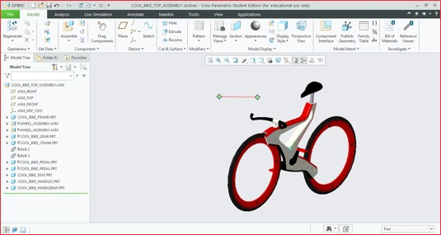

# Highlight parts

Left click

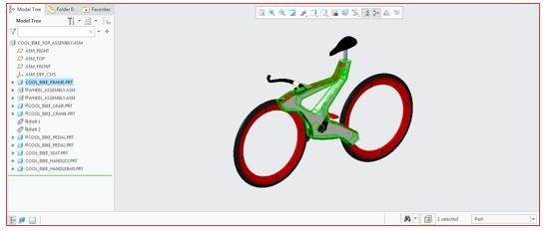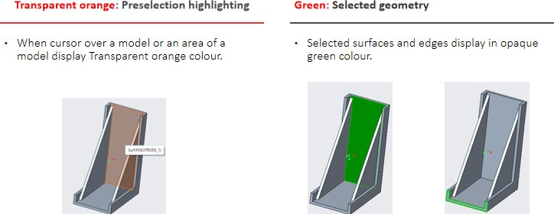

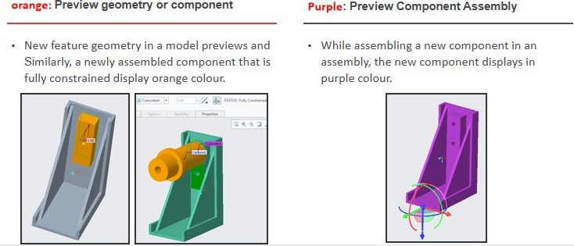

# Initial settings: Setting Up Work Directory

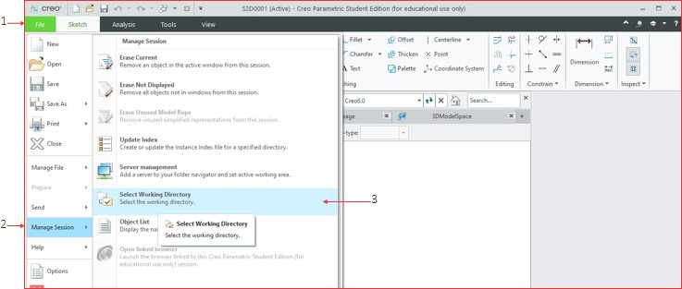

**Opening existing file from Working Directory**

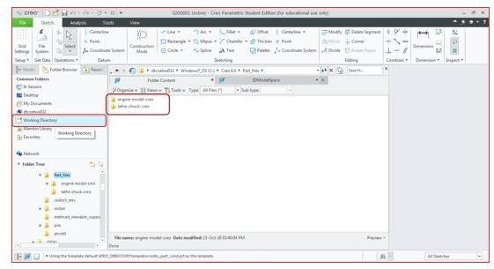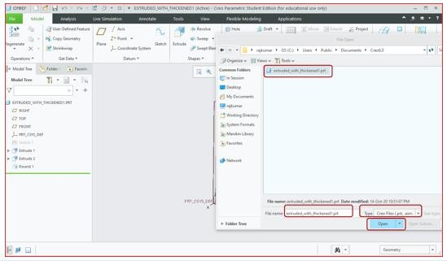

# Saving

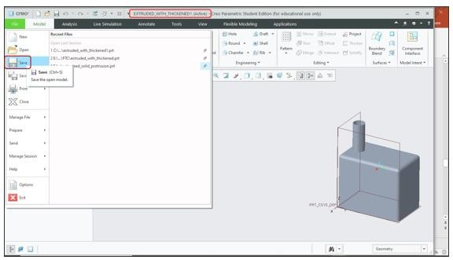

**Saving a copy of files**

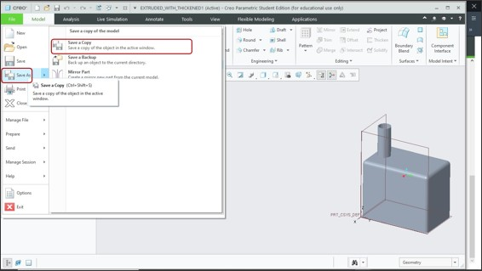

# Renaming Model

0

# Deleting Model

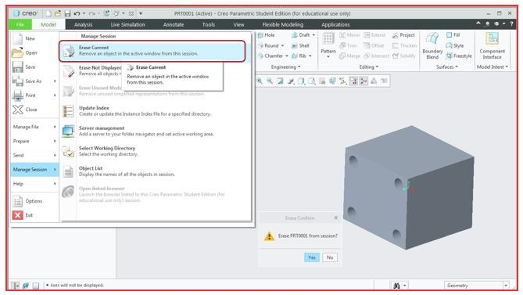

**Closing Working Model**

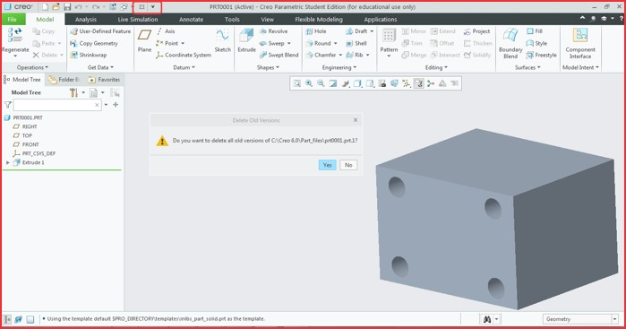

# Sketching Tools

**Description:**

* 1. Click Sketch and then click the arrow next to Ellipse. Click Center and Axis Ellipse. Select a point for the center of the ellipse. The first axis is created. Move the axis to the desired length and orientation and select an endpoint. The second axis and the ellipse circumference are created. Move the pointer to define the length of the second axis and select an endpoint. The ellipse is created.
  2. Click Sketch and then click the arrow next to Ellipse. Click Axis Ends Ellipse. Select a location for the first axis endpoint. The axis is created. Move the axis to the desired length and orientation and select the second endpoint. Drag the pointer to define the length of the second axis and select an endpoint. The ellipse is created.
  3. Click Sketch > Spline. Select a point for the spline endpoint. Select additional spline points and middle-click to exit the tool. The spline is created.
  4. Click Sketch and then click the arrow next to Fillet. Click Circular. Select the first line to be connected. Make sure to select the point at which you want to place the fillet. Select the second line to be connected at the approximate point at which you want to place the fillet. The fillet is created between the points you selected and the lines are trimmed. Construction lines extend to the intersection point.
  5. Click Sketch and then click the arrow next to Fillet. Click Elliptical. Select the first line to be connected. Make sure to select the point at which you want to place the fillet. Select the second line to be connected at the approximate point at which you want to place the

fillet. The fillet is created between the points you selected and the lines are trimmed. Construction lines extend to the intersection point.

* 1. Click Sketch and then click the arrow next to Chamfer. Click Chamfer. Select the first line or arc. Make sure to select the point at which you want to place the chamfer. Select the second line or arc at the approximate point at which you want to place the chamfer. The chamfer is created. Construction lines extend to the intersection point.
  2. On the Design tab, click Text and select a start point to set text height and orientation. Click an end point to set text height and orientation. A construction line and an arrowhead appear indicating the direction of the text. The Text dialog box opens. To define the position of the start point of the text, under Position, perform the following:
     1. To define the horizontal alignment, click the arrow next to Horizontal, and select Left, Center, or Right.
     2. To define the vertical alignment, click the arrow next to Vertical, and select Bottom, Middle, or Top.
     3. To change the aspect ratio of the text, use the slide bar next Aspect ratio.
     4. To change the slant angle of the text, use the slide bar next to Slant angle.
     5. To change the spacing between the characters of the text, use the slide bar next to Spacing.
     6. To place the text along a curve, click Place along curve and select the curve on which you want to place the text.

You can modify the horizontal and vertical positions of the start point of the text. The horizontal position defines the start point on the curve.

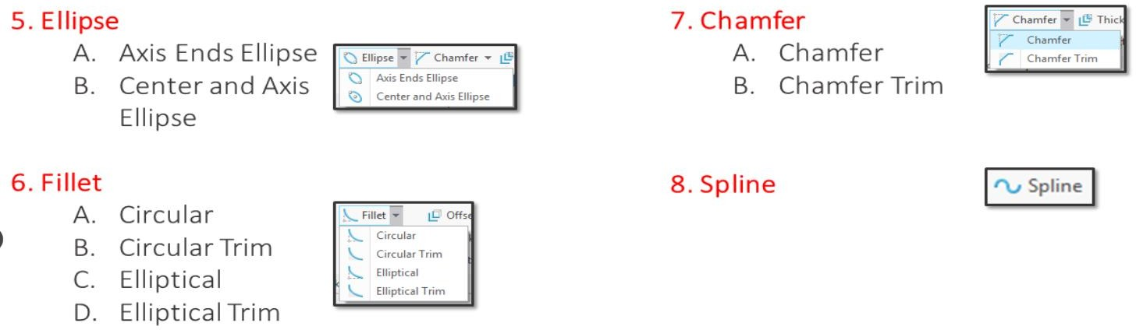

# Constraints

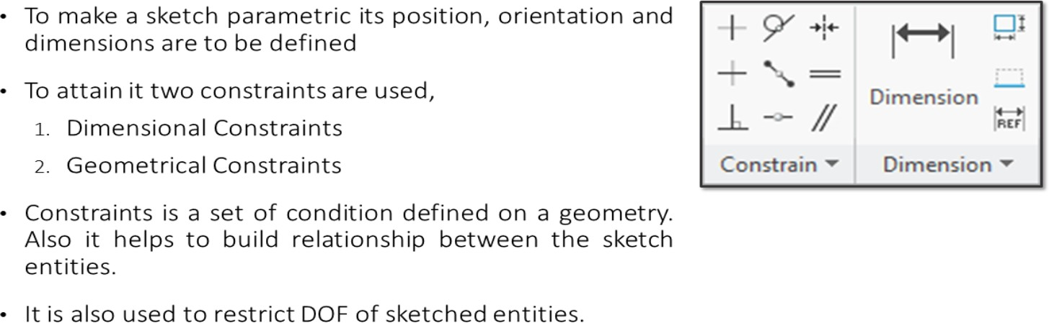

A constraint is a condition defining the geometry of the entity or a relationship among entities. Constraints can refer to geometry entities or construction entities. Create constraints or accept the constraints offered as you sketch. You can select an existing constraint, delete it, or get more information about it. The constraint tools work in Continue mode.

# Dimensional Constraints

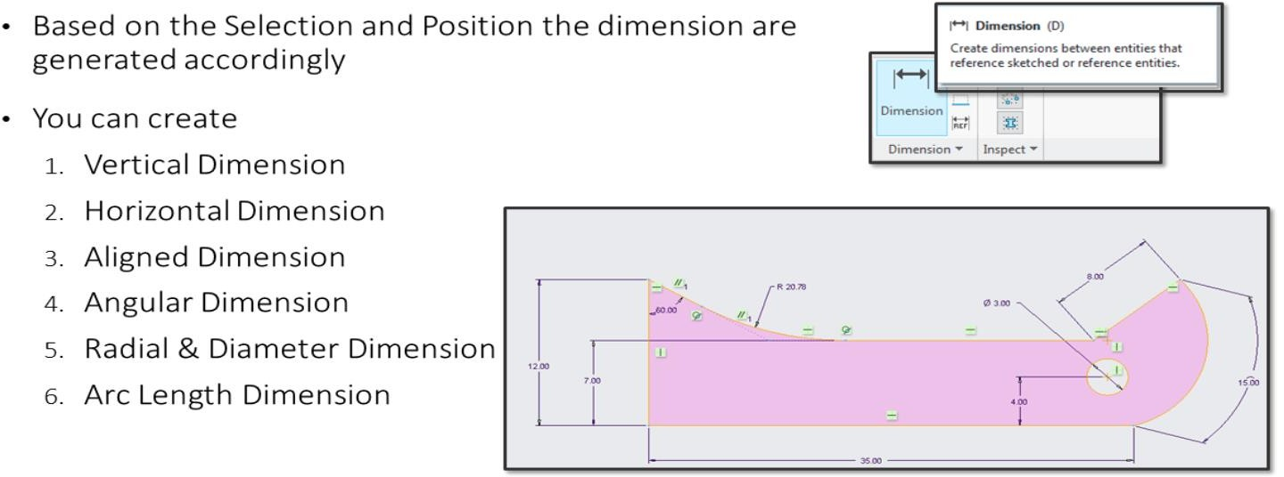

Sketches are automatically constrained and dimensioned at every stage of sketch creation to keep the section solved. You can define new dimensions, modify automatically- generated dimensions, strengthen weak dimensions, and delete dimensions. You can dimension the following types of entities:

* + - * Geometry
      * Construction
      * Reference
      * Intent datums

# Sketch Constraints

* Vertical Constraints: Makes a line or two vertices vertical.
* Tangent Constraints: Makes two entities tangent.
* Symmetric Constraint: Makes two points or vertices symmetric about a centerline.
* Horizontal Constraint: Makes a line or two vertices horizontal.
* Midpoint Constraint: Place a point on the middle of a line or an arc.
* Equal Constraint: Creates equal linear or angular dimensions, equal curvature, or equal radii.
* Perpendicular Constraint: Makes two entities perpendicular.
* Coincident Constraint: Makes points coincident.
* Parallel Constraint: Makes two or more lines parallel.

# Dimension Concepts

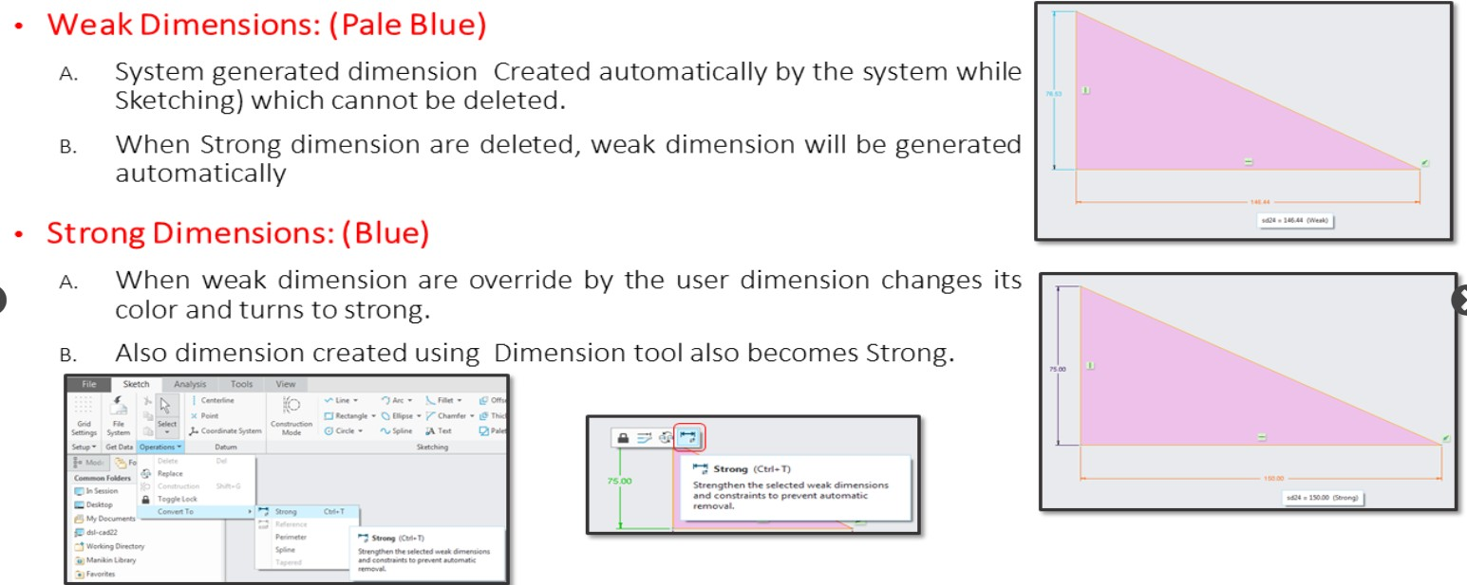

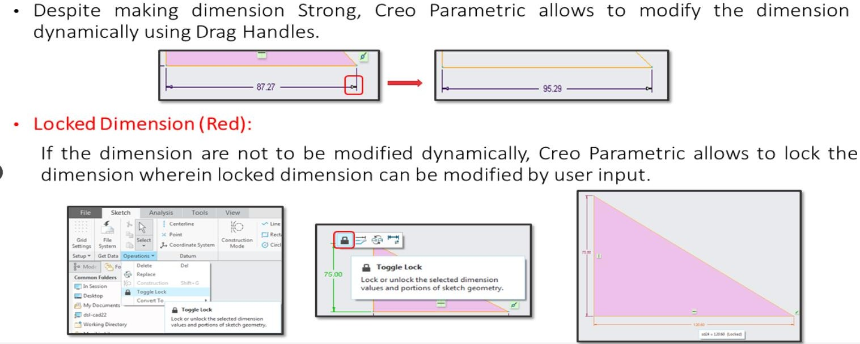

When you create an entity, weak dimensions are automatically generated. When you modify a weak dimension, it becomes a strong dimension. If you create another geometry, modify the geometry or other dimensions that relate to it, a weak dimension may disappear. You can strengthen a weak dimension without changing its value.

# Inspection Tools

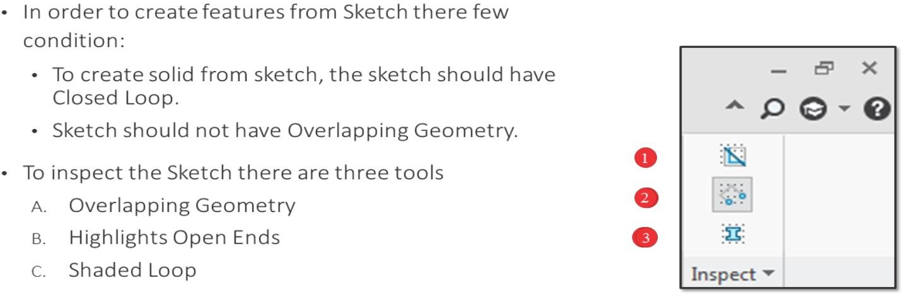

**Overlapping Geometry**

Use the Highlight Overlapping Geometry diagnostic tool to detect and highlight geometry that overlaps other geometry of an active sketch or of an active sketch group. Overlapping entities appear in the color set for Highlight Edge. To show entities that overlap, click Sketch > Overlapping Geometry.

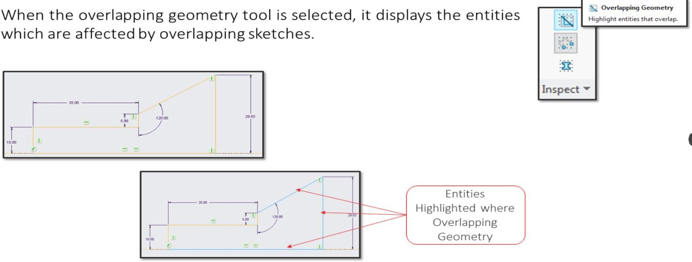

# Highlight Open Ends

Use the Highlight Open Ends diagnostic tool to highlight the end points of entities that do not coincide with end points of other entities in an active sketch or an active sketch group. In 3D sketch geometry only the open ends of valid entities are highlighted. Open end points of entities are highlighted by default. To hide the endpoints for any new sketches during the session, perform one of these operations: Click Sketch > Highlight Open Ends.

Set the sketcher_highlight_open_ends configuration option to no.

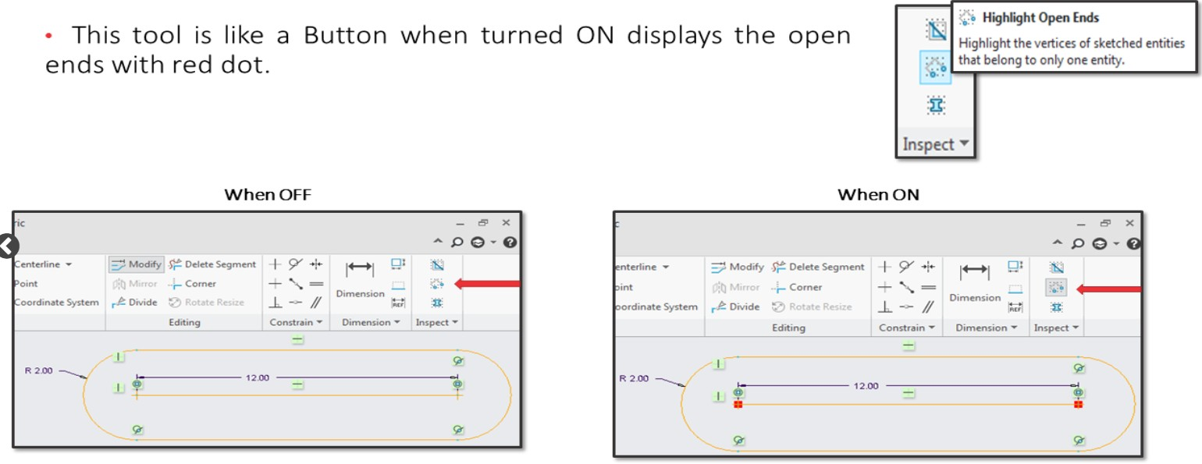

# Shaded Loops

You can use the Shade Closed Loop diagnostic tool to detect closed loops formed by sketched entities. A closed loop is a chain of entities that form a section that you can use to create a solid extrusion. For 3D sketch geometry, only the closed loops formed by valid entities appear shaded. If the sketch contains several closed loops that are internal and external to each other, the outermost loop is shaded, and the shading of the internal loops is alternated. For a sketch with multiple Sketcher groups, the criteria to identify a closed loop is applied to each group independently.

Click Sketch > Shade Closed Loops.

Set the sketcher_shade_closed_loops configuration option to no. To set the color of the shading,

click File > Options > System Appearance > Sketcher > Shaded closed loop.

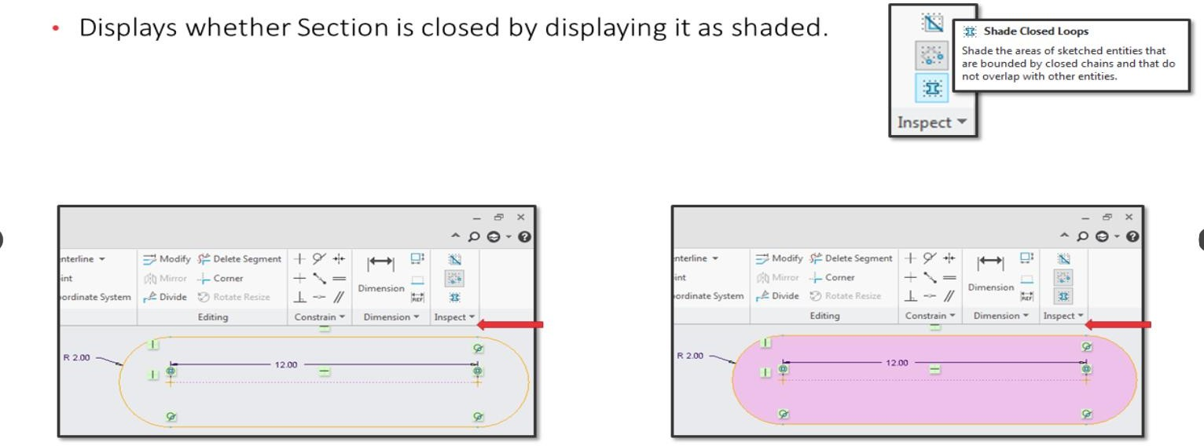

# CHAPTER 3

**Part Modeling**

Creo Part allows you to work in a interactive 3D graphics work space to design model as,

1. Solid
2. Surface

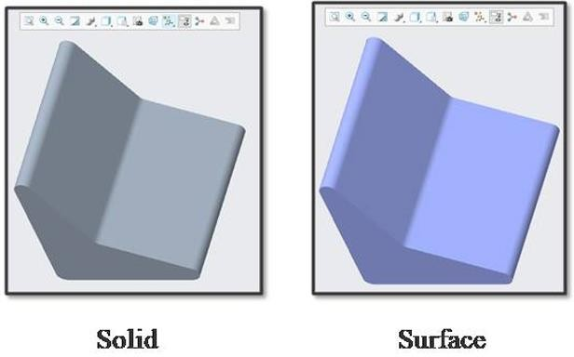

Solid are geometry which possess mass properties like

1. Volume
2. Surface Area
3. Inertia

Surface are geometry which possess Zero Wall Thickness.

# Basic modeling Guidelines

Before creating a part, it is necessary to understand design intent.

# Design Intent:

It is the idea on which a CAD user understands the relation between the objects and build model in such a way when it is subjected to modification, where in it incorporates the changes with its purpose and function throughout the design process.

* It helps in understanding the relationship between features and how to incorporate parametric relation between them.
* By understanding function, Form, fit of the product, design intent helps in building the modeling strategy.

It is important to identify the base feature up on which other features are constructed either by adding or removing the material.

# Part Modeling – Solid

To start part, click on File > New > New dialogue box appears Choose part from type and solid as Sub- type

enter name of the part and click ok

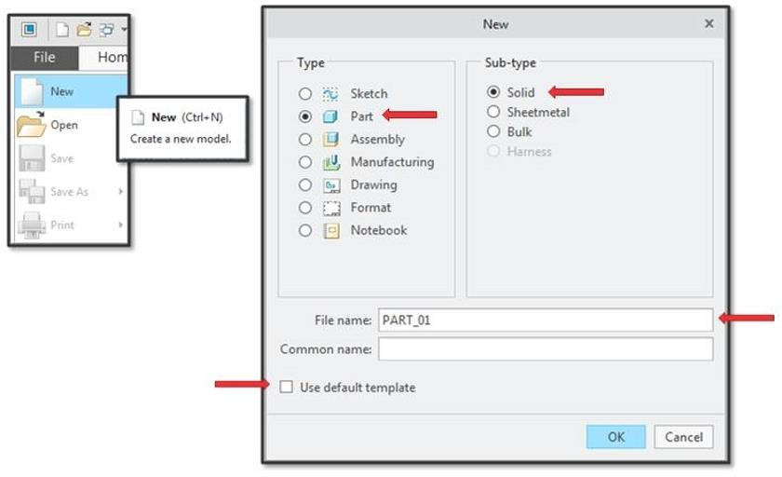

# key things to remember

* Model tree - Display Style
* Edit definition - Layer tree
* Saved orientation - Regenerate

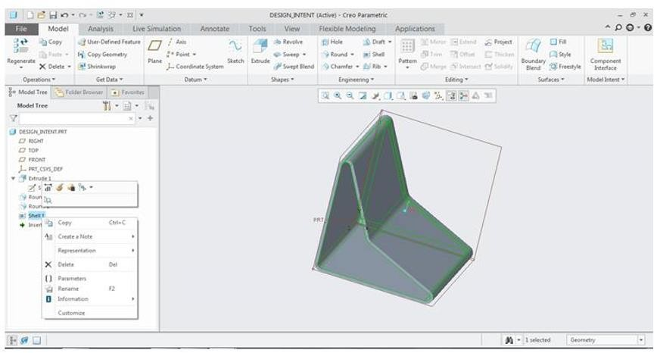

# Types of Sketches

1. External Sketch
2. 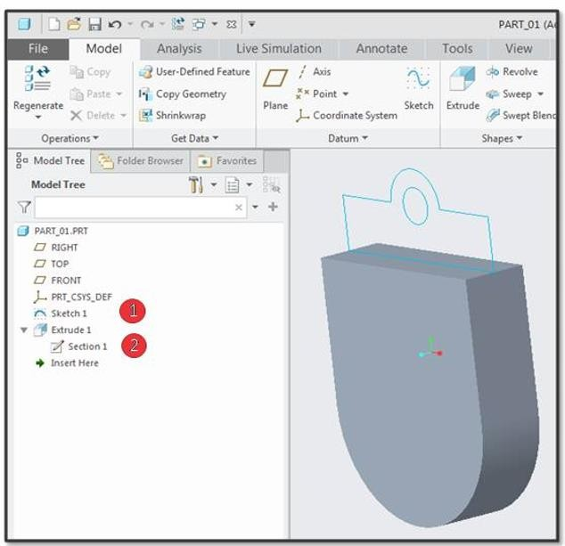Internal Sketch

# Shape feature – Extrude

Extrude creates solid normal to the direction of sketch.Use, the Extrude tool to create a solid or surface feature and to add or remove material.

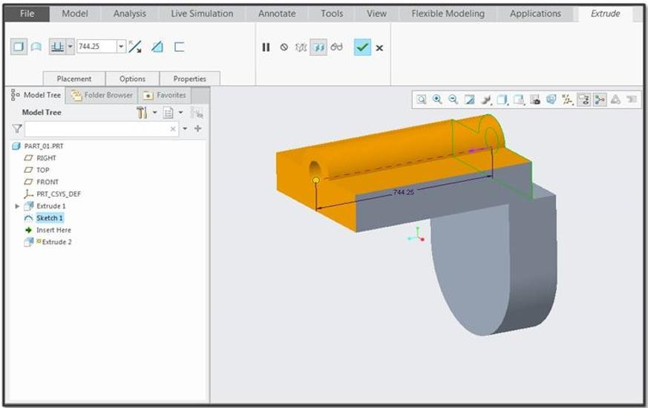

# Extrude Dashboard

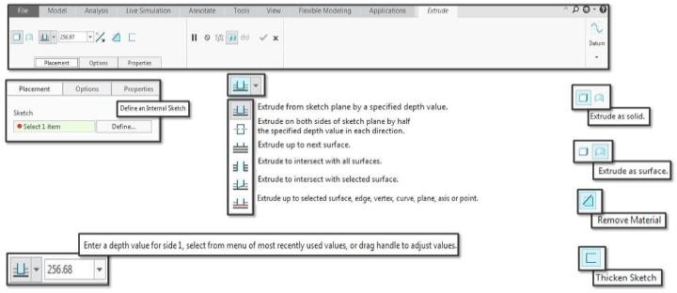

**Shape feature – Revolve**

Revolve is a method of defining three- dimensional geometry by revolving a sketched section around a center line. Use, the Revolve tool to create a solid or surface feature and to add or remove material.

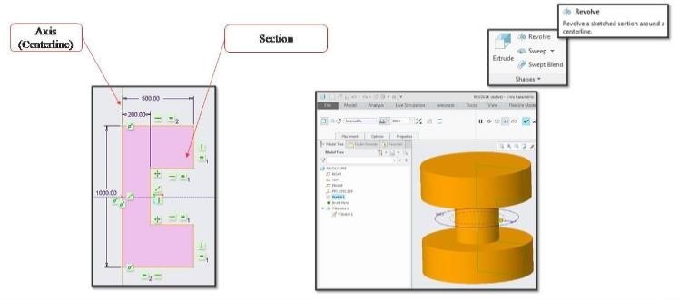

# Revolve Dashboard

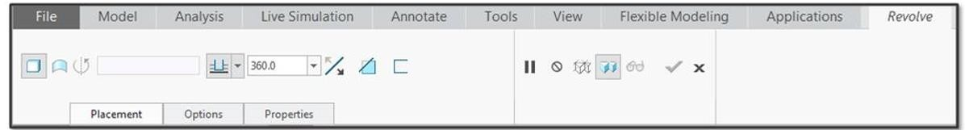

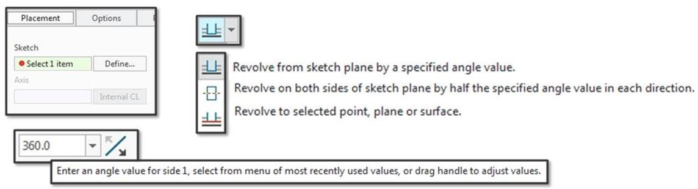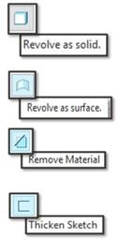

**Shape Feature – Sweep**

Sweep in Creo Parametric is the shape feature which create geometry by sweeping a sketch otherwise termed Cross – section along the path otherwise termed as Trajectories

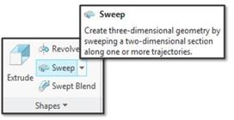

* Material can be added or removed as the sketch sweeps along trajectory.
* You can add a thickness to the sketch.
* The geometric representation of the sweep can be solid or surface.

**Constant section sweep**

The main components of the sweep tool are the trajectories. The sketched section sits on a frame that is attached to the origin trajectory and moves along its length to create geometry.

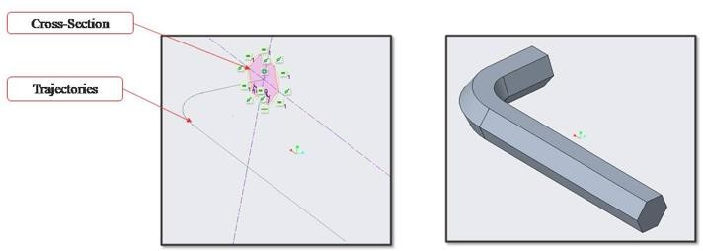

# Sweep – Dashboard

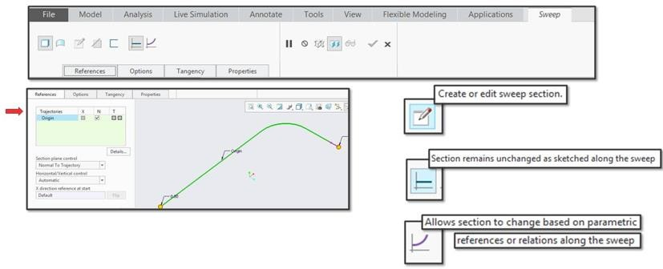

**Sweep**

# Variable section sweep

The key components of the Variable sweep in general is Trajectories which are,

* + Origin
  + Chains

Create a variable section sweep using the sweep tool you can create a solid or surface feature. You add or remove material, while sweeping a section along one or more selected trajectories by controlling the sections orientation, rotation and geometry.

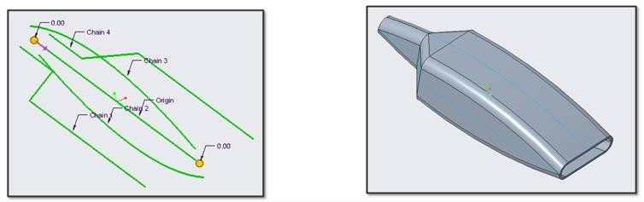

# Sweep – Helical

Create a helical sweep by sweeping a section ( cross sectional sketch) along a helix (helical trajectory). To define the helix, you define a helix profile and a Helix axis (axis of revolution for the helix).

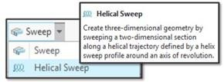

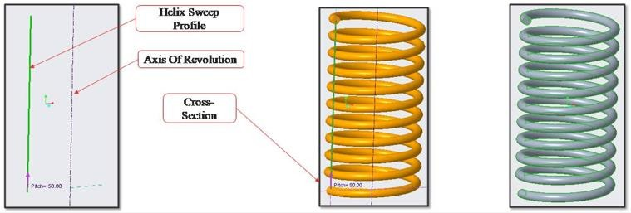

# Sweep (Helical) – Dashboard

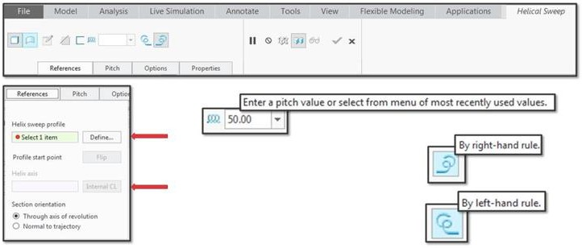

**Shape Feature – Blend**

Blend feature in Creo Parametric allows to create those shapes whose cross section are dissimilar by connecting their vertices at definite planar distance. Number of sections can be two or more.

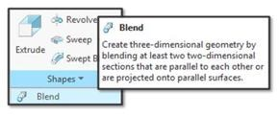

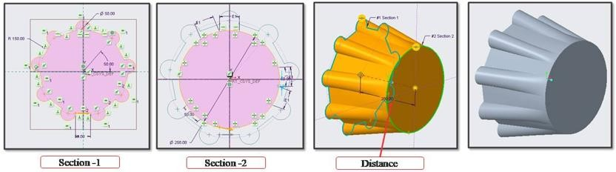

**Blend Dashboard**

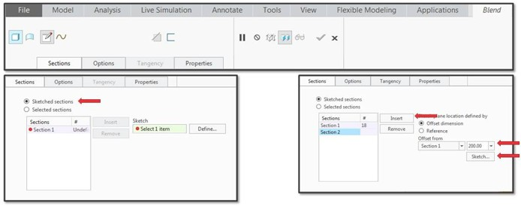

**CHAPTER 4**

# Datum Planes

Datum planes are used as a reference on a part where a reference does not already exist. For example, you can sketch or place features on a datum plane when there is no other appropriate planar surface.

Datum planes are infinite, but you can size them to fit a part, feature, surface, edge, or axis, or specify values for the height and width of the display outlines of datum planes. Alternatively, you can use the handles that are displayed to drag the boundaries of datum planes to resize their display outline.

# To select Datum plane in creo:

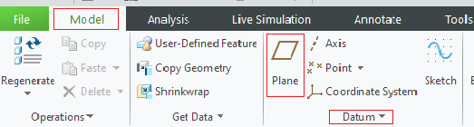

1. In Creo parametric select Part
2. In the model tab> Datum Group> Select Plane

# To Create an Offset Datum Plane:

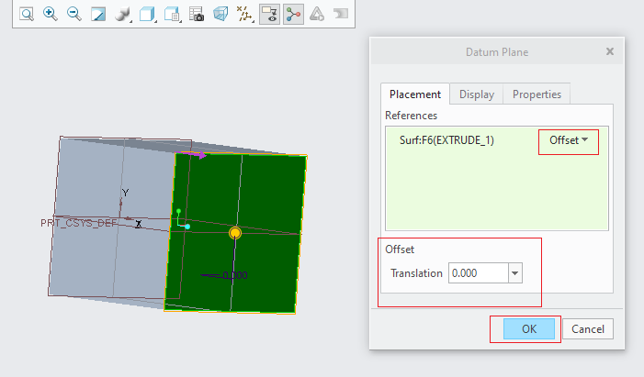

1. Click Model > Plane. The Datum Plane dialog box opens.
2. Click the References collector, and select an existing datum plane or planar surface from which to offset the new datum plane.
3. Select Offset from the constraints list in the References collector.
4. To adjust the offset distance, type a distance value in the Translation value box, or drag the handles in the graphics window.
5. Click OK

# To Create a Datum Plane with an Angular Offset:

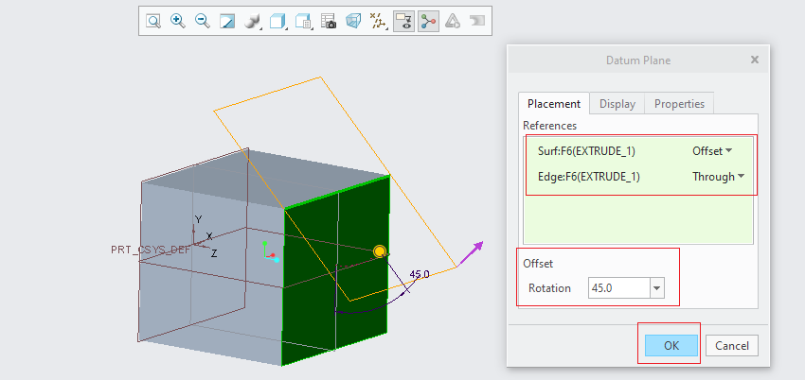

1. Click Model >  Plane. The Datum Plane dialog box opens.
2. Click the References collector and select an existing datum axis, straight edge, or straight curve.
3. Select Through from the constraints list in the References collector.
4. Hold down the CTRL key and select a datum plane or planar surface that is normal to the selected datum axis. By default Offset is selected as the constraint.
5. To adjust the angle of the datum plane, type an angular value in the Rotation value box, or drag the handles in the graphics window to manually rotate the datum plane to the required angle.
6. Click OK.

# To Create a Datum Plane Mid Plane Between Two References

Create a datum plane halfway between two parallel references, or a datum plane that bisects the angle formed by two nonparallel references.

1. Click Model >  Plane. The Datum Plane dialog box opens.
2. On the Placement tab, click the References collector, and then select the first reference. Use one of the following entities:
   1. Planar surface, datum plane
   2. Axis, linear curve, linear edge
   3. Datum point, datum coordinate system, vertex
   4. Facet face, facet edge, facet vertex
3. In the constraint list next to the first reference, click Mid plane.
4. Hold down the CTRL key while you select the second reference
5. When the two references are not parallel, next to the second reference, click the Bisector1 or Bisector2 constraint. The new plane bisects the α angle or the (180° - α) angle, depending on the location of your selections.
6. Click OK.

# About Creating a Datum Plane Tangent to a Surface

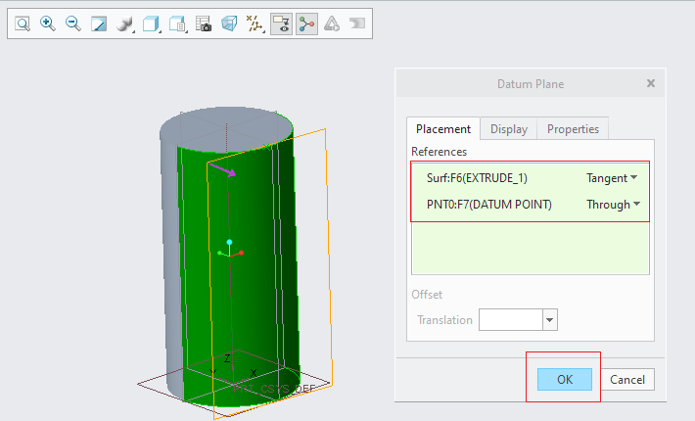

You can create a datum plane that is tangent to a surface and that passes through one of these references: a datum point, a vertex, or an endpoint of an edge. In the Datum Plane dialog box, set the constraint next to the surface reference to Tangent.

The datum plane can be tangent to these surfaces:

* Conical surfaces
* Cylindrical surfaces

# CHAPTER 5

**Engineering Features**

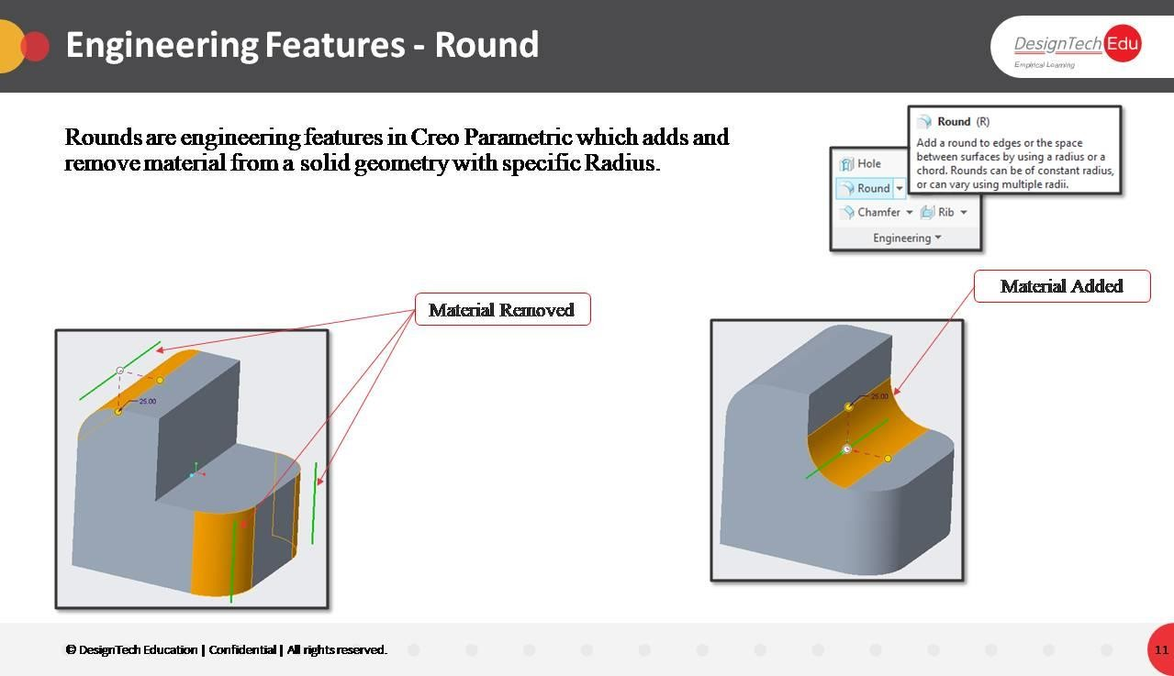

# Description:

A round is an edge treatment feature in which a radius or chord is added to one or more edges, an edge chain, or the space between surfaces. Surfaces can be solid model surfaces, or they can be zero thickness quilts or surfaces. To create rounds, you must define one or more round sets.

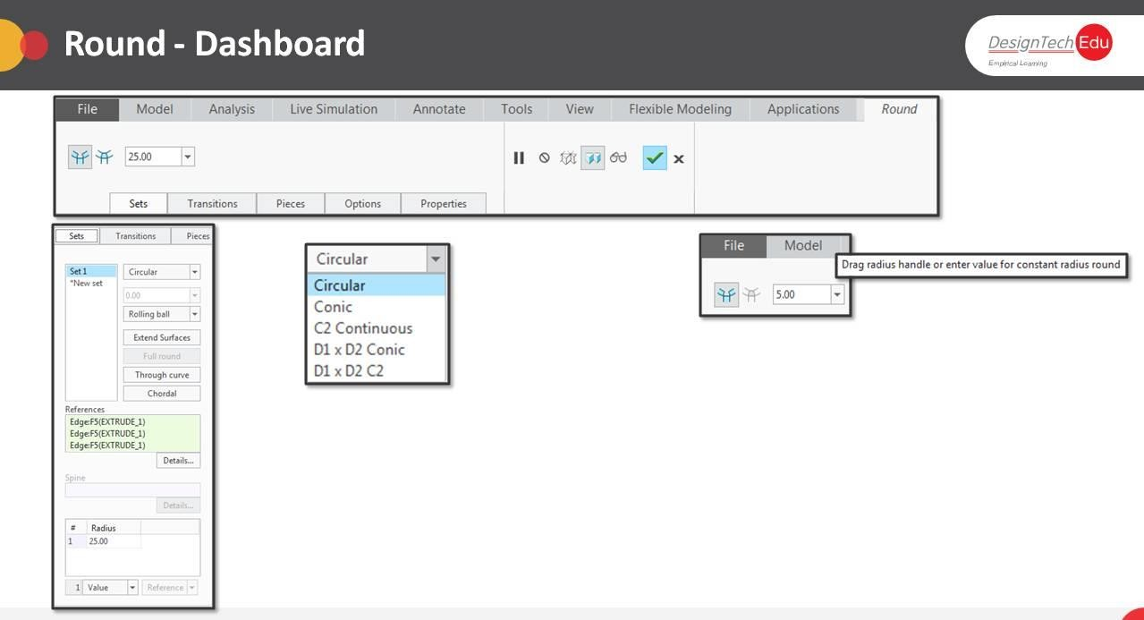

# Description:

A round consists of the following items:

* + **Sets**—Round pieces (geometry) created pertaining to the placement references. Round pieces consist of unique attributes, geometric references, and one or more radii or chords.
  + **Transitions**—Filler geometry that connects round pieces. Transitions are located where round pieces intersect or terminate. Default transitions are used during the initial round creation; though other transition types are available.
  + **Constant:** The round piece has a constant radius
  + **Variable:** The round piece has multiple radii
  + **Round driven by a curve:** The radius of the round is driven by the datum curve
  + **Full:** The full round replaces the selected surface

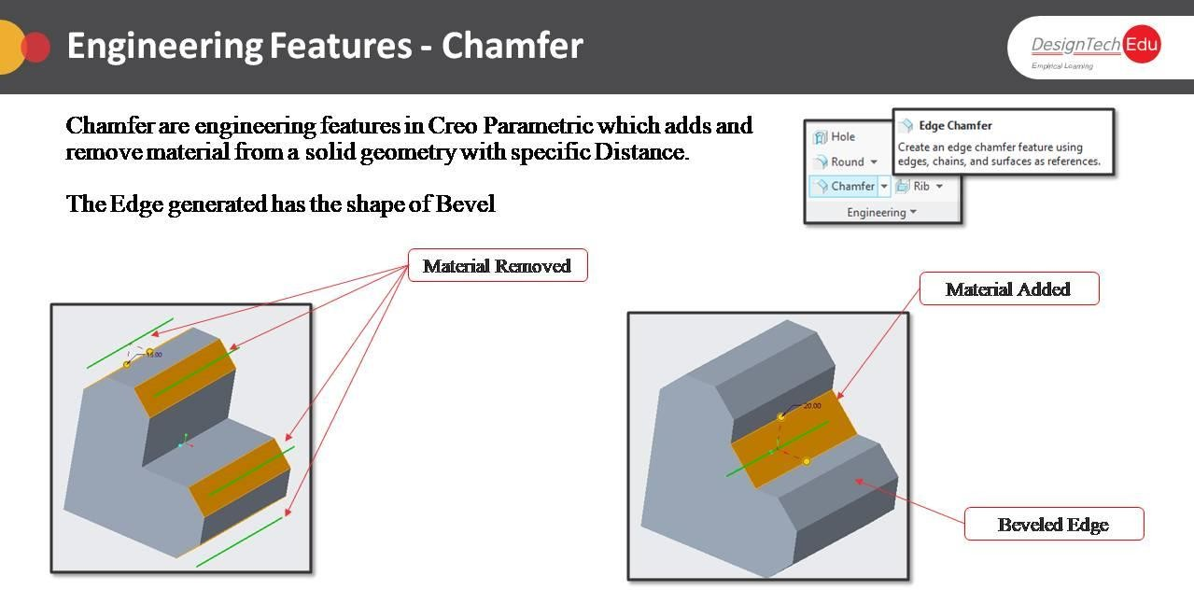

# Description:

Chamfers are a type of feature where an edge or corner is beveled. You can create two types of chamfers: corner chamfers and edge chamfers.

* **Corner Chamfers** - When you create a corner chamfer, you select a vertex defined by three edges, and then you set length values along each chamfer direction edge.
* **Edge Chamfers** - To create edge chamfers, you define one or more chamfer sets.

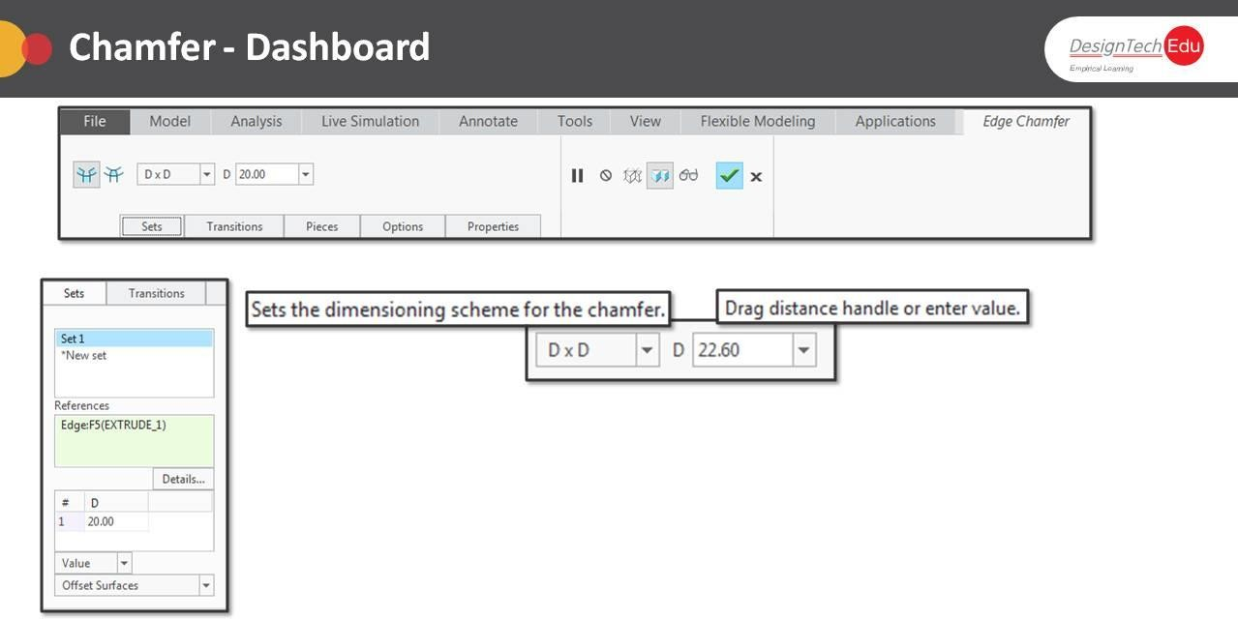

# Description:

An Edge Chamfer consists of the following:

* + **Sets**—Chamfer segments that consist of unique attributes, geometric references, and plane angles, and one or more chamfer distances: legs of the triangle formed by the chamfer and the neighboring surfaces.
  + **Transitions**—Filler geometry that connects chamfer pieces. Transitions are located where the chamfer pieces or set ends meet or terminate. The system uses default transitions during the initial chamfer creation and provides many transition types, allowing you to create and modify transitions.

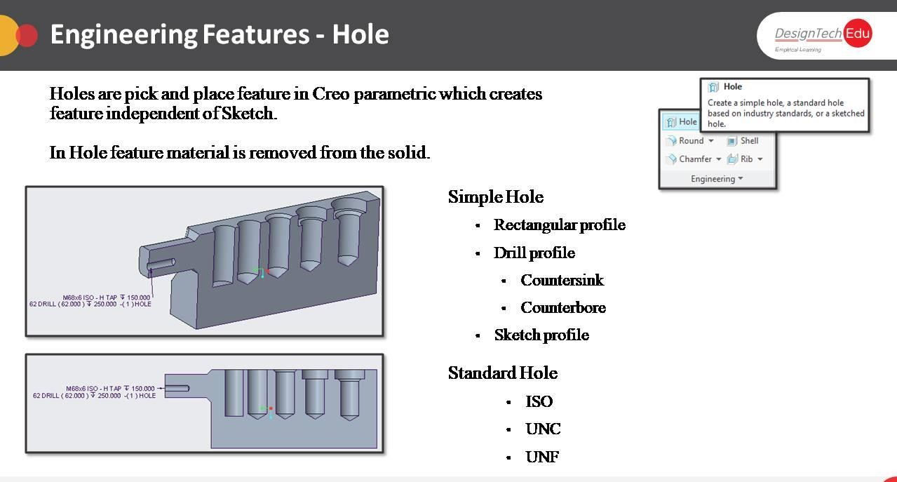

# Description:

The Hole tool enables you to add simple, custom, and industry standard holes to your models. You add holes by defining a placement reference, offset references, optional hole orientation references, and the specific characteristics of the hole.

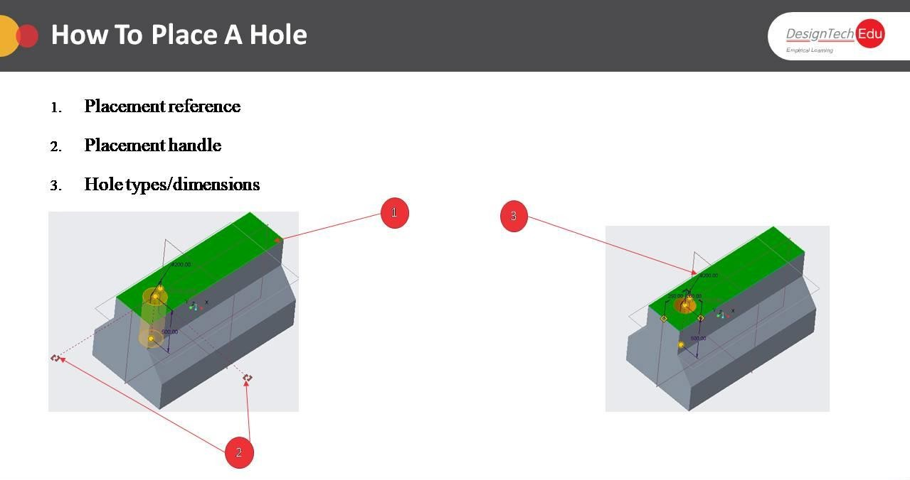

# Description:

Hole Placement References: You can place a hole in a model by selecting different placement reference combinations:

A placement reference to position the hole, and offset references to constrain the hole position in relation to the selected references.

Two placement references, a datum axis and a surface. The axis does not have to be Perpendicular to the surface.

Placement Reference: The placement reference enables you to position the hole on the model. You can relocate the hole by dragging the placement handle on the hole preview. Geometry, or by snapping the handle to a reference. You can also click the handle and then select the primary placement reference. The hole preview geometry relocates.

# Offset References:

Offset references enable you to use additional references to constrain the Hole position in relation to selected edges, datum planes, axes, points, or surfaces. You can define the offset references by snapping the secondary placement handles to references.

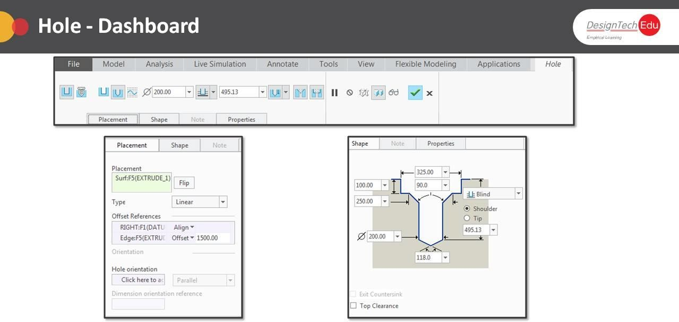

# Description:

You can create the following hole types:

* **Simple** — Consists of an extruded or revolved cut that is not directly associated with any industry standard.

You can create the following simple holes types:

* **Predefined rectangle profile** — Uses (straight) geometry predefined by the system. By default, the system creates one-Sided simple holes. However, you can create two-Sided Simple straight holes by using the Shape tab. Two-sided simple holes are typically used in assemblies and enable you to simultaneously format both hole sides.
* **Standard hole profile**—uses standard hole profile as drill hole profile. You can specify the countersink, counter bore, and tip angle for the holes.
* **Sketch**—Uses a sketch profile that you create in Sketcher.
* 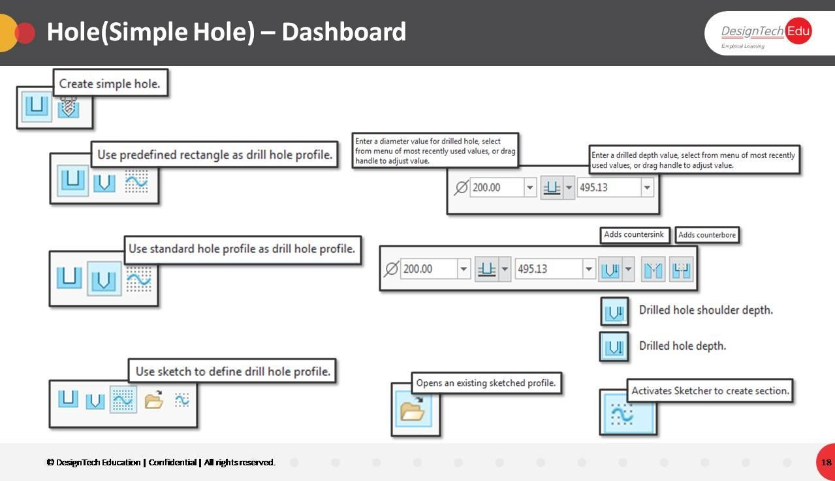**Standard**—consists of a revolved cut based on industry-standard fastener tables.



# Description:

Select the approximate hole location on the model. This is your placement reference. The selection is highlighted.

1. Click Model > Hole. The Hole tab opens and preview geometry of the hole is displayed.
2. Click Simple to create a simple hole.
3. To relocate the hole, drag the placement handle to the new location or snap it to a reference.
4. To change the hole placement type, click the Placement tab and
5. Select a new type in the placement Type box.
6. To constrain the hole, drag the offset placement reference handles to appropriate references. The handle automatically snaps to the reference.
7. To align the hole with an offset reference, click the Placement tab, select the reference in the Offset references collector, and change Offset to Align.
8. To orient the hole to be parallel to or perpendicular to a reference:
   1. Click the Placement tab, click the Hole orientation collector, and select a planar, axial, or linear reference.
   2. Select either Parallel or Perpendicular from the list.
9. To modify the hole diameter, drag the diameter handle, or double-click the diameter dimension in the graphics window and type a new value, or select a recently-used value. The geometry update is previewed.
10. Select a depth option from the Depth Options list on the Hole tab or the shortcut menu, or drag the depth handle.

* Blind
* Symmetric
* To Next
* Through All
* Through Until
* To Selected

1. Select the second side drill depth option in the Side 2 box on the Shape tab. The Symmetric depth option is not available. You can modify the second side drill depth on the tab or in the graphics window.
2. To ensure that the entire top of the hole intersects the outside of the solid geometry, on the Shape tab, make sure that the Top Clearance check box is selected.
3. To represent the hole with lightweight geometry, click Toggle Lightweight Geometry.
4. Click OK to create the hole.

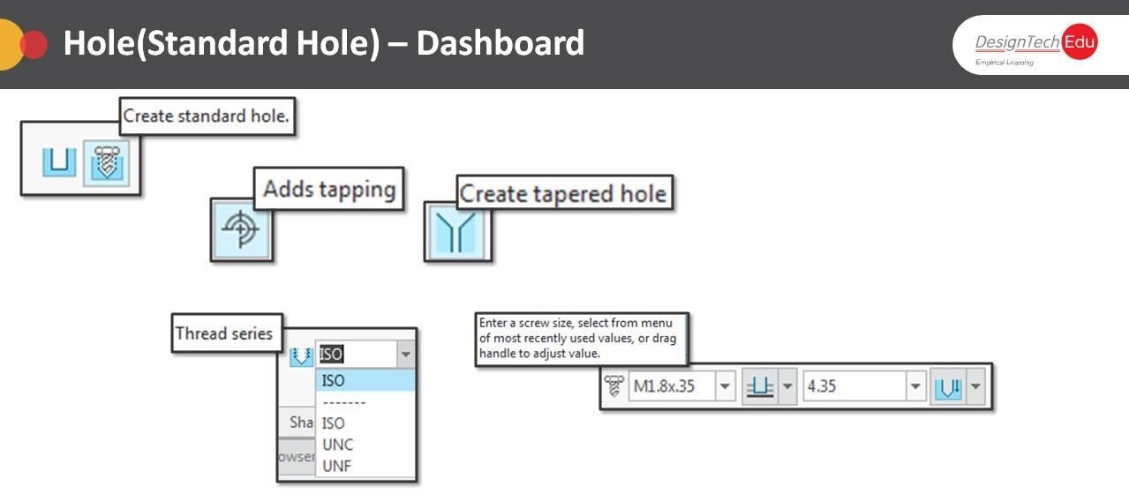

# Description:

Select the approximate hole location on the model. This is your primary placement reference. The selection is highlighted.

1. Click Model > Hole. The Hole tab opens and preview geometry of the hole is displayed.
2. Click Standard to create a standard hole. The standard hole options are shown.
3. To relocate the hole, drag the primary placement handle to the new location or snap it to a reference.
4. To change the hole placement type select a new type from the placement Type box on the Placement tab.
5. Drag the offset placement reference handles to the appropriate references to constrain the hole. As you drag each handle, the available references are highlighted as your pointer moves over them. This enables you to target the correct reference. The system automatically snaps the handle to the reference and adds them to the Offset References collector on the Placement tab.
6. To align the hole with an offset reference, select the reference from the Offset References collector on the Placement tab and change offset to Align.
7. To orient the hole to be parallel to or perpendicular to a reference:
   1. Click the Placement tab, click the Hole orientation collector, and select a planar, axial, or linear reference.
   2. Select either Parallel or Perpendicular from the list.
8. To create a tapped hole, select Add Tapping.
9. To create a tapered hole, select Tapered.
10. To create a clearance hole, click Add Tapping to deselect it and then click Clearance.
11. To create a drilled hole, click Add Tapping to deselect it and click Drilled.
12. Select the desired hole chart in the box adjacent to thread type on the Hole tab. Thread Type enables you to select industry-standard hole charts (ISO, ISO_7/1, NPT, NPTF, UNC, or UNF).
13. 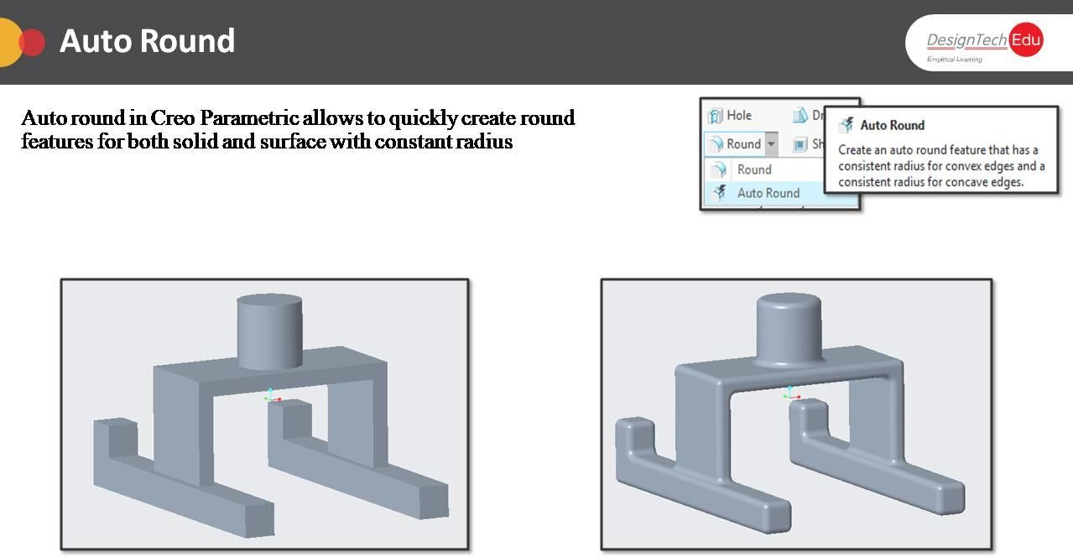Type or select a screw size in the box adjacent to Screw size.

# Description:

The Auto Round feature enables you to create round geometry of a constant radius on solid geometry or on a quilt of a part or assembly. You can access the Auto Round feature by clicking Model, click the arrow next to round, and click Auto Round.

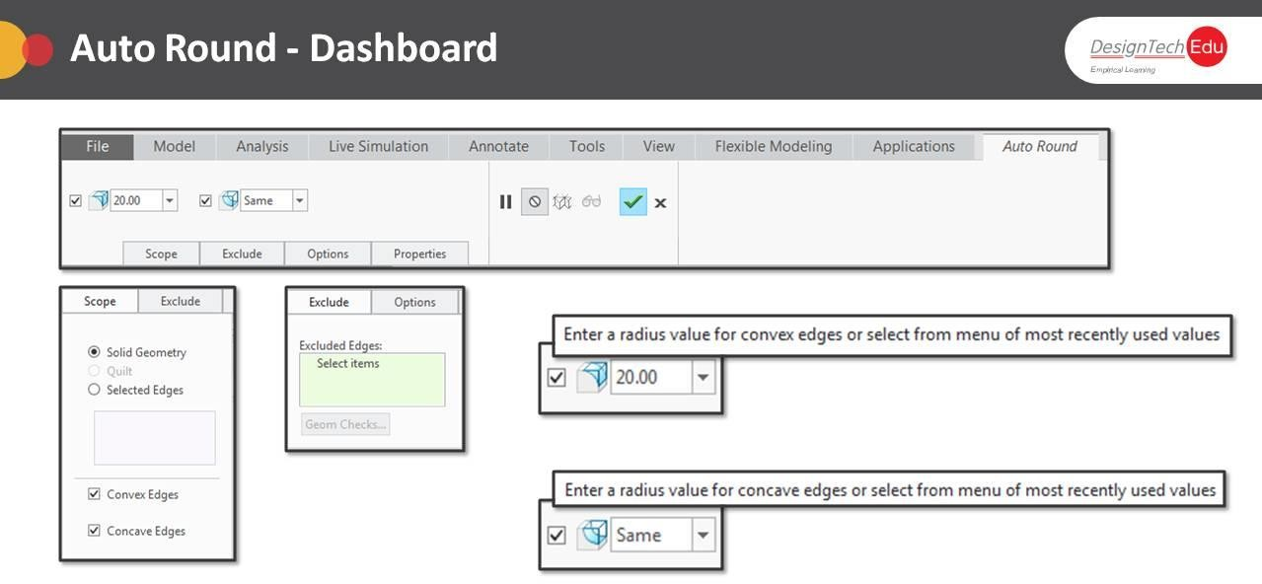

# Description:

The Auto Round tab consists of commands, tabs, and shortcut menus. Click Model, click the arrow next to Round, and click Auto Round to open the Auto Round Tab. Commands Specifies the radius to be applied for convex edges. Specifies the radius to be applied for concave edges. Tabs

* Scope
  + Solid Geometry—Creates Auto Round features on the solid geometry of the model. This option is selected by default, if the model contains solid geometry.
  + Quilt—Creates an Auto Round feature on a single quilt in the model. This Option is available only if the model contains one or more quilts.
* Quilt collector—displays a quilt with two-sided edges to be rounded by the Auto Round feature. This collector is available only if you select Quilt.
  + Selected Edges—Creates an Auto Round feature on selected edges or intent Chains.
* Selected edges collector—Displays edges or intent chains to be rounded by the Auto Round feature. You can also drag the mouse pointer diagonally over the Model to select multiple edges or intent chains. This collector is available Only if you select Selected Edges.
  + Convex Edges—Selects all convex edges in the model to be rounded by the Auto Round feature.
  + Concave Edges—Selects all concave edges in the model to be rounded by the Auto Round feature.
* Exclude
  + Excluded Edges collector—displays the edges and intent chains to exclude from the Auto Round feature. You can select one or more edges or chains of Edges to be excluded from the Auto Round feature. You can also drag the Mouse pointer diagonally over the model to exclude multiple edges or intent Chains.
  + Geometry Checks—excludes an edge or a chain of edges that could not be Rounded by the Auto Round feature. The Troubleshooter dialog box displays. The reason why the edge or chain of edges could not be rounded. Geometry Checks is available when the Auto Round feature could not round some of the edges, and you want to redefine the Auto Round feature.
* Options
  + Create Group of Regular Round Features check box—creates a group of Individual regular round features from an Auto Round feature.
  + Make Round Features Dimensions Dependent—makes the dimensions of Each individual round feature in a group dependent on each other. Changing Any one the dimension, updates the dimension of all the other round features Of that round group.

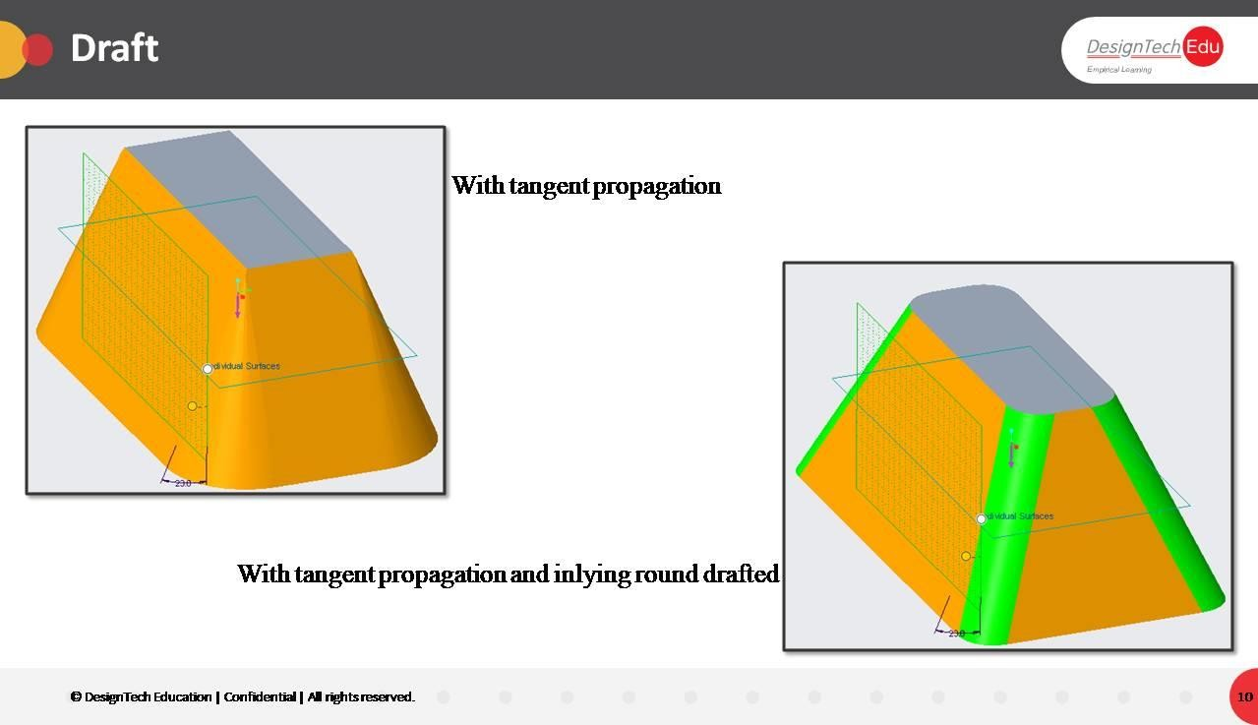

# Description:

The Draft feature adds a draft angle from -89.9° to +89.9° to individual Surfaces or to a series of surfaces. You can draft only the surfaces that are Formed by tabulated cylinders or planes. To access the Draft feature, Click Model>Draft.

You can draft either solid surfaces or quilt surfaces, but not a combination of Both. When you select surfaces to be drafted, the first selected surface Determines the type of additional surfaces, solid or quilt, that can be selected for this feature.

# Description:

The Draft tab consists of commands, tabs, and shortcut menus. Click Model > Draft to open the Draft tab.

# Commands

* Draft Hinges collector—Displays the neutral lines or curves on the draft Surfaces, that is, the lines or curves that the surfaces are pivoted about. You Can select up to two planes, quilts, or curve chains. To select a second hinge, you must first split the draft surfaces by a split object.
* Pull Direction collector—Displays the direction that is used to measure the Draft angle. You can select a plane, a straight edge or a datum axis, or an Axis of the coordinate system.
  + Reverse Pull Direction—Reverses the pull direction (indicated by an arrow).
* Angle box—Changes the value for the draft angle.
  + Reverse Angle to add or remove material—Reverses the direction of the Draft angle, to switch between adding and removing the material. For split drafts with independently drafted sides, the tab contains a Second Angle box and Reverse Angle button to control the draft angle on the second side.
* Automatically propagates the draft to surfaces that are tangent to the Selected draft surfaces.
* Preserves inlying round surfaces as rounds. They will not be drafted.

# Variable Pull Direction Draft Feature

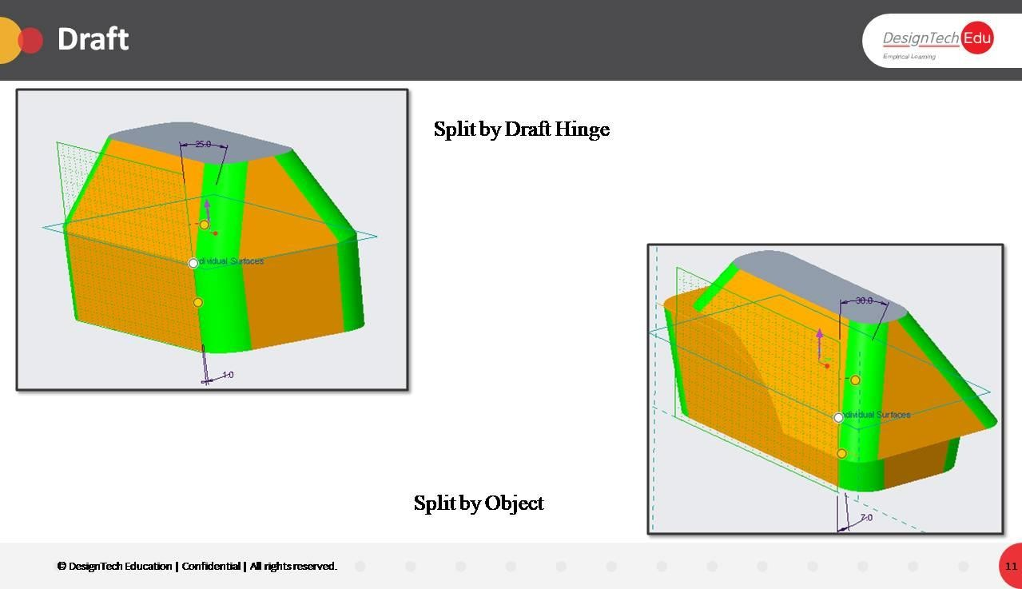

The draft angles of a Variable Pull Direction Draft feature can be set at selected points:

* At the end points of the draft edges or curves.
* At datum points that lie on the draft edges or curves.
* Along the draft surface.

You can also set the draft hinge in a separate position from the pull direction reference surface.

A good example of a variable pull direction draft is the design of an automobile tire. You can design the treads to become narrower as they become deeper, and you can apply deeper drafts from the same reference surface as the shallower drafts.

You can apply a Variable Pull Direction Draft to either solid surfaces or quilt surfaces but not a combination of both. The first selected surface determines the type of additional surfaces to which you can apply the feature.

# About the Variable Pull Direction Draft User Interface

The Variable Pull Direction Draft tab consists of commands, tabs, and shortcut menus. Click Model, click the arrow next to  Draft, and click  Variable Pull Direction Draft to open the Variable Pull Direction Draft tab.

# Commands

•  collector—Displays a surface, a quilt, or a plane to determine the draft pull direction.

o —Reverses the pull direction indicated by a yellow arrow.

•  collector—Displays multiple curve or edge chains that are draft hinges and that will have the same draft attributes.

o —Switches the draft surfaces of the set to the other side of the draft hinge.

•  box—Sets the value for the draft angle.

* Extent list—Sets the length of the draft surface when quilt geometry is selected. If you activated split draft geometry, it sets the length of the end section of the split-surfaced draft surface. The list is also available on the **Options** tab and the shortcut menu.
  + **Specify Length**—Extends the geometry by a specified length.
* Length box—Sets a length value.
  + **To Selected**—Extends the geometry to the selected surface, quilt, or datum plane.
* Extent reference collector—Displays a surface, quilt, or datum plane to define the extent of the draft geometry.
  + **To Next**—Extends the geometry up to the next intersected surface.
  + **Unattached**—Creates quilt geometry as a lightweight representation of solid geometry.

# Tabs

* **References**
  + **Pull Direction Reference Surface** collector—Displays a surface or surfaces that are tangent to each other, a quilt, or a plane to determine the draft pull direction.
* **Flip**—Reverses the pull direction. Select a reference surface first.
  + Sets table—Displays the draft set list. Click **New Set** to create a new set. Click a set number to activate the set.
  + **Draft Hinges** chain collector—Displays curve or edge chains that are hinges for draft geometry. You can define multiple draft points along the draft hinge to set various draft angles.
* **Details**—Opens the **Chain** dialog box to manipulate the draft hinge chains.
* Set **Flip**—Switches the draft surfaces of the set to the other side of the draft hinge.
  + **Splitting Surfaces** check box—Activates the **Splitting Surfaces** collector that defines the split draft geometry.
* **Splitting Surfaces collector**—Displays up to two points on the length of the draft surface at which you can vary the draft angles that are already defined on the draft hinge. This point can be a datum plane, a quilt, or a surface. The splitting objects must not intersect each other or the pull direction reference surface.
  + Angles table—Displays the angles and locations of the hinges of the active draft set.

# Options

* **Attachment**—Specifies whether to create solid or quilt geometry.
* **Attach to solid or quilt**—Attaches the draft geometry to existing solid or quilt geometry.
* **Create new quilts**—Creates new uncapped quilt geometry and specifies the length of the surface.
* **Extent** list—Sets the length of the draft surface when **Create new quilts** is selected.
* **Specify Length**—Extends the geometry by a specified length.
* **Length box**—Sets a length value.
* **To Selected**—Extends the geometry to the selected surface, quilt, or datum plane.
* Extent reference collector—Displays a surface, quilt, or datum plane to define the extent of the draft geometry.
* **To Next**—Extends the geometry up to the next intersected surface.
* **Unattached**—Creates quilt geometry that looks exactly like the solid geometry that would be added to the model, if the **Attach to solid or quilt** option were selected. This is also called cap geometry as the quilt ends are capped.

# Properties

* **Name** box—Sets a name for a feature.

• —Displays detailed component information in a browser.

# Shortcut Menus

Right-click the graphics window to access shortcut menu commands:

* **Pull Direction Reference Surface**—Activates the **Pull Direction Reference Surface** collector where you select a surface, a quilt, or a plane to determine the draft pull direction.
* **Draft Hinges**—Activates the **Draft Hinges** collector where you collect curve or edge chains that are hinges for draft geometry.
* **Splitting Surfaces**—Activates the **Splitting Surfaces** collector.
* **Clear**—Empties the active collector.
* **Add Set**—Creates a new draft set.
* **Delete Set**—Deletes the selected draft set.
* **Make Constant**—Deletes all draft handles in the set of the selected handle, leaving only the handle selected.
* **Make variable**—Adds one draft angle in a set.
* Extent list—Sets the length of the draft surface when quilt geometry is selected.
  + **Specify Length**
  + **To Selected**
* **Bottom Surface**—Activates the **Extent** reference collector.
  + **To Next**
  + **Unattached**

Right-click the Pull Direction arrow to access shortcut menu commands:

* **Flip**—Changes the pull direction of the direction arrow and of the draft surface selection. Right-click the draft angle dragger to access shortcut menu commands:
* **Add Angle**—Adds another draft angle handle at a default location.
* **Delete Angle**—Deletes a selected draft angle.

Right-click the Angles table on the References tab to access shortcut menu commands:

* **Add Angle**—Adds another draft angle handle at a default location.
* **Delete Angle**—Deletes a selected draft angle. Available IF more than one draft angle handle has been created.

# To Create a Variable Pull Direction Draft

1. Click **Model**, click the arrow next to  **Draft**, and click  **Variable Pull Direction Draft**. The **Variable Pull Direction Draft** tab opens.
2. Click the  **Pull Direction Reference Surface** collector and select a surface, a datum plane, or a quilt for the pull direction reference surface. The reference surface is highlighted.
3. Click the  **Draft Hinges** collector and then click an edge or a curve for a draft hinge. A preview draft with a draft angle handle attached to one end of the hinge is displayed.
4. To add another draft angle handle to the draft edge or curve, right-click the draft angle handle or right-click the **Angles** box on the **References** tab and choose **Add Angle** from the shortcut menu. A second draft angle handle appears and the two handles snap to the hinge ends. You can add additional draft angle handles that will appear between the first two handles.
5. Drag the draft handles, or change the values in the  box on the **Variable Pull Direction Draft** tab or the **Angles** table on the **References** tab, to change the draft angles if desired.
6. To create a split on the draft surface, on the **References** tab in **Sets** area, select the **Splitting Surfaces** check box. Select a surface, a datum plane, or a quilt as a reference. A draft angle dragger is added to each of the set's draft handles at the splitting surface reference position. You can adjust the draft angles at this point in reference to the pull direction reference surface.
7. To add a draft hinge on another plane leading from the same draft reference surface, click **New Set**. **Set 2** appears and is activated in the Sets list.
8. Select an edge for the new draft hinge and define it as described in steps 2 through 5. You can toggle between **Set 1** and **Set 2**, but you cannot activate both at the same time.
9. On the **Options** tab:
   * To choose solid draft geometry, select **Attach to solid or quilt**.
   * To choose quilt draft geometry, select **Create new quilts**. The **Extent** list becomes available on the **Variable Pull Direction Draft** tab and on the **Options** tab. To define the features of the last section of the quilt geometry, select an extent option from the **Extent** list or drag the draft length handles.
10. To extend the draft features to other edges of the pull direction reference surface, click **Details** under **Sets** on the **References** tab. The **Chain** dialog box opens.
11. Click OK.

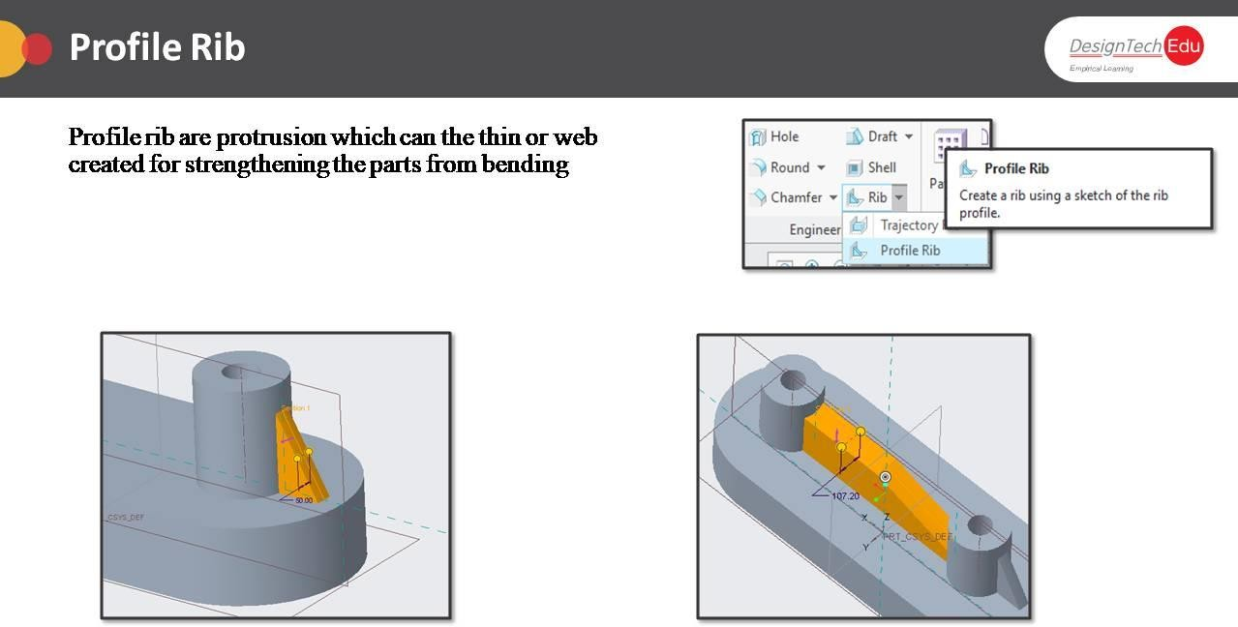

# Description:

A Profile Rib feature is a thin fin or web protrusion that attaches to solid Surfaces in your design. Typically, these ribs are designed to strengthen Parts in your design and are often used to prevent unwanted bending. You Can create a profile rib by defining the feature cross section

between two Perpendicular surfaces. Profile Rib features are only available in Part mode, and they are subject to Normal feature operations, including patterning, modifying, editing References, and redefining.

Designing a Profile rib feature requires you to:

* Create a dependent section by selecting a Sketch feature from the Model Tree, or to sketch a new independent section.
* Determine the rib material side with respect to the sketching plane and Desired rib geometry.

You can enter the Profile Rib tool and begin designing your rib feature under The following conditions:

* Sketch Not Selected—Entering the Rib tool and then selecting an existing Sketch or creating a new sketch for the Rib feature.
* Sketch Selected—Selecting an existing sketch for the Rib feature and then Entering the Rib tool.

In either case, after you designate a sketch for the rib, the validity of your Sketch is examined and, if valid, it is placed in the collector. The reference Collector only accepts one valid rib sketch at a time.

After you specify a valid sketch for the rib feature, preview geometry appears in the graphics window. You can directly manipulate and define your model Either in the graphics window, on the Profile Rib tab, or a combination of The two. The preview geometry automatically updates, reflecting any Modifications.

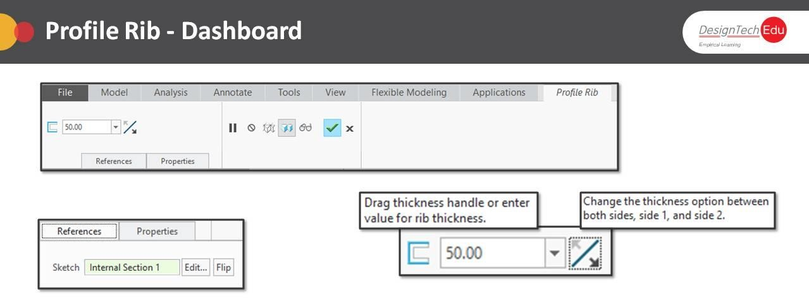

# Description:

The Profile Rib tab consists of commands, tabs, and shortcut menus. Click Model, click the arrow next to Rib, and click Profile Rib to open The Profile Rib tab.

# Commands

* Thickness box—sets the material thickness of the rib feature. The Dimension box contains the most recently used dimension values.
* Switches the thickness side of the rib feature. Clicking the button cycles You from one side, to the other side, and then symmetric about the Sketching plane.

# Tabs

* References
  + Sketch collector—displays the valid Sketch reference. You can use Remove From the shortcut menu (pointer in the collector) to remove the sketch reference.
* Define—opens the Sketch dialog box enabling you to use Sketcher to define An internal section. Note that Define is available only if the Sketch collector Is empty (no section defined or sketch selected). You can also use the Define Internal Sketch shortcut menu command from the graphics window.
* Edit—opens the Sketch dialog box enabling you to use Sketcher to redefine The internal section. Note that Edit is available only for sketch – based features that use an internal section. You can also use the Edit Internal Sketch shortcut menu command from the graphics window.
* Unlink—breaks the association between the dependent section and the parent Sketch feature. The Sketch feature references are copied to the new internal Section. Note that Unlink is available only if the rib feature uses a dependent Section.
  + Flip button—switches the material to the other side of the sketch. Clicking the Button changes the direction arrow from one side to the other.
* Properties
  + Name box—sets a name for a feature.
  + Displays detailed component information in a browser.

# Shortcut Menus

Right-click the graphics window to access shortcut menu commands.

* Define Internal Sketch—Opens the Sketch dialog box enabling you to use sketcher to define an internal section.
* Edit Internal Sketch—Opens the Sketch dialog box enabling you to use Sketcher to edit an internal section.
* Clear—deletes the sketch reference for the rib feature.
* Symmetric—Sets the rib thickness symmetric about the sketching plane.
* Show Section Dimensions—Display the sketch dimensions in the graphics Window.
* Hide Section Dimensions—Removes the sketch dimensions from display in the graphics window.

Right-click the direction arrow to access shortcut menu commands.

* Flip—Switches the material to the other side of the sketch.

Right-click the Sketch collector on the References tab to access shortcut Menu commands.

* Remove—Deletes the sketch reference for the rib feature.

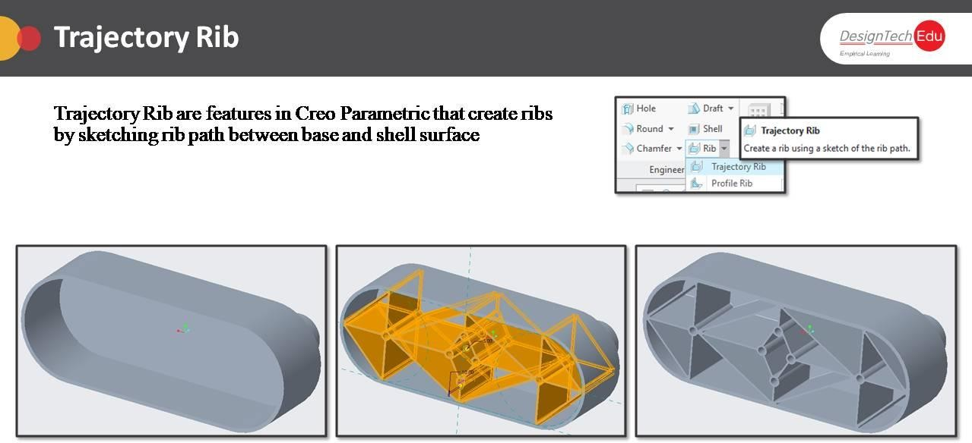

# Description:

Trajectory ribs are most often used to strengthen plastic parts that include a Base and a shell or other hollow area between pocket surfaces. The pocket Surface and base must consist of solid geometry. Create a trajectory rib by Sketching the rib path between pocket surfaces, or by selecting an existing Sketch. The rib has a top and a bottom. The bottom is the end that intersects

The part surface. The sketch plane that you select defines the top surface of The rib. The rib geometry's side surfaces extend to the next surface Encountered. The rib sketch can contain open, closed, and self-intersecting, or Multiple loops.

A Trajectory Rib feature is one trajectory, which can include any number of Segments in any shape. The feature can also include a round for each edge and a draft. You can define the draft, rounds, and rib width in the graphics Window or on the Trajectory Rib tab. You can separate rounds as a standalone feature that can be redefined as another feature.

Trajectory rib edges and surfaces are grouped by type into intent objects. These include the rib side surfaces and different types of rounds.

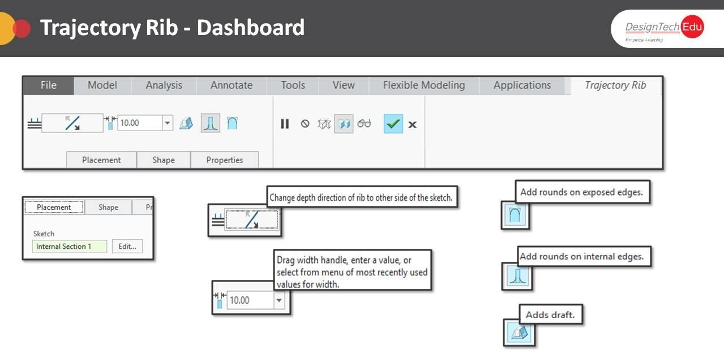

# Description:

The Trajectory Rib tab consists of commands, tabs, and shortcut menus. Click Model, click the arrow next to Rib, and click Trajectory Rib to open the Trajectory Rib tab.

# Commands

* Switches the depth direction to the other side of the sketch. The rib is Extended to the next solid surface encountered.
* Sets the rib width value.
* Adds drafts to the side surfaces.
* Adds rounds to the rib-to-rib and rib-to-model edges.
* Adds rounds to the exposed edges.

# Tabs

* Placement
  + Sketch collector—displays the sketch reference of the Trajectory Rib feature.
* Define—Opens Sketcher so you can define a sketch.
* Edit—Opens Sketcher so you can edit a sketch.
* Shape Use this tab to define rounds and a draft angle and to preview a cross section of the rib.
  + Round top by—sets the round radius on the upper part of the rib.
* Two-Tangent round—Creates a full round. It is driven by a relation that is Dependent on the width and draft angle of the trajectory rib.
* Specified Value—opens a value box for the round radius.
  + Round bottom radius—defines the round radius at the internal edges.
* Same as top—Available only when Specified Value is selected for the upper radius.
* Specified Value—opens a value box for the round radius.
  + Width box—sets the rib width.
  + Draft angle box—sets the rib draft angle.
* Properties
  + Name box—Sets a name for a feature.
  + Displays detailed component information in a browser.

# Shortcut Menu

Right-click the graphics window to access shortcut menu commands.

* Define Internal Sketch—Opens the Sketch dialog box enabling you to use Sketcher to define an internal section.
* Edit Internal Sketch—Opens the Sketch dialog box enabling you to use Sketcher to edit an internal section.
* Clear—deletes the sketch reference for the rib feature.
* Add Internal Rounds—Adds rounds to the rib-to-rib and rib-to-model edges.
* Add Exposed Rounds—Adds rounds to the exposed edges.
* Add Draft—Adds drafts to the side surfaces.
* Flip Depth Direction—Switches the depth direction to the other side of the sketch.
* Show Section Dimensions—Display the sketch dimensions in the graphics window.
* Hide Section Dimensions—Removes the sketch dimensions from display in the graphics window.

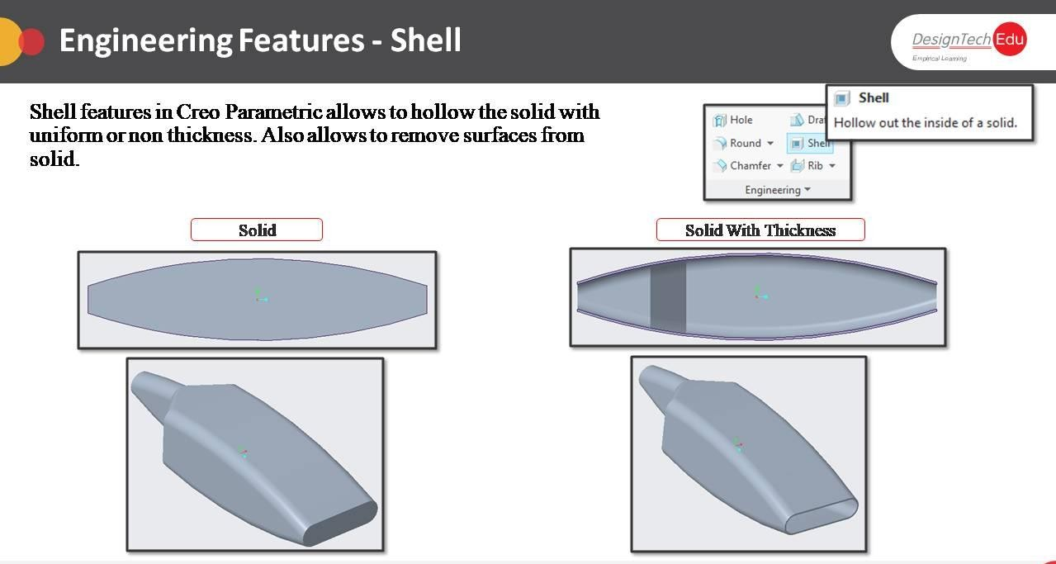

# Description:

The Shell feature hollows out the inside of the solid, leaving a shell of a specified wall thickness. It lets you specify a surface or surfaces that you want to remove from the shell. If you

do not select a surface to remove, a "closed" shell is created, with the whole inside of the part hollowed out and no access to the hollow. In this case, you can later add the necessary cuts or holes to achieve proper geometry. If you flip the thickness side (for example, by entering a negative value, or by clicking on the Shell tab), the shell thickness is added to the outside of the part.

When defining a shell, you can also select surfaces where you want to assign A different thickness. You can specify independent thickness values for each Such surface. However, you cannot enter negative thickness values, or flip The thickness side, for these surfaces. The thickness side is determined by The default thickness of the shell. The Shell feature allows you to select the adjacent tangent surfaces. This Enables you to remove or offset (independently or with different thickness) The surfaces which are tangent to their neighboring surface at one or more Boundaries. At the tangent edge, where the separation of the shell offset Occurs, a normal capping surface is constructed to close the gap.

You can also exclude one or more surfaces from being shelled by specifying the surfaces in the Exclude Surface collector. This process is called partial Shelling. You can also exclude surfaces with adjacent tangent surfaces. To Exclude more than one surface, hold down the CTRL key while selecting the Surfaces. The system cannot shell material that is normal to the Surfaces Specified in the Excluded surfaces collector.

When the shell is created, all the features that were added to the solid before You created the Shell feature are hollowed out. Therefore, the order of Feature creation is very important when you use Shell (see example).

To access the Shell feature, click Model > Shell.

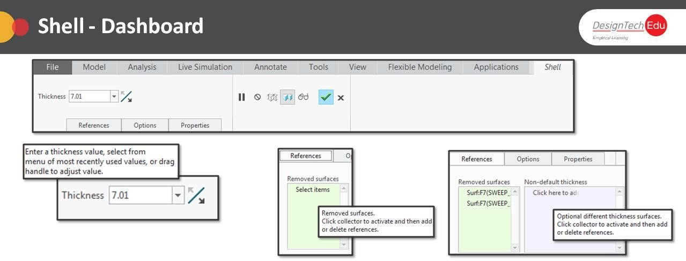

# Description:

The Shell tab consists of commands, tabs, and shortcut menus. Click Model > Shell to open the Shell tab.

# Commands

* Thickness box—sets the value for default shell thickness.
  + Flips the direction of the Shell feature.

# Tabs

* References
  + Removed surfaces—Displays the surfaces to remove. If you do not select any surfaces, a "closed" shell is created, with the whole inside of the part hollowed out and no access to the hollow.
  + Non-default thickness—Displays surfaces to which to assign a different thickness. For each surface included in this collector, you can specify an individual thickness value.
* Options
  + Excluded surfaces—Displays one or more surfaces to exclude from the shell. If you do not select any surface to exclude, the entire part is shelled.
* Details—opens the Surface Sets dialog box to add or remove surfaces.
  + Extend inner surfaces—Forms a cover over the inner surfaces of the shell feature.
  + Extend excluded surfaces—Forms a cover over the excluded surfaces of the
* Shell feature.
  + Concave corners—prevents the shell from cutting through the solid at concave corners.
  + Convex corners—prevents the shell from cutting through the solid at convex corners.
* •Properties
  + Name box—sets a name for a feature.
  + Displays detailed component information in a browser.

# Shortcut Menus

Right-click the graphics window to access shortcut menu commands.

* Remove Surfaces—Activates the Removed surfaces collector.
* Non Default Thickness—Activates the Non-default thickness collector.
* Exclude Surfaces—Activates the Excluded surfaces collector.
* Clear—clears the active collector.
* Flip—Flips the shell side.

Right-click the handle or value connected to the O_THICK label to access shortcut menu commands.

* Flip—Flips the shell side.

Right-click the handle or value connected to a THICK label to access shortcut Menu commands.

* Remove—Removes the current surface from the Non-default thickness collector. Right-click the Individual Surfaces label to access shortcut menu commands.
* Remove Set—Removes the selected surface or surfaces from the Excluded surfaces collector.
* Solid Surfaces—Constructs the surface set and adds all solid surfaces to the Set.

Right-click the Seed and Boundary Surfaces label to access shortcut menu Commands.

* Activate Set—Activates the selected set for adding or removing surfaces from the set.
* Remove Set—Removes the seed and boundary surface set from the Excluded surfaces collector.

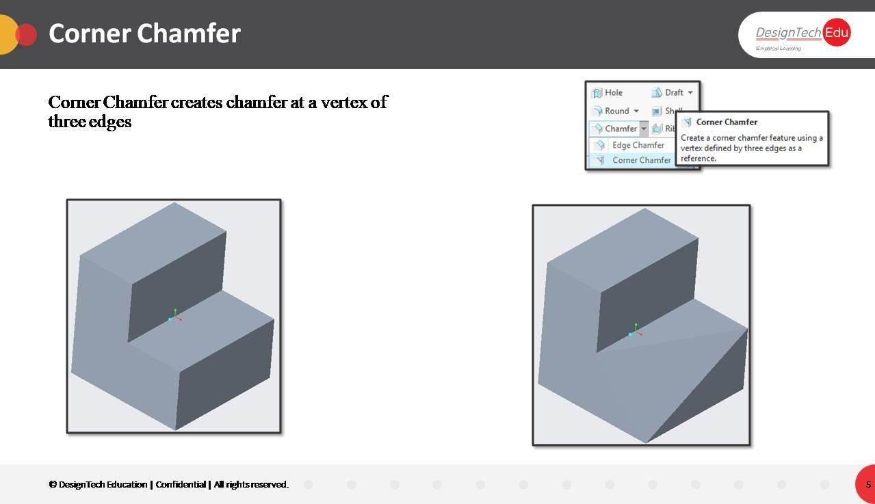

# Description:

A corner chamfer removes material from the corner of a part, creating a Beveled surface between the three original surfaces common to the corner. When you create a corner chamfer, you select a vertex defined by three edges, and then you set length values along each chamfer direction edge.

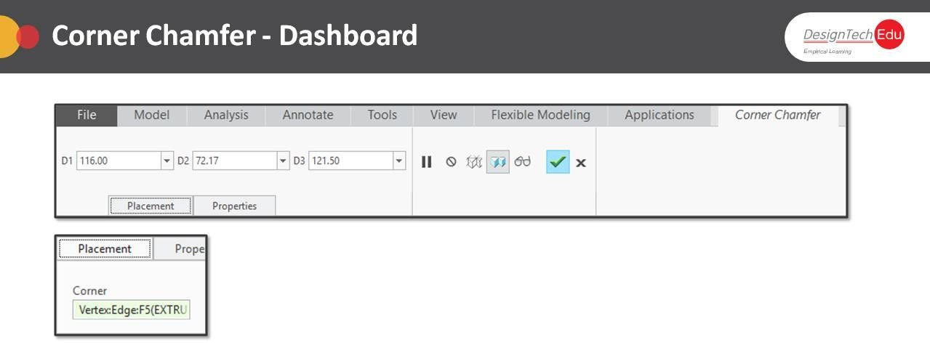

# Description:

The Corner Chamfer tab consists of commands, tabs, and shortcut menus. On the Model tab, click the arrow next to Chamfer, and click Corner Chamfer to open the Corner Chamfer tab.

# Commands

* D1—sets a distance value from the vertex to the chamfer along the first Direction edge.
* D2—sets a distance value from the vertex to the chamfer along the second Direction edge.
* D3—sets a distance value from the vertex to the chamfer along the third direction edge.

# Tabs

* Placement
  + Corner collector—displays the vertex on which to place a corner chamfer.
* Properties
  + Name box—sets a name for the feature.
  + Displays detailed component information in a browser.

# Chapter 6 – Pattern Features Pattern Features

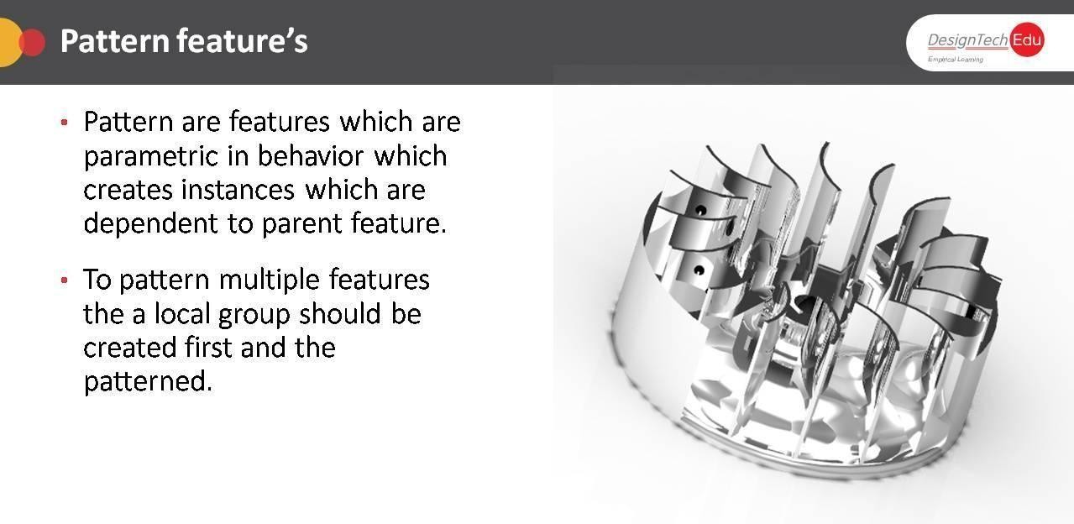

Patterns are feature which are parametric in behavior which creates instances which are dependent to parent feature. To pattern multiple features a local group should be created first and the patterned.

A pattern consists of multiple instances of a feature. Select a pattern type and define dimensions, placement points, or a fill area and shape to place the pattern members. The result of the operation is a feature pattern. When you pattern this feature pattern, the result is a feature pattern pattern. You cannot pattern either a group pattern or a feature pattern pattern.

For most pattern types, the feature or feature pattern selected for patterning is the pattern leader. After you pattern the selected feature or feature pattern, the pattern leader that you selected is the pattern header while the instances are pattern members. To copy, mirror, and move patterns, you must select the pattern header instead of the pattern members.

You can mirror a pattern, group pattern, or pattern of a pattern. You can also apply move or rotational transformations to a pattern, group pattern, or pattern of a pattern.

# Patterns offer the following benefits:

* Creating a pattern is a quick way to reproduce a feature.
* A pattern is para metrically controlled. Therefore, you can modify a pattern by changing pattern parameters, such as the number of instances, spacing between instances, and original feature dimensions.
* Modifying patterns is more efficient than modifying individual features. In a pattern, when you change
* dimensions of the original feature, the whole pattern is updated.
* It may be easier or more effective to perform operations once on the multiple features contained in a
* pattern, rather than on the individual features. For example, suppressing a pattern or adding it to a layer.

# Pattern Types

There are several ways to pattern a feature:

**Dimension**—Controls the pattern by using driving dimensions and specifying the incremental changes to the pattern. Dimensional patterns can be unidirectional and bidirectional.

**Direction**—Creates a free-form pattern by specifying direction and using drag handles to set the orientation and increment of pattern growth. Direction patterns can be unidirectional and bidirectional.

**Axis**—Creates a free-form radial pattern by using drag handles to set the angular and radial increments of the pattern. The pattern can also be dragged into a spiral.

**Fill**—Controls the pattern by filling an area with instances according to a selected grid.

**Table**—Controls the pattern by using a pattern table and specifying the dimension values for every pattern instance.

**Reference**—Controls the pattern by referencing another pattern.

**Curve**—Controls the pattern by specifying either the distance between the pattern members or by specifying the number of pattern members along the curve.

**Point**—Places the pattern members on geometry sketch points, geometry sketch coordinate systems, or datum points.

Pattern creation methods are different, depending on the pattern type.

To create a pattern, select the feature or feature pattern that you want to pattern and click Model > Pattern, or right-click the feature name or feature pattern name on the Model Tree and choose Pattern on the shortcut menu.

# Internal Sketches for Patterns

You can use an internal sketch to define pattern member placement for the following pattern types:

* **Point**
* **Fill**
* **Curve**

When you enter Sketcher to create the internal section, the pattern leader is represented with a known point at its origin. Horizontal and vertical reference lines that pass through the pattern leader point are displayed.

# Dimension:

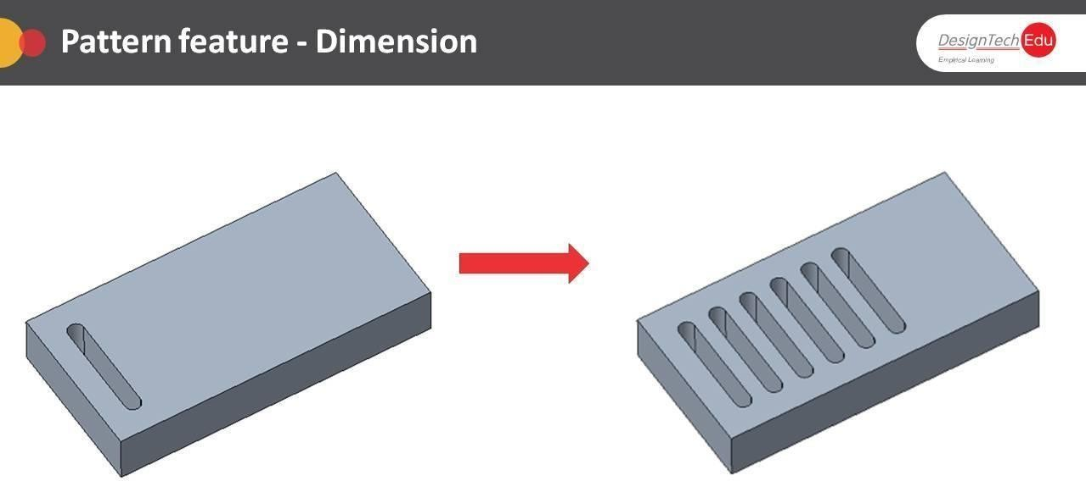

When you create a Dimension pattern, you select feature dimensions and specify the incremental changes to these dimensions and the number of instances of the feature in the pattern.

Dimension patterns can be unidirectional (such as a linear pattern of holes) or bidirectional (such as a rectangular array of holes). In other words, bidirectional patterns place instances in rows and columns. You can select a plane (in which case the direction is normal to the plane), a straight edge, a datum axis, or an axis of the coordinate system as a dimension reference. Depending on what dimensions are chosen to vary, patterns can be linear or angular.

When you create Dimension patterns, remember these tips:

* You can use a feature as a pattern leader for a single pattern only. After you create the pattern, the leader becomes part of the pattern and can no longer act independently.
* When you create a pattern leader, think of the dimensions you may need to specify the location of the increments. Keep in mind that for rotational patterns, a feature must have a built-in angular dimension. For other patterns, create a pattern leader with meaningful dimensions that will be used later to control the location and size of the increments
* An angular dimension controlling a center line of a sketched feature should not be used to establish an angular reference. Use an asynchronously created datum plane to set an angular dimension of the feature. Asynchronous datum features are automatically grouped with the feature. You can then create the angular pattern of this group.

When you select the pattern type, consider the regeneration time. For simple patterns, use the Identical or Variable options to speed up the regeneration of the model.

Use relations to control the location of instances when you expect the number of instances to vary. In this case, whenever you modify the number of instances, the system calculates the spacing according to the formula you entered.

# Direction:

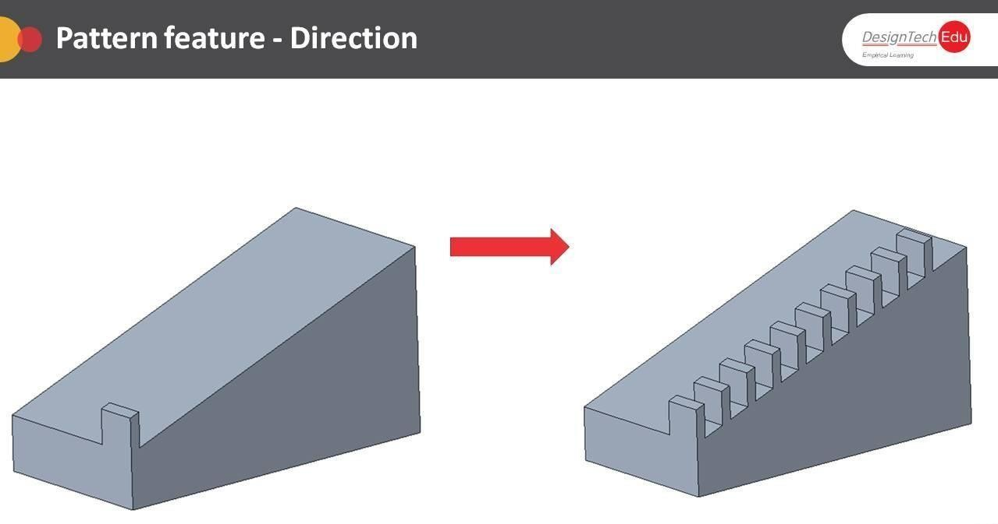

**Description:**

The Direction pattern to add pattern members in one or two selected directions. In the Direction pattern, you can drag the placement handle in each direction to adjust the distance between pattern members or to flip the pattern in the opposite direction.

While creating or redefining the Direction pattern, you can vary the following items:

* Spacing in each direction—Drag each placement handle to adjust spacing, or type the increment in the tab text box.
* Number of pattern members in each direction—Type the number of members in the tab text box or edit it by double-clicking in the graphics window.
* Feature dimensions—You can vary dimensions of the patterned feature by using the Dimensions tab. For example, you can vary the hole diameter or depth.
* Skip pattern members—To skip a pattern member, click the black dot identifying that pattern member. The black dot turns white. To restore the member, click the white dot.

Direction of pattern members—To change the direction of the pattern, drag the placement handle in the opposite direction, click , or type a negative number for the increment in the text box.

You can pattern a feature by using directional references and dragging the patterned features. Directional patterns can be unidirectional and bidirectional.

# To Create a Direction Pattern

Select the feature you want to pattern and click Model >  Pattern. The Pattern tab opens. To set the pattern type to Direction, select Direction from the list box of pattern types. The layout of the Pattern tab changes. The collector of first direction becomes active.

Select one of the following entities to use as a direction reference:

* + Straight edge
  + Plane or planar surface
  + Linear curve
  + Axis of a coordinate system
  + Datum axis
* The system creates a default pattern of two members, indicated by a black dot, in the selected direction.
* Type the number of pattern members in the first direction.
* To change the distance between the pattern members, drag the placement handle.
* To add pattern members in another direction, click the second direction collector and select the second direction reference.
* Type the number of pattern members in the second direction in the box labeled 2.
* Adjust the distance between the members in the second direction by dragging the placement handle in the second direction or by typing the increment.
* To reverse the direction of the pattern, click  for each direction, or enter a negative increment value.
* (Optional) To create a variable pattern, add dimensions to vary on the Dimensions tab.
* Click .

# Axis:

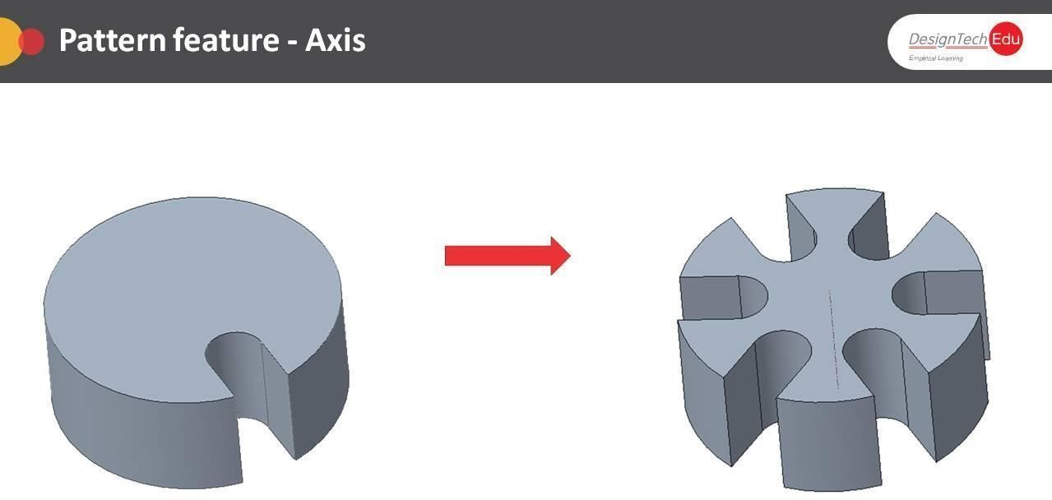

**Description:**

Use the Axis pattern to create a pattern by revolving a feature around a selected axis. An Axis pattern allows you to place members in two directions:

* **Angular** — (First direction) Pattern members are revolved around the axis. The default Axis pattern places members equally spaced in the counterclockwise direction
* **Radial** — (Second direction) Pattern members are added in the radial direction. There are two ways to place pattern members in the angular direction:
* Specify the number of members, including the first member, and the distance between the members (increment).
* Specify the angular extent and the number of members, including the first member. The range for the angular extent is from -360° to +360°. Pattern members are equally spaced within the specified angular extent.

While creating or redefining the Axis pattern, you can vary the following items:

* **Spacing in the angular direction**—Drag the placement handle in the angular direction or type the increment in the tab text box.
* **Spacing in the radial direction**—Drag the placement handle in the radial direction or type the increment in the tab text box.
* **Number of pattern members in each direction**—Type the number of members in the tab text box or edit it by double-clicking in the graphics window.
* **The angular extent of the members**—Type the angular extent in the text box.
* **Feature dimensions**—You can vary dimensions of the patterned feature by using the Dimensions tab. For example, you can vary the hole diameter or depth.
* **Skip pattern members**—To skip a pattern member, click the black dot identifying that pattern member. The black dot turns white. To restore the member, click the white dot.
* **Direction of pattern members**—To change the direction of the pattern, drag the placement handle in the opposite direction, click , or type a negative number for the increment in the tab text box.

# To Create an Axis Pattern

* Select the feature you want to pattern and click Model >  Pattern. The Pattern tab opens.
* Select Axis from the list of pattern types. The Axis pattern options open.
* Select or create a datum axis at the center of the pattern. A default pattern in the angular direction is previewed, with the pattern members indicated by black dots.
* To specify the number of pattern members in the angular direction, type the number in the text box on the Pattern tab.
* Use one of these methods to space pattern members:
* Type the angle between pattern members in the box.
* Click  and type an angular extent in the box
* To add pattern members in the radial direction, type the number of members in the 2 box.
* To space members in the radial direction, type the distance between members in the text box.
* To reverse the direction of the pattern, click  for each direction, or enter a negative increment value.
* Set one or more of the following optional parameters:
* To create a variable pattern, add dimensions to vary on the Dimensions tab.
* Include a numerical increment or select the Define increment by relation check box.
* To set a new origin for the pattern members, select the Use alternate origin check box on the Options tab.
* To rotate the pattern members about the axis, select the Follow axis rotation check box on the Options tab Click . The pattern is created.

# Curve:

**Description:**

A Curve pattern creates instances of a feature along a sketched curve. While creating or redefining a Curve pattern, you can set the following parameters:

* **Spacing**—Type the increment value between the pattern members in the Pattern tab text box.
* **Number of pattern members**—Type the number of pattern members to be created in the Pattern tab text box.
* **Skip pattern members**—To skip a pattern member, click the black dot that identifies the pattern member. The black dot turns white. To restore the pattern member, click the white dot
* **Pattern member orientation**—Orient pattern members to reflect the curve tangent direction at an origin, or create pattern members with identical orientation to the pattern leader.

The distance or number of member’s parameter you set becomes a dimension after the pattern is created. You can edit this dimension to modify the space between the members or the number of members. You can also use this dimension in a relation.

The start point of the Curve pattern is at the start of the curve by default. To accurately align the pattern members along the curve, the pattern leader should be placed at the start of the curve. A yellow direction arrow identifies the start point and direction of the Curve pattern.

# To Create a Curve Pattern

* Select the feature that you want to pattern and click Model >  Pattern. The Pattern tab opens.
* Select Curve from the list of pattern types. The Curve pattern options open.
* Select or create a sketched curve to define the pattern. To sketch a curve, click the References tab and click Define.
* Type a value for distance between pattern members in the box.
* Type a number of pattern members in the box.

Click the Options tab to set one or more of the following optional parameters:

* **Regeneration option**—Reduces regeneration time by selecting a more restrictive regeneration option, depending on the complexity of the pattern:
* **Identical**—All the pattern members are identical in size, are placed on the same surface, and do not intersect each other or part boundaries.
* **Variable**—The pattern members can vary in size, or be placed on different surfaces, but they cannot intersect each other or part boundaries.
* **General**—There are no pattern member restrictions.
* **Use alternate origin**—Uses an origin different than the default geometric center of the lead feature or geometry to place the pattern leader.
* **Follow surface shape**—Positions pattern members to follow the shape of the selected surface. Click the collector and select a surface.
* **Follow surface direction**—Orients the pattern members to follow the surface direction.
* **Spacing**—Sets the way that the pattern leader and pattern members are projected onto the surface.
* **Follow curve direction**—Places pattern members in the sketch plane to follow the curve.

To change the start point and direction of the curve, click the References tab and click Edit to enter Sketcher mode.

Select a curve end from the sketch as the start point for open sketches or select any vertex from the sketch for a closed sketch and click Sketch > Setup > Feature Tools > Start Point. The selected curve end or vertex is set as the start point.

To exclude a pattern member, click the corresponding black dot (). The black dot changes to white () to show that the pattern member has been excluded. To re-include the pattern member, click the white dot again.

The pattern leader is identified by Click. The feature is patterned.

# Point:

**Description:**

You can create a pattern by placing pattern members at points or coordinate systems. Create or select any of the following references when you use a Point pattern:

* A sketch feature that contains one or more geometry sketch points or geometry sketch coordinate systems.
* An internal sketch that contains one or more geometry sketch points or geometry sketch coordinate systems.

# A datum point feature

* An import feature that includes one or more datum points
* An analysis feature that includes one or more datum points

# To Create a Point Pattern with a Sketch

* Select the feature to be patterned and click Model >  Pattern. The Pattern tab opens.
* Select Point from the pattern type box. The Point pattern options appear. To use a sketch that will place pattern members, click .

To select or create a sketch do one of the following:

* To select a sketch, make sure the collector on the Pattern tab is active, and select a sketch. The sketch must contain geometry points, a geometry coordinate system, or both.

To create a sketch:

* Click the References tab.
* Click Define to create an internal sketch. The Sketch dialog box opens.
* Select a Sketch plane, Reference, and Orientation and click Sketch. The Sketch tab opens.
* Sketch one or more geometry points or geometry coordinate systems.
* Click  OK. The Sketch tab closes.

Optionally, to align the pattern members with the leader by using an origin different from the default origin, click the Use alternate origin collector, and then select a datum point, coordinate system, curve end, or vertex. The default origin is located at the center of an imaginary bounding box around the pattern leader geometry.

Set one or more of the optional parameters on the Options tab:

* **Regeneration option**—Reduces regeneration time by selecting a more restrictive regeneration option, depending on the complexity of the pattern:
* **Identical**—All the pattern members are identical in size, are placed on the same surface, and do not intersect each other or part boundaries.
* **Variable**—The pattern members can vary in size, or be placed on different surfaces, but they cannot intersect each other or part boundaries.
* **General**—There are no pattern member restrictions.
* **Follow leader location**—Offsets all pattern members from the sketch plane using the same distance as the pattern leader's offset.
* **Follow surface shape**—Positions pattern members to follow the shape of the selected surface. Click the collector and select a surface.
* **Follow surface direction**—Orients the pattern members to follow the surface direction.
* Spacing—Sets the way that the pattern leader and pattern members are projected onto the surface.
* Follow curve direction—Places pattern members in the sketch plane to follow the curve.
* Click . The pattern is created and the Pattern tab closes.

# Fill:

**Description:**

* You can pattern features using a table pattern.

Pattern tables allow you to create complicated or irregular patterns of features or groups by letting you specify unique dimensions for each instance in the pattern through an editable table. Multiple tables can be established for a pattern, so you can change the pattern by switching the table that drives it.

* You can modify a pattern table at any time after you create the pattern. Suppressing or deleting a table-driven pattern suppresses or deletes the pattern leader as well.

If you redefine dimension, direction, or axis pattern types as a table pattern, the table in the table pattern displays values only if the selected pattern has a secondary dimension. The table is empty if you select a fill pattern, curve pattern, direction pattern without a secondary dimension, or an axis pattern without a secondary dimension.

* You can use pattern tables in Assembly mode to pattern assembly features and components.

Pattern tables are not family tables. Pattern tables can only drive pattern dimensions, and unless they are patterned, pattern instances cannot be made independent.

* You can also include pattern tables in family tables so a particular family instance can use a specified pattern table

**To Create a Fill Pattern**

1. Select the feature that you want to pattern and click Model >  Pattern. The Pattern tab opens.
2. Select Fill from the list of pattern types. The Fill pattern options open.
3. Select an existing sketched curve, or click References > Define and sketch the area to be filled by the pattern.
4. Click  OK to complete the sketch. When you select a curve or quit Sketcher, a preview of the pattern grid is displayed, based on the default values. Each pattern member is identified by .
5. Select a grid template.
   1. To change the spacing between pattern member centers, type or select a value in the box adjacent to . Alternatively, in the graphics window, drag the handle or double-click the value associated with the Space label and type a new value.
   2. To change the minimum distance between the pattern member centers and the sketch boundary, type or select a value in the box adjacent to . A negative value makes the center lie outside the sketch.
6. Alternatively, in the graphics window, drag the handle or double-click the value associated with the handle and type a new value.
   1. To specify the rotation angle of the grid about the origin, type or select a value in the box adjacent to . Alternatively, in the graphics window, drag the handle or double-click the value associated with the handle and type a value.
   2. Set one or both of the following optional parameters for  circular and  spiral grids:
      1. To change the radial spacing, type or select a value in the box adjacent to . Alternatively, in the graphics window, drag the handle or double-click the value associated with the handle and type a new value.
      2. To rotate pattern members about an origin, select the Follow template rotation check box on the Options tab.

Set one or more of the optional parameters on the Options tab:

**Regeneration option**—Reduces regeneration time by selecting a more restrictive regeneration option, depending on the complexity of the pattern:

**Identical**—All the pattern members are identical in size, are placed on the same surface, and do not intersect each other or part boundaries.

**Variable**—The pattern members can vary in size, or be placed on different surfaces, but they cannot intersect each other or part boundaries.

**General**—There are no pattern member restrictions.

**Use alternate origin**—Uses an origin different than the default geometric center of the lead feature or geometry to place the pattern leader.

**Follow leader location**—Offsets all pattern members from the sketch plane using the same distance as the pattern leader's offset.

**Follow surface shape**—Positions pattern members to follow the shape of the selected surface. Click the collector and select a surface.

**Follow surface direction**—Orients the pattern members to follow the surface direction.

To exclude a pattern member at a certain location, click the corresponding black dot that identifies the pattern member in the graphics window. The black dot changes to white ( ) to show that the pattern member has been excluded. You can click the white dot again while redefining the pattern to re-include the pattern member.

Click .

# Table:

**Description:**

* You can pattern features using a table pattern.

Pattern tables allow you to create complicated or irregular patterns of features or groups by letting you specify unique dimensions for each instance in the pattern through an editable table. Multiple tables can be established for a pattern, so you can change the pattern by switching the table that drives it.

* You can modify a pattern table at any time after you create the pattern. Suppressing or deleting a table-driven pattern suppresses or deletes the pattern leader as well.

If you redefine dimension, direction, or axis pattern types as a table pattern, the table in the table pattern displays values only if the selected pattern has a secondary dimension. The table is empty if you select a fill pattern, curve pattern, direction pattern without a secondary dimension, or an axis pattern without a secondary dimension.

* You can use pattern tables in Assembly mode to pattern assembly features and components.

Pattern tables are not family tables. Pattern tables can only drive pattern dimensions, and unless they are patterned, pattern instances cannot be made independent.

* You can also include pattern tables in family tables so a particular family instance can use a specified pattern table.

# To Create a Table Pattern

This procedure describes how to pattern a feature by using a pattern table and specifying the dimension values for every pattern instance.

1. Select the feature you want to pattern and click Model >  Pattern. The Pattern tab opens.
   1. To set the pattern type to Table, select Table from the list box. The layout of the tab changes. The dimensions collector to be included in the pattern table becomes active.
2. Select dimensions to be included in the pattern table. Hold down the CTRL key to select multiple dimensions.
   1. Click Edit. The table editor window opens either Pro/TABLE or Excel depending on the value set for the part_table_editor configuration option.

The table contains an index column, for specifying the index for each pattern member, and a column for each dimension selected in step 3. The header for a dimension column contains the dimension symbol, with the default value, equal to the dimension value of the pattern leader, next to the symbol in parenthesis.

For each pattern member, add a row in the table, starting with the index number, and specify the dimension values for this pattern member. Use an asterisk (*) to retain the default dimension value. The pattern indices start from

They must be unique, but do not have to be sequential. You can import a previously saved pattern table by clicking File > Read in the top menu bar in the table editor window and typing the name of the table file. You can also save the current table for future use by clicking File > Save or by clicking File > Save As and typing the file name.

1. When finished editing the pattern table, click File > Exit in the top menu bar in the table editor window.
   1. To create additional pattern tables, click the Tables tab, right-click it, and select Add from the shortcut menu. The table editor window opens to let you edit the new table. When finished editing the pattern table, click File > Exit.

If you have more than one pattern table defined, select the active table from the Active table list on the Pattern tab.

1. Click .

# Reference:

**Description:**

A Reference pattern creates a pattern of a feature or group “on top of” any other patterned feature or group. You can create a Reference pattern of a feature or group that references the geometry of any pattern member. Some references to locate the new Reference pattern feature must be to the original patterned feature or group only.

The instance number is always the same as the original pattern; therefore, the pattern parameter is not used to control this pattern. If you add a feature that does not use the originally patterned feature to get its geometry references, you cannot use Reference patterning for the new feature. The Reference pattern type is available on the pattern type list on the Pattern tab only if the selected feature or group references another patterned feature or group.

# To Create a Reference Pattern

1. Select the feature or group to pattern and click Model >  Pattern. The Pattern tab opens.

If the selected feature can be patterned independently, such as a coaxial hole, the Pattern tab opens, with the default pattern type set to Reference. The pattern leader is identified by  and the pattern members are identified

by .

1. To exclude a pattern member at a certain location, click the corresponding black dot. The black dot changes to white ( ) to show that the pattern member has been excluded. To restore the pattern member, click the white dot again at any time while redefining the pattern.
2. Click .

**Note:**

The selected feature or group must reference another patterned feature or group. If the selected feature is of a type that cannot be patterned any other way, such as a round or chamfer, a Reference pattern of this feature is created.

A Reference pattern is limited to referencing a single existing pattern or group. Because of this:

* Do not create a Reference pattern of a feature or group that references members of two or more patterns.
* Do not create a Reference pattern of a feature or group that references two or more members of the same pattern.

To create a Reference pattern of a feature that references two or more features, first create a pattern of a group that includes the parent features. You can then create a Reference pattern that references the pattern of the group

# Mirror:

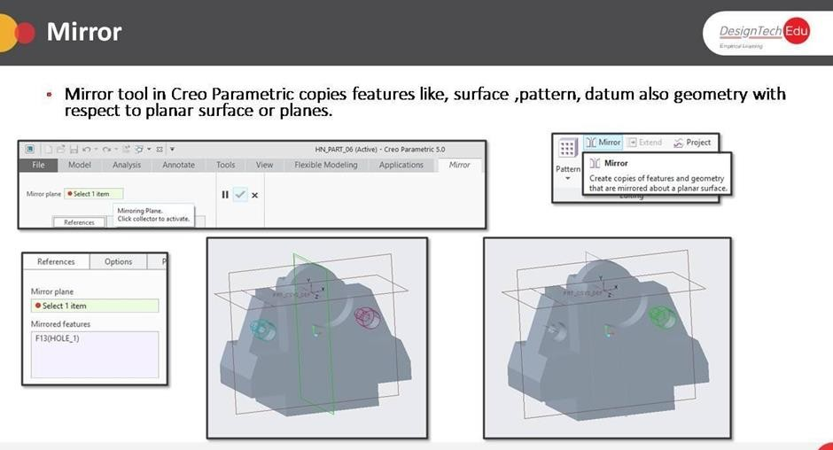

**To Add Features to or Remove Features from a Mirror Feature**

This topic describes adding features to or removing features from a Mirror feature when you create a Mirror feature, or when you edit the definition of a Mirror feature.

# Creating a Mirror feature

While you create a Mirror feature, you can add and remove features depending on the dependency of the mirror. Independent or partially dependent Mirror features

* Select the Mirror items collector on the References tab.
* To add features to the Mirror feature, hold down the CTRL key while you select features in the graphics window or Model Tree.
* To remove features from the Mirror feature, select the features to remove in the Mirror items collector, and right-click and choose Remove.

# Fully dependent Mirror features

When Dependent copy is already selected on the Options tab, you can’t add features to or remove features from the Mirror feature. If you change the Mirror feature type to fully dependent, and the Mirror items collector is empty, you can add only one feature to the Mirror items collector.

# Editing the definition of a Mirror feature

You can use this procedure when you edit the definition of an independent or partially dependent Mirror feature, but not when you edit the definition of a fully dependent Mirror feature. The procedure can only be used in Part mode.

1. In the Model Tree, select an independent or a partially dependent Mirror feature, and right-click and choose  Edit Definition. The Mirror tool opens.
2. Select the Reapply Mirror check box. The Mirror items collector becomes available.
3. Click the References tab, click the Mirror items collector, and then perform the needed actions:
   1. To add features to the Mirror feature, hold down the CTRL key while you select features in the graphics window or Model Tree.
   2. To remove features from the Mirror feature, select the features to remove in the Mirror items collector, and right-click and choose Remove.

# Chapter 7 – Assembly Assembly Section:

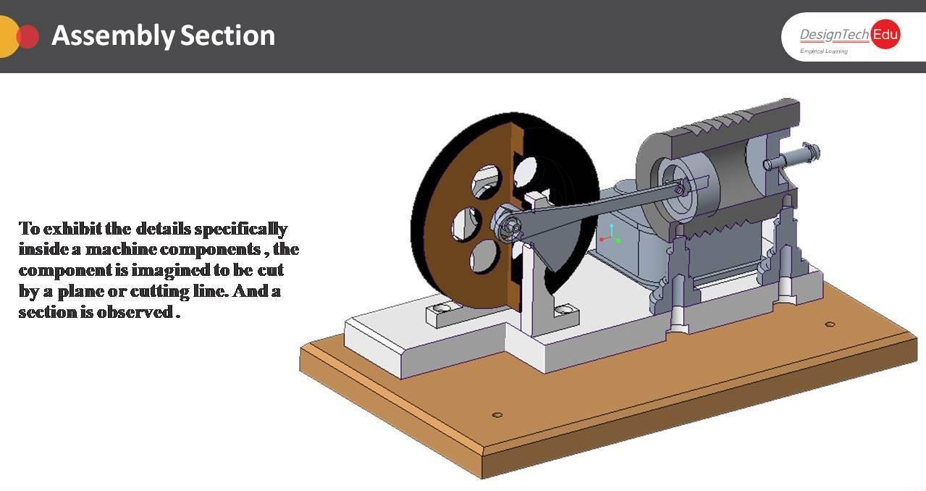

**Description:**

You can create and save a cross section in Part or Assembly mode and show it in a drawing. When inserting a view, you can add a cross section to the view.

When creating a cross section, you can define it using one of the following two basic methods:

* Following a selected datum plane or planar surface. This is a planar cross section.
* Drawing a path offset from a reference plane through a solid. This is an offset cross section.

When inserting views, you can set each view type to use one of the cross section techniques described in the sections that follow.

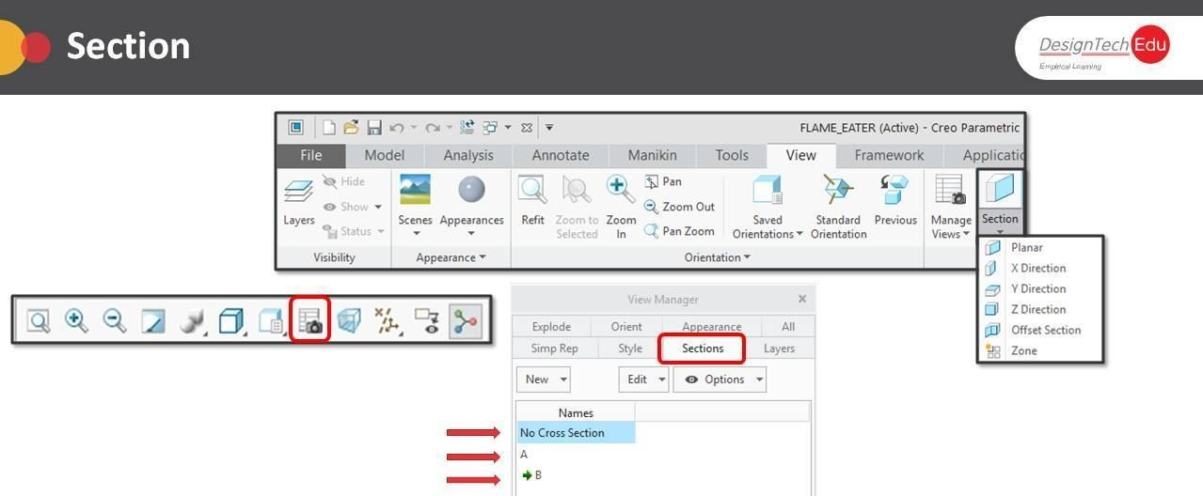

# Description:

To Create a Planar Cross Section

1. Open a part.
2. On the View tab, click the arrow next to Section and then click Planar. The Section tab opens.
3. Select a planar surface, datum plane, or coordinate system axes reference to intersect the model. A cross section is automatically created. A dragger appears at the center of the clipping plane. The dragger is normal to the clipping plane and indicates the clipping direction.

The Section reference collector on the References tab displays the name of the reference used to create the cross section. Alternatively, you can choose to first select the planar surface, datum plane, or coordinate system axis and then launch the Section tool.

1. Select the constraint type from the drop-down list:
   1. Offset—Creates the cross section at the specified distance from the selected reference. Click and type a value for the offset distance.
   2. Through—Creates the cross section along the selected reference.
2. Click to change the clipping direction.
3. Change the location of the cross section by using the dragger or click to enable free positioning of the clipping plane. When free positioning is enabled, you can translate and rotate the orientation of the clipping plane using the dragger.
4. Click or middle-click. The cross section is added to the Model Tree.

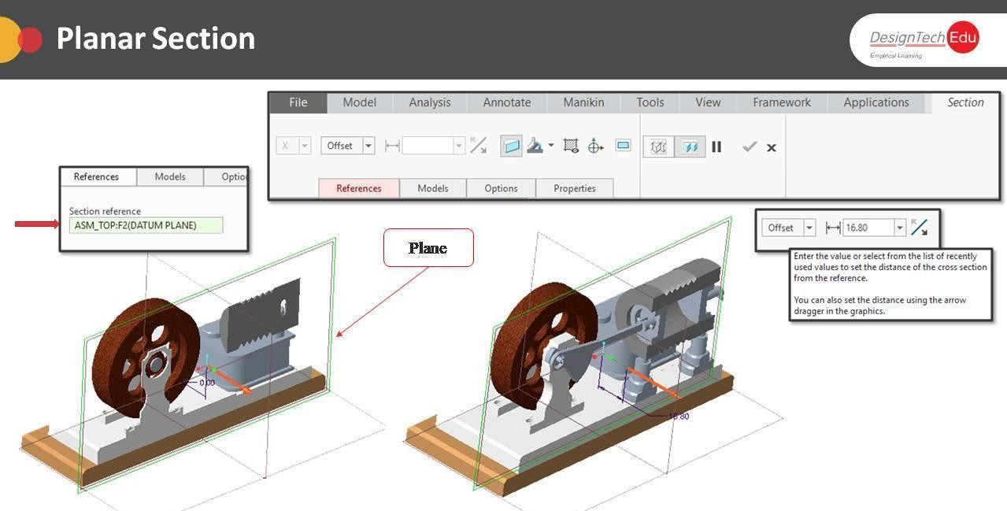

# Description:

Display the section view

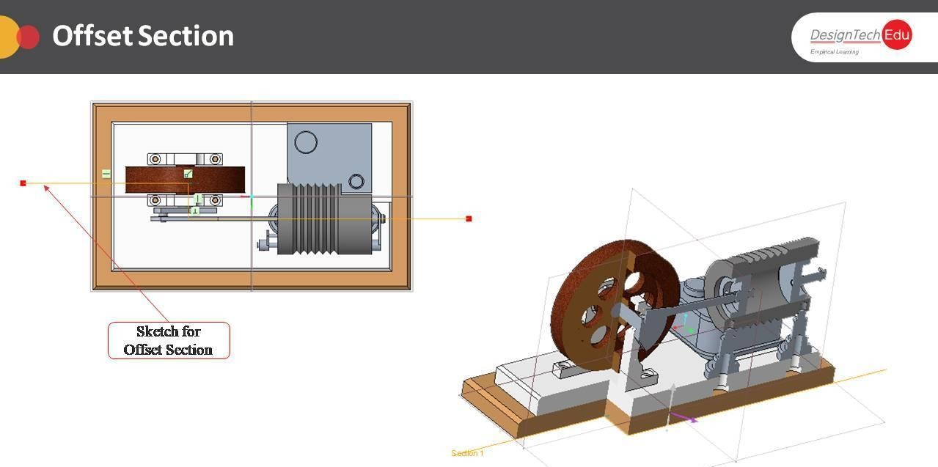

# Description:

1. Open a part.
2. On the View tab, click the arrow next to Section.
3. Click Offset. The Section tab opens.
4. Select an existing sketch. A cross section is automatically created. Alternatively, to create a sketch perform the following steps:

* Click the arrow next to Datum on the Section tab. A list opens.
* Click to. The section tool pauses and the Sketch dialog box opens.
* Select a datum plane and click Sketch. The Sketch tab opens.
* Use the Sketch tab to draw a sketch.
* Click to save the sketch and close the Sketch tab.
* On the Section tab, click to resume the Section tool.

If the newly created sketch can be used as a reference for the current section, it is automatically selected and a section is created.

1. You can extend the cross section to one side of the sketch or both sides of the sketch using on the Section tab. The cross section is extended normal to the sketch reference.
   1. Extends the cross section to the first side of the sketch.
   2. none — Does not extend the sketch reference to the first side.
   3. Extends the cross section to the second side of the sketch.
   4. none — Does not extend the sketch reference to the second side.
2. Click to change the clipping direction.
3. Click or middle-click. The section is added to the Model Tree.

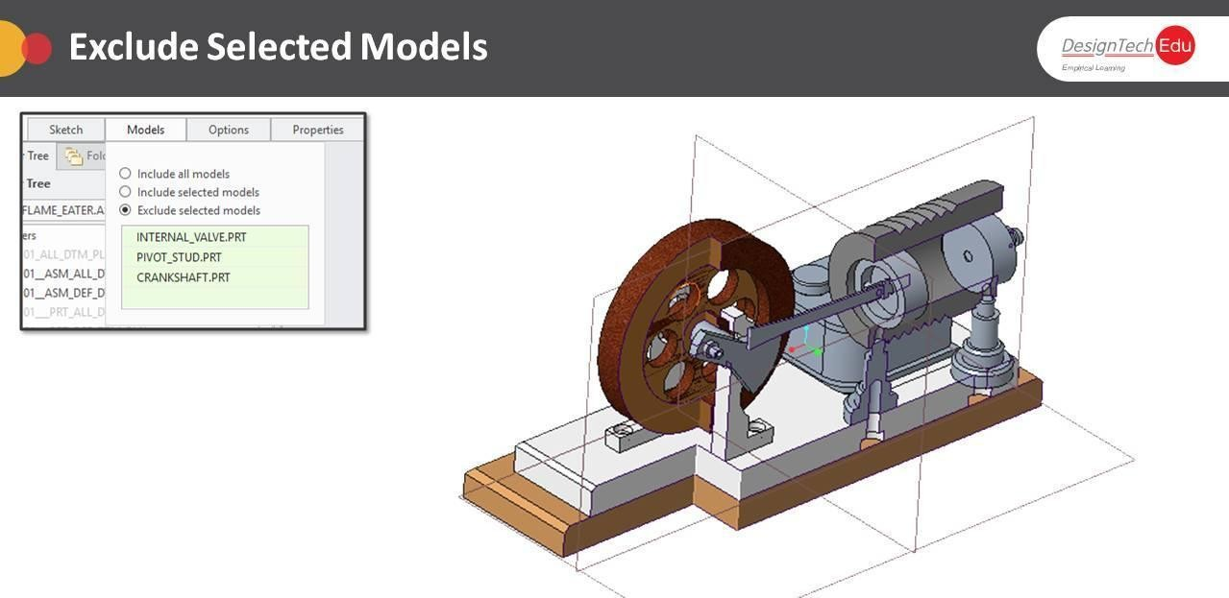

**Description:**

You exclude the part which is not to be sectioned in assembly

# Chapter 8 – Drafting

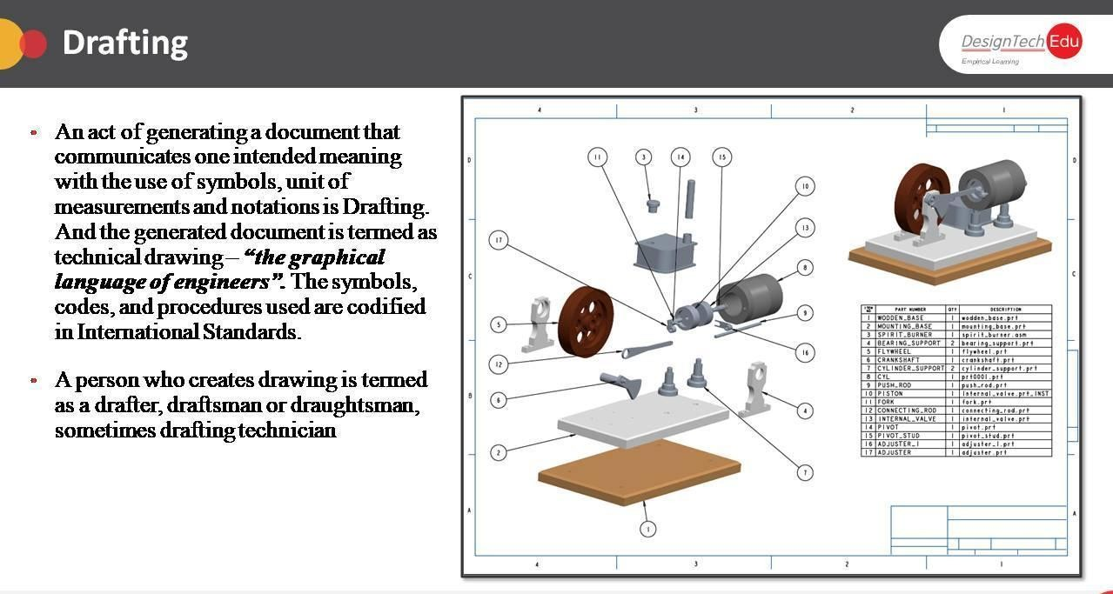

**Description:**

Using a drafting tool make a drawing containing list of parts, show them on a drawing sheet in the tabular form and show auto-balloons indicating the number of parts visually.

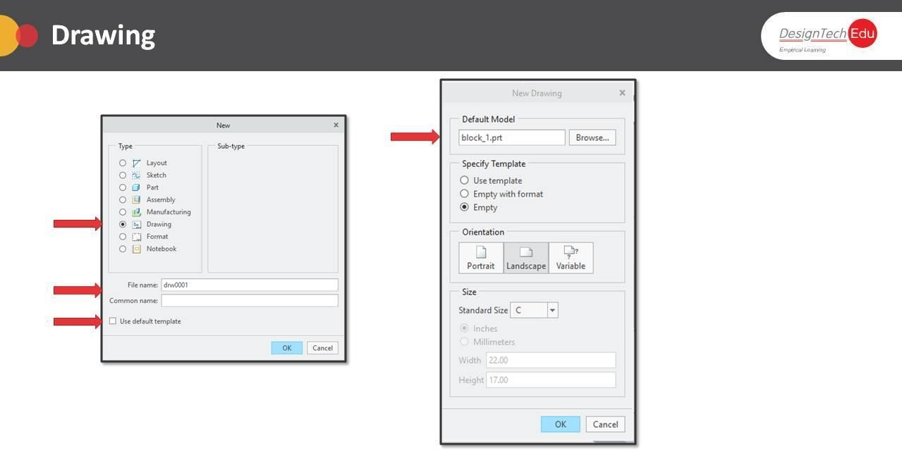

# Description:

* From New > Drawing as type
* Enter the name
* Uncheck the Use default template and choose
* Choose paper size

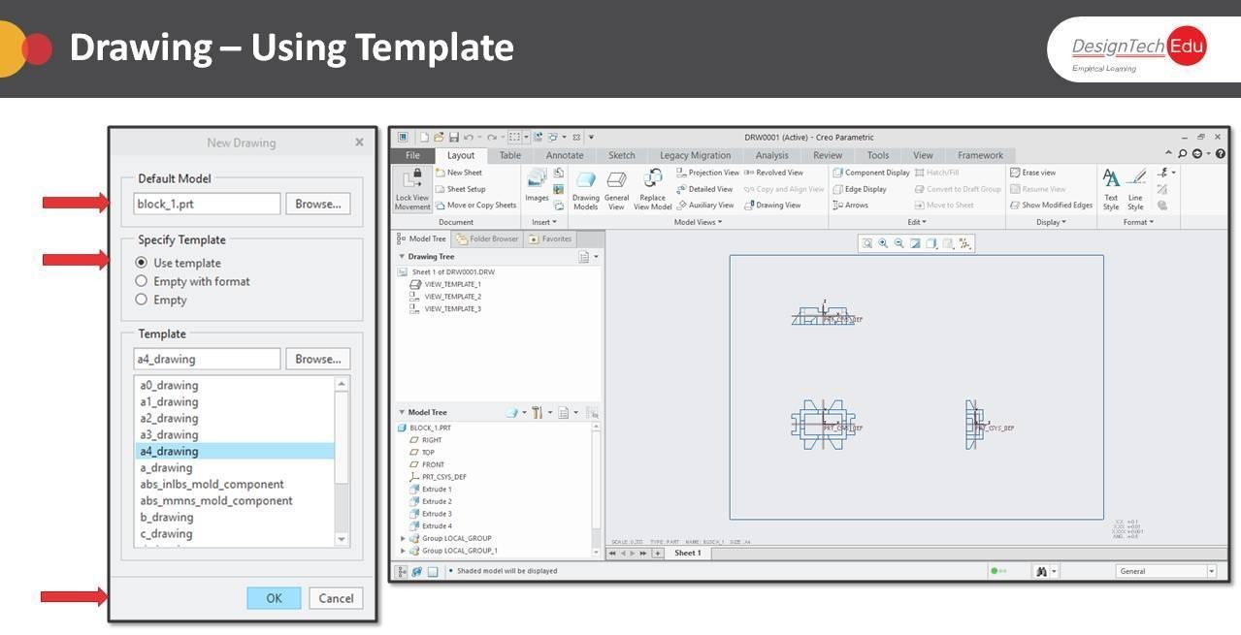

# Description:

Template allows you to create views automatically as defined in template

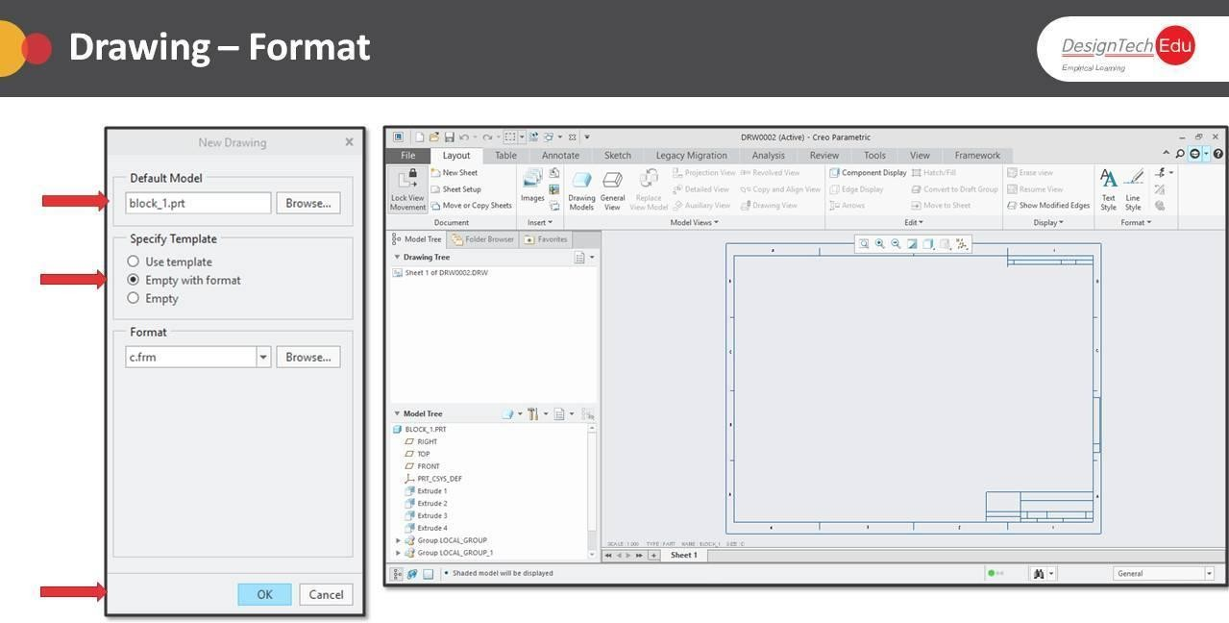



# Description:

Allows you to create drawing with predefined formats

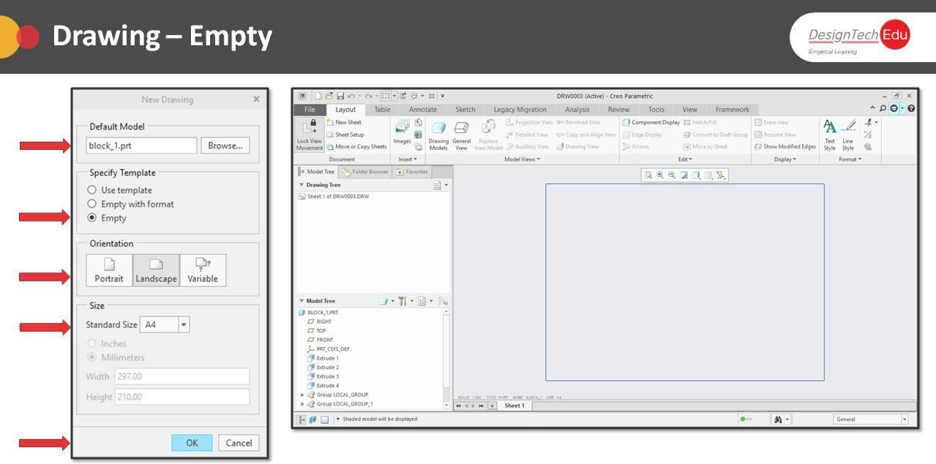

**Description:**

Allow you to create empty sheet with paper size defined

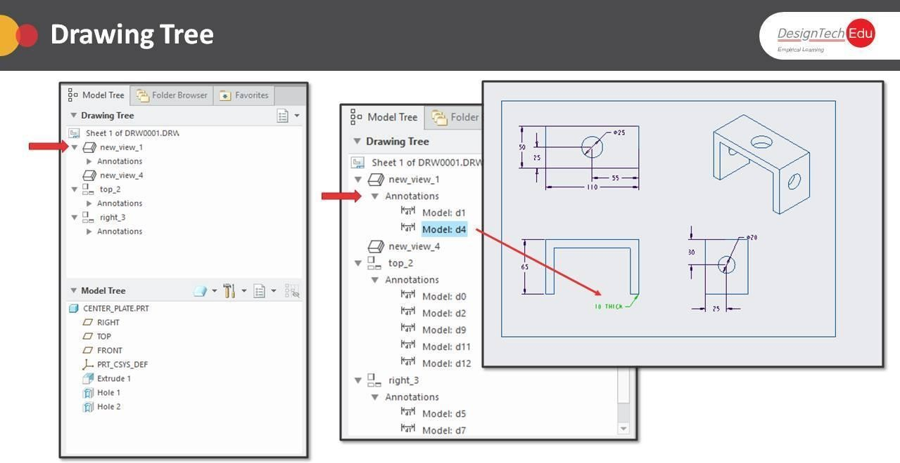

# Description:

Drawing views annotation are place in drawing tree

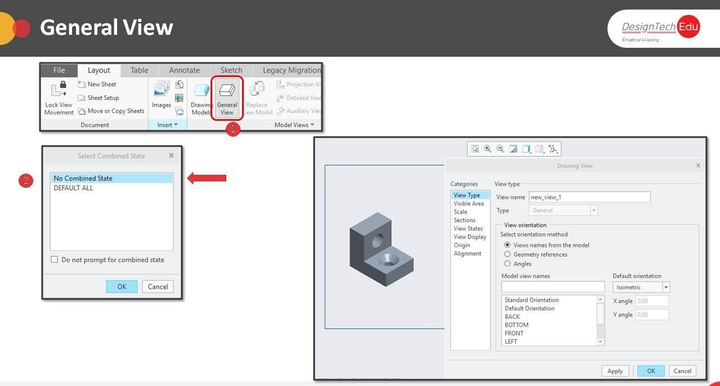

# Description:

Use general view tab to place base views

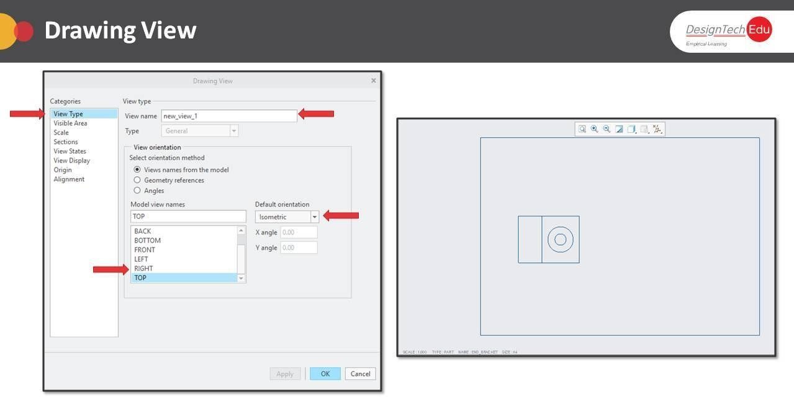

# Description:

From Drawing view choose the view orientation from view type.

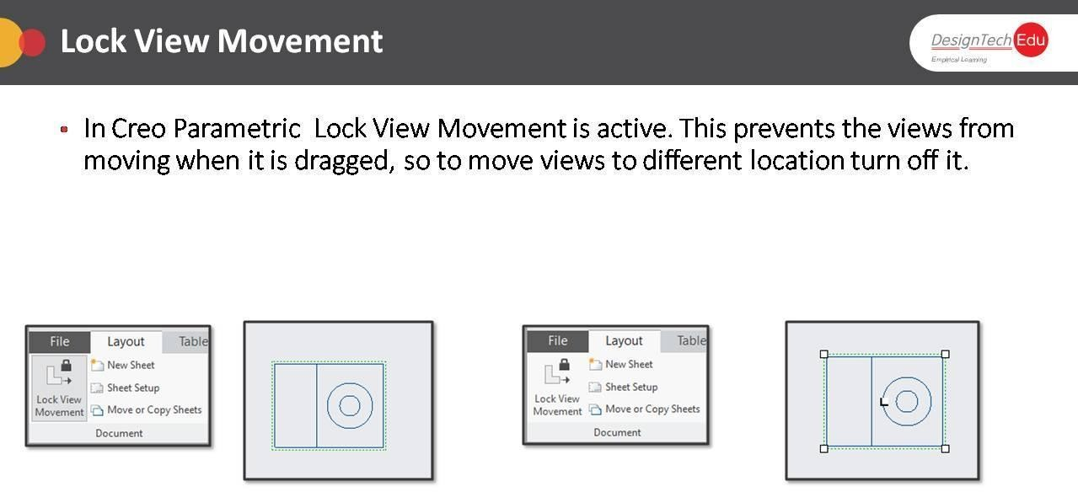

# Description:

Lock view movement prevents the movement of the view. Disable it to move the views in the drawing

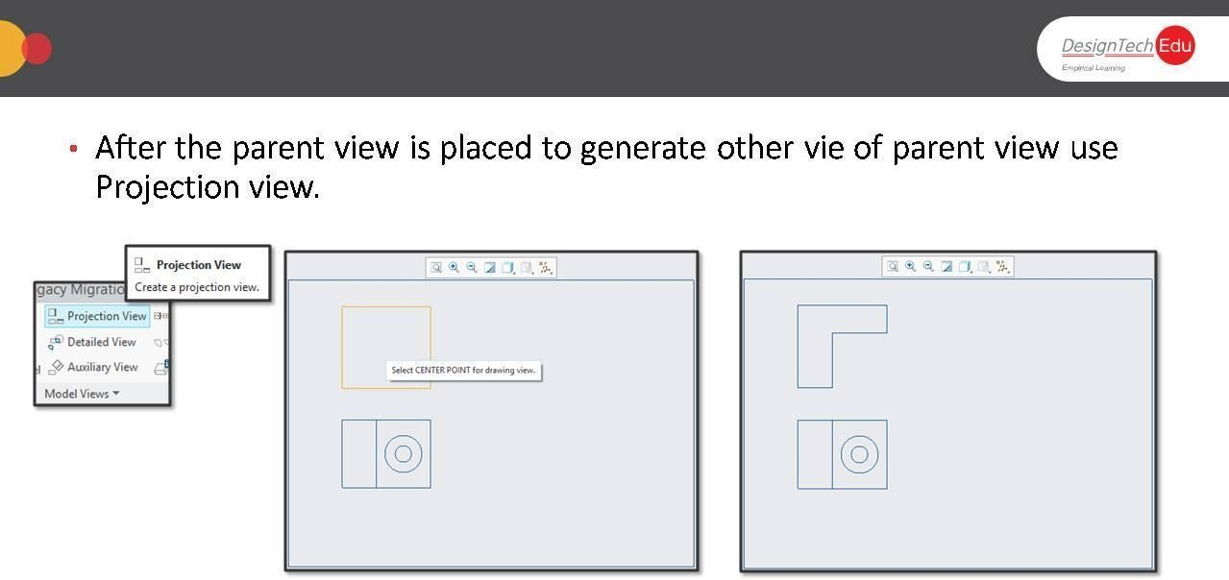

**Description:**

Use projection view to place projected view for the selected view.

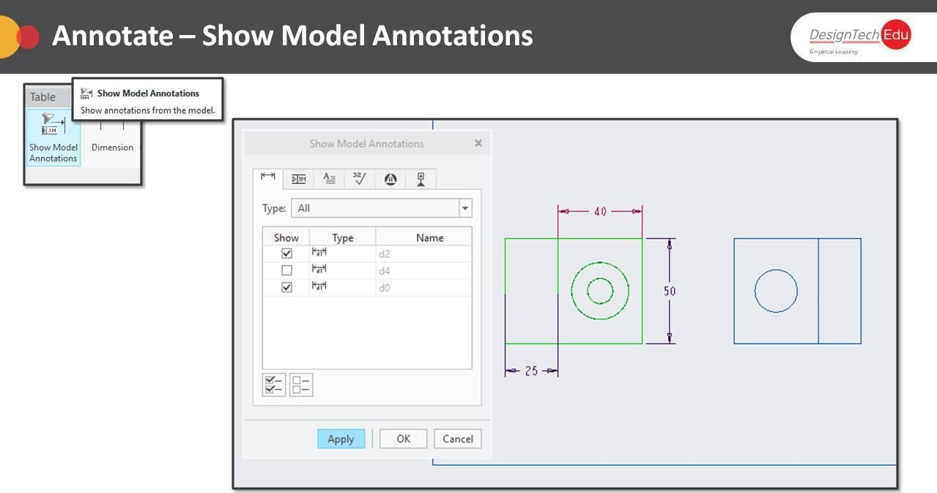

# Description:

Use Show model annotation to bring all the dimension notes labels defined in the model to the drawing. The dimensions generated are bi directional associative which means if the dimension are modified in drawing the changes are reflected to the model.

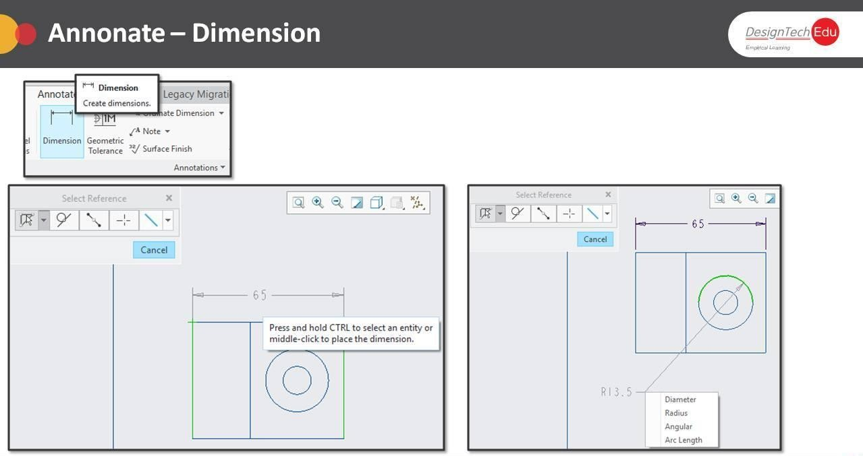

# Description:

Use this option to create dimension by selecting the reference entities. Hold CTRL key to select the reference

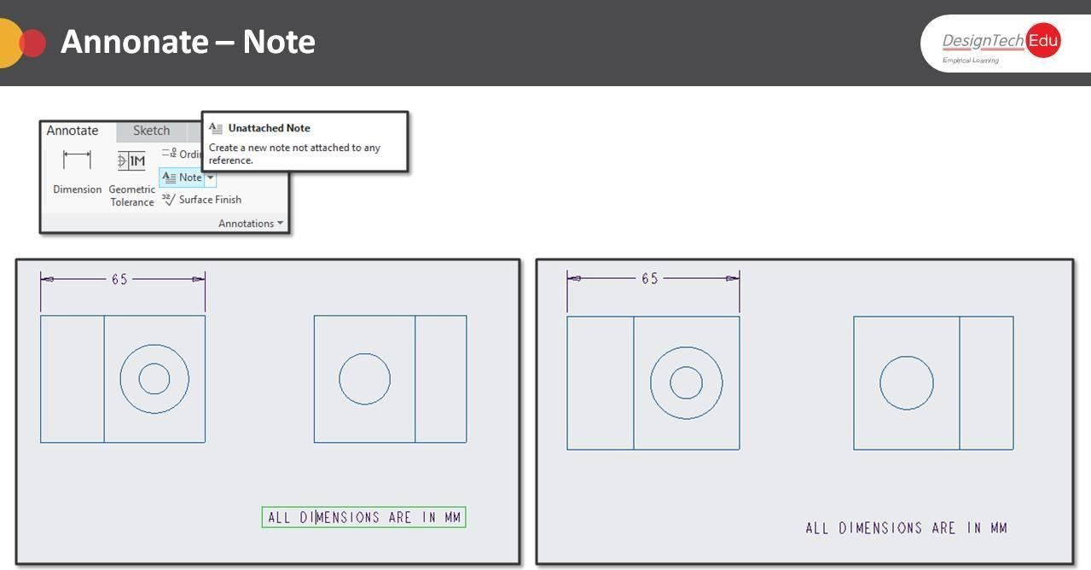

# Description:

Use note option to add additional text to the drawing sheet



# Chapter 9 – Views

**Placing the First View (Base View)**

First View or Base View is an independent view and all other views are placed with reference to this view either directly or indirectly. The Base view is placed by using the General View tool. The procedure to place base view is given next.

* Click on the General View tool from the Model Views panel of the Ribbon. The Select Combined State dialog box will be displayed.

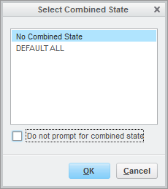

Select Combined State dialog box

* Select the No Combine State option from the dialog box and select the Do not prompt for combined state check box. Using the No Combine State option, you specify that no user defined states are required in the drawing mode.
* Click on the OK button from the dialog box. You are asked to specify the center location for the base view.
* Click in the drawing area at desired location to place the base view. As soon as you click in the drawing area, the default view of model and Drawing View dialog box are displayed.

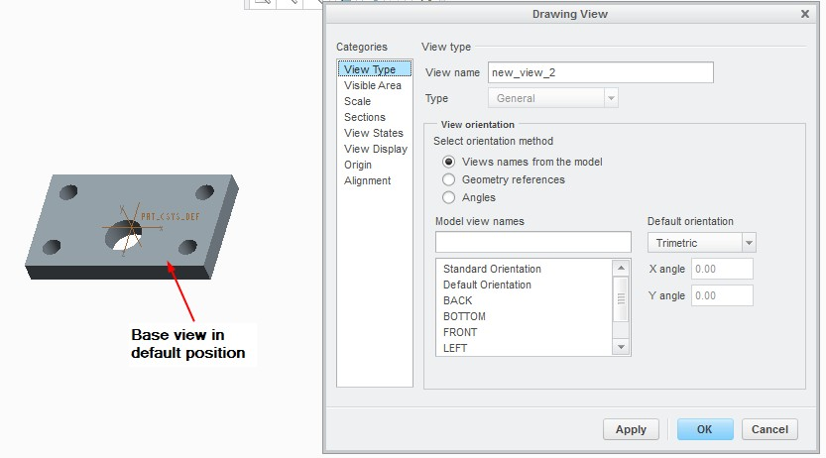

Base view with Drawing View dialog box

# View Type options

* Click in the View name edit box in the dialog box and specify the desired name for the view, like Front view or Top view.
* Select the desired model view from the Model view names list box. Like, FRONT or TOP.
* You can select the Default Orientation option and specify it as Trimetric, Isometric or user defined by using the option in the Default orientation drop-down in the dialog box.
* After selecting the desired view, click on the Apply button from the dialog box.

# Visible Area options

* To clip the view or, display half or partial view; click on the Visible Area option from the Categories list box in the dialog box.

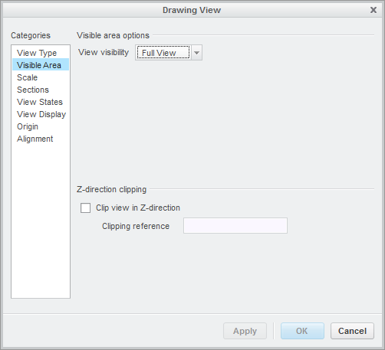

Base view with Drawing Visible area dialog box

# Half-View

* Click in the View visibility drop-down and select the desired option. If you select the Half view option, then you need to select a plane normal to the selected view. Select the side that you want to keep by using the Flip button and then click on the Apply button to see the half-view.

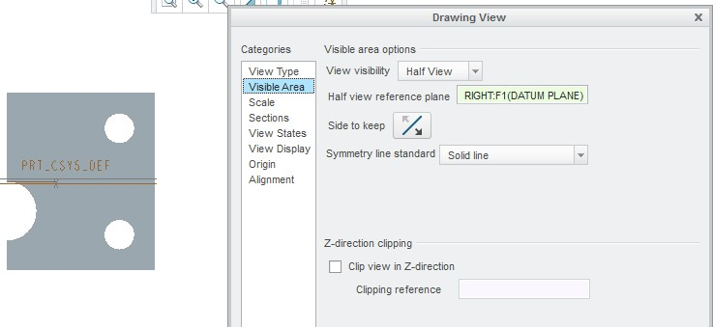

Half-view of model

# Partial View

* To create the partial view, click on the Partial View option from the View visibility drop- down. You are asked to select a reference point. Select a point and then create a spline around it.
* Click on the Apply button from the dialog box to check the partial view.

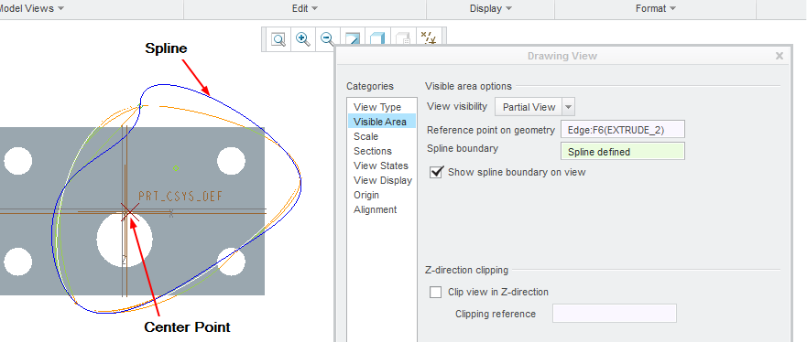

Spline created for partial view

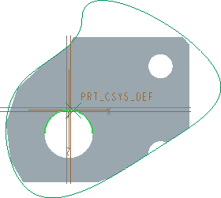

Partial view

# Broken View

* Click on the Broken View option from the View visibility drop-down and then click on the ‘+’ button to add the break lines.

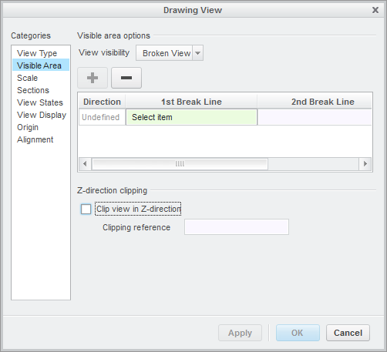

Drawing View dialog box for broken view

* Click on the straight edge of the model to define the starting point of break line.

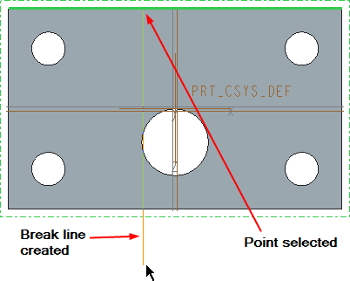

Break line creation



* + Click to specify the end point of the break line. You are asked to specify the starting point for the second break line.
  + Click to specify starting point of second break line. The break line will be created.

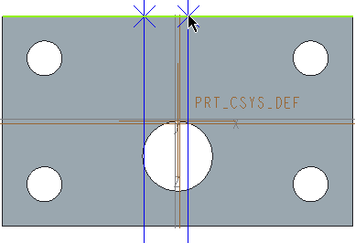

Second break line

* + Move the slider in the dialog box to right and select the desired Break Line Style from the drop-down.

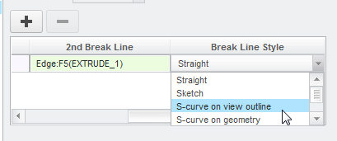

Break line style options

* + After selecting the desired style, click on the Apply button from the dialog box to create the broken view.

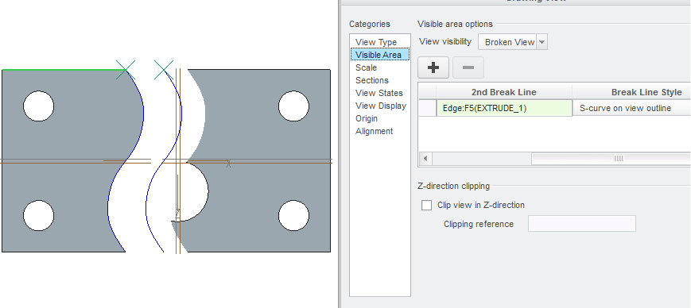

Broken view created

# View States options

The View States options are generally used for assembly models, so you should have assembly model selected as Drawing Model.

* + Click on the View States option from the Categories list box.

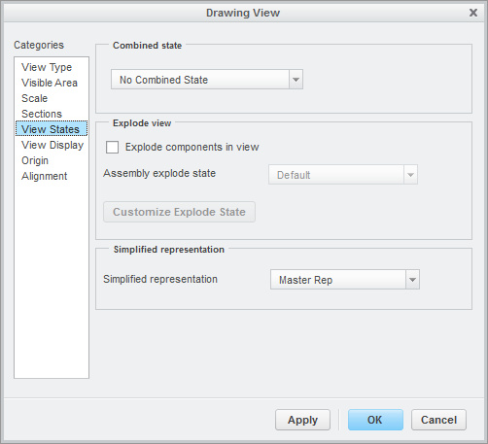

Drawing View dialog box with View States options

* + Select the Explode components in view check box to enable the options related to exploded view of assembly model.
  + Select the desired exploded state of the model from the Assembly explode state drop- down and click on the Apply button to display the exploded view.

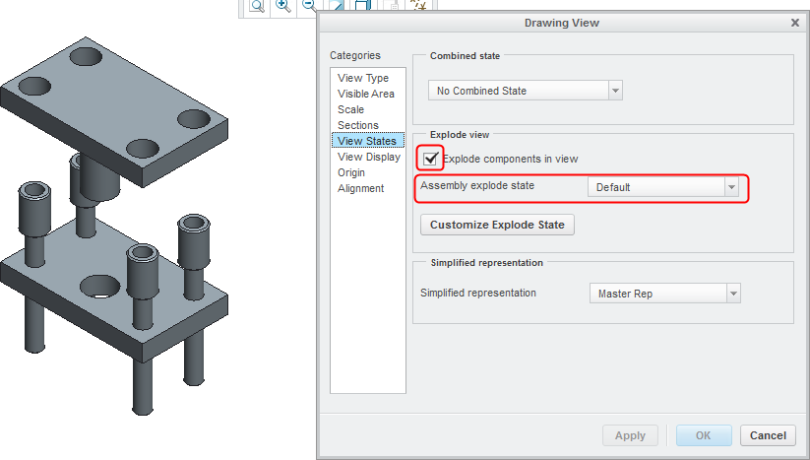

Exploded view of assembly

* + Select the desired representation from the Simplified representation drop-down. By default, Master Rep is selected in the drop-down.

# View Display options

* + Click on the View Display option from the Categories list box.

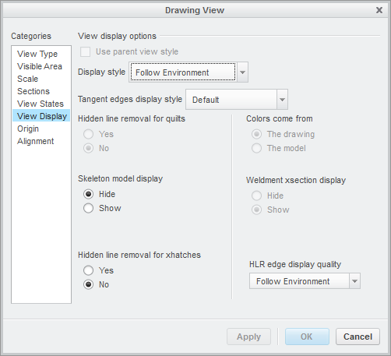

Drawing View dialog box with View Display options

* + Click on the Display style drop-down and select the desired option from the drop-down to specify the display style.

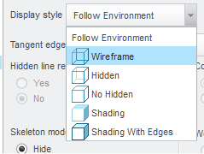

Display style drop-down

* + Specify the other display style options from the dialog box and click on the Apply button to accept the changes.

The Origin and Alignment options in the dialog box are used to specify origin of view and alignment for the view respectively.

# Projection Views

The steps to create projection views from the base view are given next.

* + Click on the Projection View button from the Model Views panel in the Ribbon. Projection of the base view will get attached to the cursor.

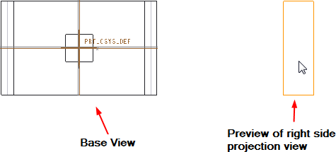

Preview of projection view

* + Click at the desired distance to place the view. By default, the view will be displayed as shade.

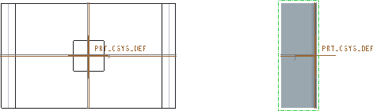

Shaded projection view

* + Double-click on the projection view. The Drawing View dialog box will be displayed. Select the Add projection arrows check box if you want to display projection arrows in the drawing.
  + Using the options in the View Display category, you can change the display of view to Hidden, No Hidden, or Wireframe for presentation purpose.

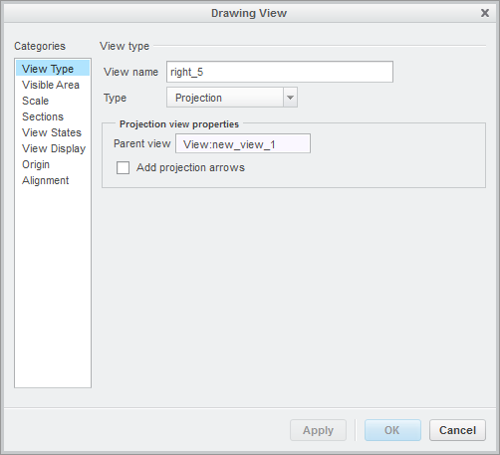

Drawing View dialog box

* + - Click on the OK button from dialog box.
    - Click again on the Projection View button and select the base view as parent view for projection. Repeat the same procedure to place other views.

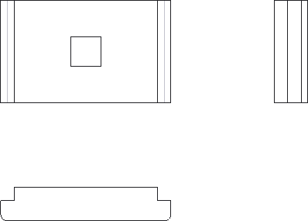

Views placed in drawing

# Detailed View

The detailed views are used to highlight a small section of drawing which has minute details that are to be considered while manufacturing. The procedure to create detailed views is given next.

* + Click on the Detailed View tool from the Model Views panel in the Ribbon. You are asked to specify the center point for the view.
  + Click at the location on model which is center for your detailed view. You are asked to draw a non-self-intersecting spline.

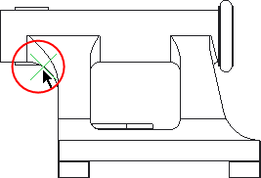

Center point selection

* + Create a closed spline around the center point which is covering all the entities that you want to include in the detailed view; refer to Figure-41 and press the MMB. A circle will be drawn around the center point and you are asked to specify placement point for detailed view.

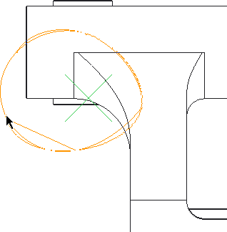

Spline created for detailed view

* + Click at the desired location in the drawing sheet to place the detailed view.

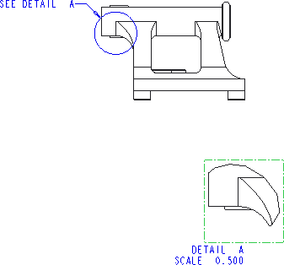

Detailed view

* + Double-click on the detailed view to change the details like display style, scale and so on.

# Auxiliary View

Auxiliary views are orthographic views taken from a direction of sight other than top, front, right side, left side, bottom, or rear. Auxiliary views are often used to show inclined and oblique surfaces true size. Inclined and oblique surfaces do not show true size in the standard views. The procedure to create auxiliary view is given next.

* + Click on the Auxiliary View tool from the Model Views panel in the Ribbon. You are asked to select an edge, axis, datum plane or surface.
  + Select the entity through which you want to create the auxiliary view. The view will get attached to the cursor.

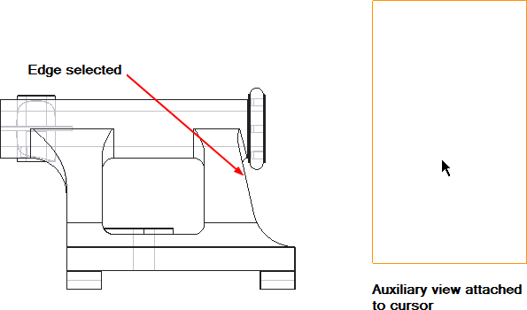

Auxiliary view attached to cursor

* + Click at the desired location to place the view.

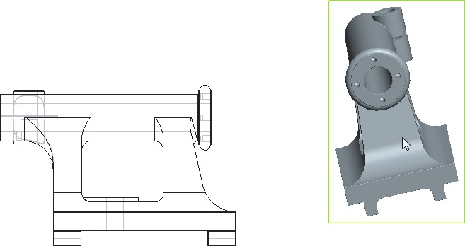

Auxiliary view placed

# Revolved View

The Revolved view is created to show detail of a part after revolving and sectioning a specific area of part. This type of view is used to show hidden details of part. The procedure is given next.

* + Click on the Revolved View tool from the Model Views panel in the Ribbon. You are asked to select parent view.
  + Select the view for which you want to create the revolved view. You are asked to specify center point for revolved view.
  + Click at the desired location to place the view. The XSEC CREATE Menu Manager will be displayed along with the Drawing View dialog box.
  + Select the Planar and Single option from the Menu Manager and click on the OK button.
  + Click on the Done button from the Menu Manager. You are asked to specify name for the section.
  + Enter the desired name in the input box displayed. The SETUP PLANE Menu Manager will be displayed.
  + Click on the Make Datum option and select the desired option from the DATUM PLANE area in the Menu Manager. Note that we are going to create a datum plane which will act as cutting plane for creating the cross-section.
  + After selecting the desired option (which is Through in our case), select the respective reference

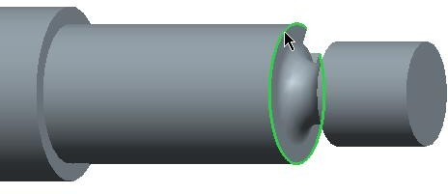

Edge selected

* + Click on the Done option from the Menu Manager. Preview of the revolve view will be displayed. Note that it can be overlapping with the parent view.

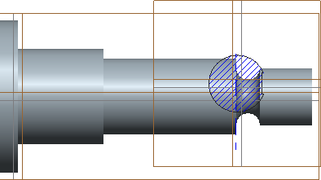

Preview of revolved view

* + Click on the OK button from the Drawing View dialog box to create the view.
  + Release the Lock View Movement toggle button from the Document panel in the Ribbon and drag the view to desired distance from the base view.

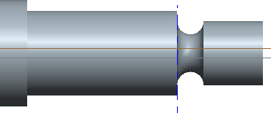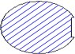

# Annotations

Annotations are used to displayed geometric and dimensional tolerances of the parts. In Creo Parametric, you can apply the dimensions manually or you can import the dimensions from

Part or assembly environment. First, we will discuss the method to import dimensions from Part/Assembly environment and then we will discuss the method to manually apply dimensions.

# Importing dimensions

When we create model of a part/assembly, we apply some dimensions to it in Part/Assembly environment. These dimensions decide the shape and size of the part/assembly. We can import these dimensions in the drawing environment by following the steps given next.

* + Click on the Show Model Annotations button from the Annotations panel in the Annotate tab of the Ribbon. The Show Model Annotations dialog box will be displayed.

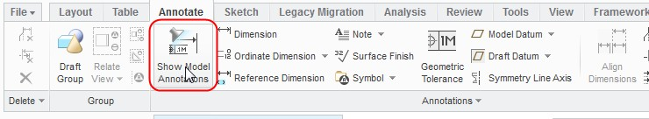

Show Model Annotations button

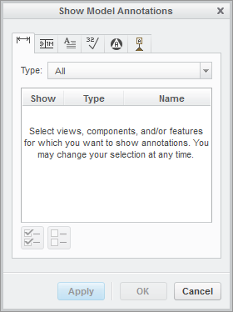

Show Model Annotations dialog box

* + Select the view to which you want to apply the annotations. Dimensions will be displayed on the view. Note that you can select multiple views by holding the CTRL key while selecting.

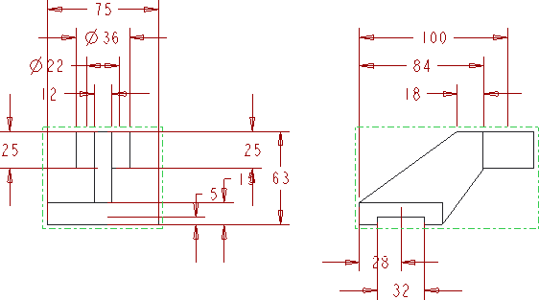

Dimensions displayed with the views

* + One by one, click on the dimensions in the drawing that you want to keep or click on the Select All button to displayed all the dimensions.
  + Click on the Apply button to display the selected dimension in the view. In the same way, you can import other geometric tolerances by using other tabs in the Show Model Annotations dialog box.

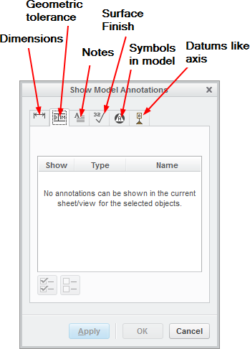

Detail of tabs

To change any of the dimension, double-click on it and specify the desired value. On selecting the Regenerate button from Quick Access Toolbar the modifications are applied to the model.

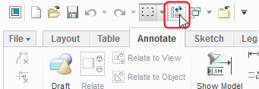

# Ordinate Dimension

The Ordinate Dimension tool works in the same way as it does in Part environment. The procedure is given next.

* + Click on the Ordinate Dimension tool from the Ordinate Dimension drop-down in the Annotations panel in the Ribbon. The Select Reference dialog box will be displayed.

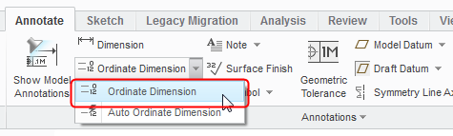

Ordinate Dimension tool

* + Select the reference edge which will be set a zero reference and then select all the entities to which you want to apply the dimensions while holding the CTRL key. Preview of ordinate dimensions will be displayed. Press the MMB at desired location to place the dimensions

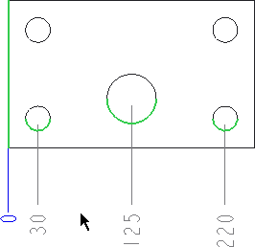

Preview of ordinate dimensions

# Auto Ordinate Dimension

Using this tool, you can apply the ordinate dimension to all the entities on the selected surface/sur-faces. Note the if you want to apply ordinate dimension to more than one surfaces then the surfaces must be parallel to each other. The procedure to use Auto Ordinate Dimension tool is given next.

* + Click on the Auto Ordinate Dimension tool from the Ordinate Dimension drop-down. You are asked to select one or more surfaces.
  + Select the surface whose entities are to be dimensioned.

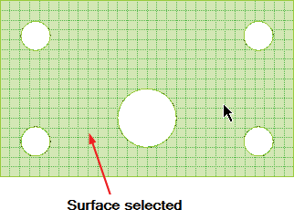

Surface selected

* + Press the MMB. You are asked to select a base line entity.
  + Select an edge, curve or datum plane. Preview of ordinate dimensions will be displayed

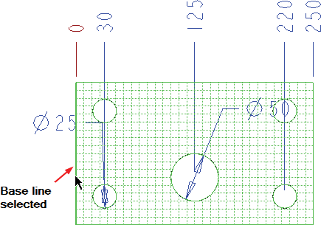

Ordinate dimension created

* + Click on the Select Base Line option from the Menu Manager displayed to select base line for other direction. Press the Middle Mouse Button to apply the dimensions.

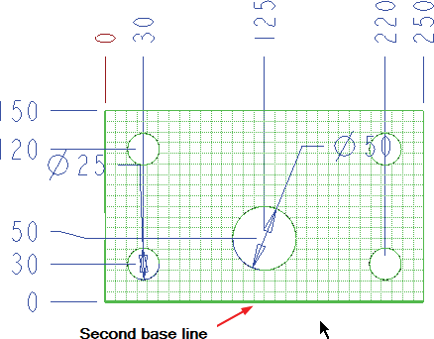

Ordinate dimension with two base lines

# Notes

Notes are used to give information which is not defined till now in the drawing with the

help of dimensions and symbols. The tools to create notes are given in the Note drop-down in the Annotations panel of the Ribbon; refer to Figure-89. Here, we will discuss the Unattached Note tool and Leader Note tool. The other tools for creating note work in the same way.

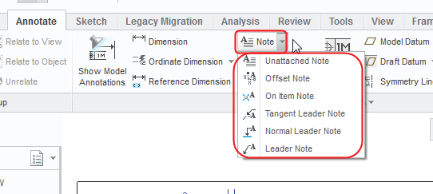

Note drop-down

# Unattached Note

* + Click on the Unattached Note tool from the Note drop-down. A text box will get attached to cursor and the Select Point dialog box will be displayed.
  + Click at the desired location to define placement of note. You are asked to type the desired text. Also, the Format contextual tab will be displayed.

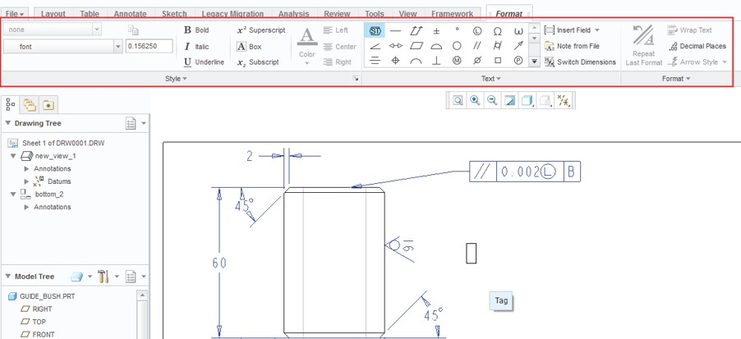

Format contextual tab

* + Write the desire note and apply formatting and symbols by using the options in the Format contextual tab. Press the Middle Mouse Button to create the note.

# Leader Note

* + Click on the Leader Note tool from the Note drop-down. A text box with leader will get attached to cursor and the Select Reference dialog box will be displayed.
  + Click at the desired location to specify the starting point of the leader. You are asked to specify the end point of the leader.
  + Press the middle mouse button (MMB) to specify the end point of leader. Rest of the procedure is same as discussed for Unattached Note tool.

# Generating Balloons

Balloons are used to identify the components by their index numbers. Balloons are generally used in combination with Bill of Materials. The procedure to generate balloons is given next.

* + Click on the Create Balloons drop-down from the Balloons panel in the Ribbon. The tools related to balloons will be displayed

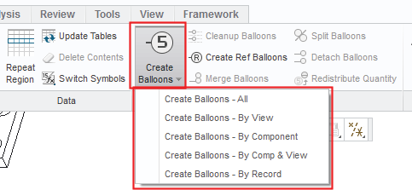

Create Balloons drop-down

* + Click on the Create Balloons-All tool from the drop-down. The balloons will be created attached to the respective component.

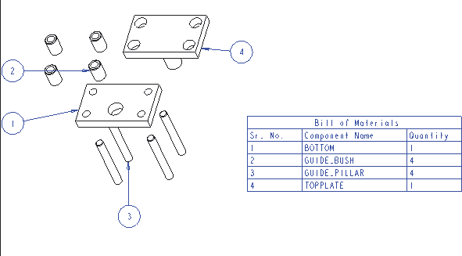

Balloons created

* + Click on the balloon and drag it to the desired location if it is out of sheet boundary.

# Creating Tables

Tables are used to tabulate the data required for various purposes. For example, you can tabulate the data related to team developing the part in the drawing. The procedure to create a table in Creo Parametric is given next.

* + Click on the Table drop-down in the Table panel of Table tab in the Ribbon. The options related to table insertion are displayed.

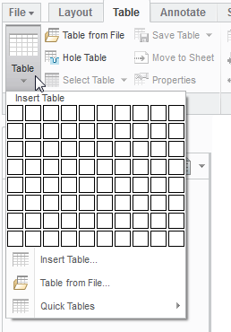

Table drop-down

# Inserting Table dynamically

Over the cursor over the boxes to define the number of row and columns of table. Click on the boxes when you get desired number of rows and columns. Preview of table attached to cursor will be displayed.

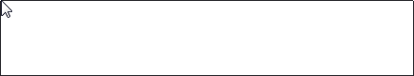

* + Click to place the table.

Preview of table attached

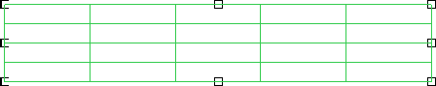

Table placed

* + To enter data in any field, double click on it. (Make sure you have General option selected in the Selection Filter drop-down at the bottom-right corner of the interface.)
  + You can perform the operations like merging cells, unmerging cells and so on by using the tools in the Rows & Columns panel in the Ribbon

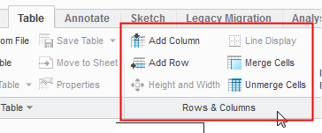

Rows and Columns panel

* + To merge the cells, select two or more cells while holding the CTRL key and click on the Merge Cells tool.
  + To adjust the height and width of a cell, click on the cell and then select the Height and Width tool from the Rows & Columns panel. The Height and Width dialog box will be Displayed.

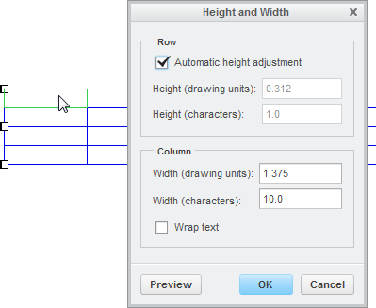

Height and Width dialog box

* + By default, the Automatic height adjustment check box is selected. So, the height of columns automatically adjusted according to the data entered in the cell. To define a specific height, clear the check box and specify the value in the Height (drawing units) or Height (characters) edit box. Similarly, you can change the width of the cell.

# Inserting Table by dialog box

* + Click on the Insert Table tool from the Table drop-down in the Table panel of Table tab in the Ribbon. The Insert Table dialog box will be displayed.
  + Specify the number of columns and rows of the table by using the spinners in the Table Size area of the dialog box.
  + Specify height and width of cells by using the related edit boxes and click on the OK button from the dialog box. The Select Point dialog box will be displayed and you will be prompted to specify the insertion point for the table.

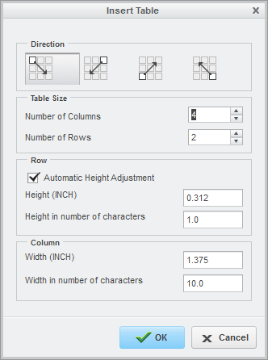

Insert Table dialog box

1. Click in the drawing to place the table. Rest of the procedure is same as discussed earlier.

# Quick Tables

There are various predefined templates of tables available in the Quick Tables cascading menu in the Table drop-down; refer to Figure-100. If your desired table matches with the templates, then click on the desired template and place it at desired location. Rest of the procedure is same as discussed earlier.

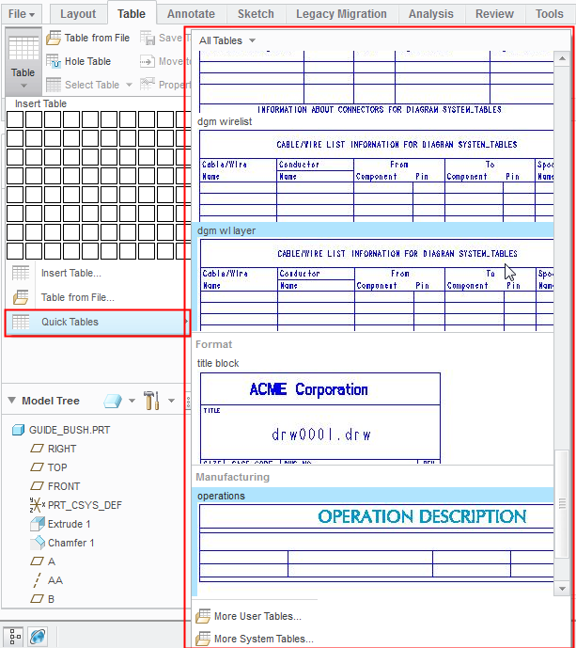

# Chapter – 10 Sheet Metal Planar

**Planar**

The Planar Wall tool to create a planar first wall or one or more unattached planar walls.

While you can use the tool to create the side walls of a design before creating the First wall, you must connect or merge the walls to complete the project. Create a closed loop for your planar wall sketch. Use the tool to set the sheet metal thickness for the first planar wall. Any other walls that you create automatically use the same thickness.

To Create a Planar Wall

1. Click Model >  Planar. The Planar tab opens.
2. Click References. The References tab opens.
3. Click Define. The Sketch dialog box opens. Select sketch references and click Sketch.
4. Create a closed loop sketch and click  OK to accept the sketch.
5. Type a value for the wall thickness or accept the default value. You can set thickness only for the first planar wall, which sets the thickness for all other walls.
6. To flip the wall thickness, click .
7. To flip the driving surface, click Options. The Options tab opens. Select Set driving surface opposite sketch plane.
8. Click .

To access the Planar Wall tool,

click Model >  Planar Commands

# Commands

•  Thickness box—Sets the sheet metal thickness. (Available only for the first planar wall.)

• —Flips the direction of the sheet metal thickness.

# Tabs

* References—Displays the selected sketch in the collector. Edit opens Sketcher to edit the sketch.
* Options—Options include:
  + Set driving surface opposite sketch plane—Flips the driving surface of the sheet metal. This option is not available for a first wall.
  + Merge to model—Merges the wall to an existing wall in the design. Keep merged edges—Wall edges are not merged with existing wall edges.
* Properties—Displays detailed feature information:
  + Name—Shows a name for the wall.

# http://support.ptc.com/help/creo/creo_pma/usascii/sheetmetal/sheetmetaldesign/images/smt_flange16x16.pngFlange Walls

A flange wall is an attached secondary wall, dependent on a first wall. It has an open cross-sectional sketch that is extruded or swept along a trajectory. An attachment edge can be linear or nonlinear. The surface adjacent to the attachment edge does not need to be planar.

|  |  |  |
| --- | --- | --- |
| http://support.ptc.com/help/creo/creo_pma/usascii/sheetmetal/sheetmetaldesign/images/sketched_flange1.png  1. Attachment trajectory | http://support.ptc.com/help/creo/creo_pma/usascii/sheetmetal/sheetmetaldesign/images/sketched_flange2.png | http://support.ptc.com/help/creo/creo_pma/usascii/sheetmetal/sheetmetaldesign/images/sketched_flange3.png |
| Existing wall with selected edges | Flange wall sketch | Completed flange wall |

# Standard Flange Wall Shapes

There are two types of standard flange wall shapes as shown below:

* Hem—Open, Flushed, Joggle, Duck, C, and Z
* Other standard shapes—I, Arc, and S

|  |  |  |  |  |  |
| --- | --- | --- | --- | --- | --- |
| Open | Flushed | Joggle | Duck | C | Z |
| http://support.ptc.com/help/creo/creo_pma/usascii/sheetmetal/sheetmetaldesign/images/flange_open3.png | http://support.ptc.com/help/creo/creo_pma/usascii/sheetmetal/sheetmetaldesign/images/flange_flushed3.png | http://support.ptc.com/help/creo/creo_pma/usascii/sheetmetal/sheetmetaldesign/images/flange_joggle3.png | http://support.ptc.com/help/creo/creo_pma/usascii/sheetmetal/sheetmetaldesign/images/flange_duck3.png | http://support.ptc.com/help/creo/creo_pma/usascii/sheetmetal/sheetmetaldesign/images/flange_c3.png | http://support.ptc.com/help/creo/creo_pma/usascii/sheetmetal/sheetmetaldesign/images/flange_z3.png |

Hem shapes

|  |  |  |
| --- | --- | --- |
| I | Arc | S |
| http://support.ptc.com/help/creo/creo_pma/usascii/sheetmetal/sheetmetaldesign/images/flange_i3.png | http://support.ptc.com/help/creo/creo_pma/usascii/sheetmetal/sheetmetaldesign/images/flange_arc3.png | http://support.ptc.com/help/creo/creo_pma/usascii/sheetmetal/sheetmetaldesign/images/flange_s3.png |

# To Create a Flange Wall

1. Click Model >  Flange. The Flange tab opens.
2. Select an attachment edge. The selected edge is displayed in the Placement collector. An I-shaped flange wall is created by default.
3. To choose a different flange wall shape, select one from the Shape list.
4. Click Shape. The Shape tab opens.
   1. To set the wall dimensions and attachment angle, use one of the following actions:
      1. Edit the wall dimensions and wall angle using the sketch window.
      2. Drag the handles to set the dimensions or to adjust the wall angle.
      3. Click a wall dimension or angle value and type a new value.
   2. To round sharp edges, click Add bends on sharp edges.
5. To flip the  material thickness direction, click .
6. To set the length of each side of the flange wall, click a Flange End Location button or use the Length Tab. Type a value or select a reference.
7. To add a bend to the attachment edge, click .
8. Set the value for the bend radius using one of the following actions:
   1. Select a value from the Bend Radius list.
   2. Drag the handles into position.
   3. Edit the Bend Radius value.
9. Set the bend dimension location:



* 1. Click to dimension the radius from the outside surface of the wall.
  2. Click to dimension the radius from the inside surface of the wall.
  3. Click to dimension the radius according to the location controlled by the SMT_DFLT_RADIUS_SIDE parameter.

1. To add the wall to an offset edge, click Offset. The Offset tab opens.
2. Select Offset wall with respect to attachment edge. Select an attachment option.
3. When you create 2 non tangent wall segments, click Edge Treatment to [define the way](http://support.ptc.com/help/creo/creo_pma/usascii/sheetmetal/sheetmetaldesign/Your_Design/About_Edge_Treatment.html#wwconnect_header) [the segments intersect](http://support.ptc.com/help/creo/creo_pma/usascii/sheetmetal/sheetmetaldesign/Your_Design/About_Edge_Treatment.html#wwconnect_header).
4. Click Relief. The Relief tab opens.
   1. To apply a different type of bend relief, perform the following steps:
      1. Click Bend Relief and select a relief type to apply to both sides of the wall. For a Stretch relief, set the angle value and width.

For Rectangular and Obround reliefs, set values for the depth, length, and width.

* + 1. To define bend relief separately for each side, click Define each side separately.
    2. Select a side and a relief type.
  1. To apply corner relief, perform the following steps:
     1. Click Corner Relief.
     2. Click the Define corner relief check box.
     3. To create the relief geometry in the feature, click the Create relief geometry check box.
     4. Select a relief type and a relief anchor point.

For Circular, Rectangular, Obround and, Square relief, perform these operations as necessary:

* 1. Set the Origin and Orientation of the relief.
  2. Set the dimensions of the relief width and depth.
  3. Rotate the placement of the relief about the origin.
  4. Offset the relief perpendicular to the bisector.

1. To set feature-specific bend allowance and calculate the developed length using a different method from that of the part, perform the following operations:
   1. Click Bend Allowance. The Bend Allowance tab opens.
   2. Click Use feature settings.
   3. Perform one of the following operations:
   4. Click by K factor or by Y factor and type a new factor value or select one from the list.
   5. To use a bend table to calculate developed length for arcs, click by bend table. Use the default table, select a new one from the list, or click Browse to browse to a different table.
2. Click .

# http://support.ptc.com/help/creo/creo_pma/usascii/sheetmetal/sheetmetaldesign/images/smt_flat_wall16x16.pngFlat

An attached flat wall is dependent on a first wall. It has any flat shape with a linear

attachment edge. An attached flat wall requires an open loop sketch that is extruded as a flat section.

|  |  |  |
| --- | --- | --- |
| http://support.ptc.com/help/creo/creo_pma/usascii/sheetmetal/sheetmetaldesign/images/sketched_flat1.png  1. Attachment edge | http://support.ptc.com/help/creo/creo_pma/usascii/sheetmetal/sheetmetaldesign/images/sketched_flat2.png | http://support.ptc.com/help/creo/creo_pma/usascii/sheetmetal/sheetmetaldesign/images/sketched_flat3.png |
| Existing walls with selected edge | Flat wall sketch with an open loop | Completed flat wall |

# To Create an Attached Flat Wall

1. Click Model >  Flat. The Flat tab opens.
2. Select an attachment edge. The selected edge is displayed in the Placement collector. A rectangular wall is created by default.
3. To choose a different wall shape, select one from the Shape list.
4. Set the wall dimensions using one of the following actions:
   1. Click Shape. The Shape tab opens. Edit the wall dimensions using the Sketch window.
   2. Drag the handles to set the dimensions.
   3. Click a wall dimension and edit the value.
5. Set a bend angle for the attachment wall using one of the following actions:
   1. Select an angle from the Angle list.
   2. Type a value in the Angle box.
   3. Drag the handles to adjust the angle.
   4. Double-click an angle value and type a new one.
6. To add a bend to the attachment edge, click .
7. Set the value for the bend radius using one of the following actions:
   1. Select a value from the Bend Radius list.
   2. Drag the handles into position.
   3. Edit the value of the bend radius.
8. Set the bend dimension location:
   1. Click  to dimension the radius from the outside surface of the wall.
   2. Click  to dimension the radius from the inside surface of the wall.
   3. Click  to dimension the radius according to the location controlled by the SMT_DFLT_RADIUS_SIDE parameter.
9. To flip the material thickness direction, click .
10. To set the offset of the wall from the attachment edge, click Offset. The Offset tab opens. Select Offset wall with respect to attachment edge and an attachment option. For by value, type a value in the box or drag the handle to extend the base of the wall or to trim the existing wall at the attachment edge.
11. To change the default rip relief, click Relief. The Relief tab opens.
    1. To define the same relief for both sides, make sure the Define each side separately check box is cleared and select a relief type to apply from the list.

* For a Stretch relief, set the angle value and width. For Rectangular and Obround reliefs, set values for the depth, length, and width.

1. To define the relief differently for each side, perform the following tasks:
   1. Select the Define each side separately check box.
   2. Click Side 1 or Side 2.
   3. Select a relief type to apply from the list.

* For a Stretch relief, set the angle value and width. For Rectangular and Obround reliefs, set values for the depth, length, and width.

i. Set relief for the other side.

1. To set feature-specific bend allowance and calculate the developed length using a different method from that of the part, perform the following operations:
   1. Click Bend Allowance. The Bend Allowance tab opens.
   2. Click Use feature settings.
   3. Perform one of the following operations:
   4. Click by K factor or by Y factor and type a new factor value or select one from the list.
   5. To use a bend table to calculate developed length for arcs, click by bend table. Use the default table, select a new one from the list, or click Browse to browse to a different table.
2. Click .

# http://support.ptc.com/help/creo/creo_pma/usascii/sheetmetal/sheetmetaldesign/images/smt_bend16x16.pngBend

Use the Bend tool to bend a sheet metal wall into an angled or rolled shape. You can add a Bend to a single wall surface or to multiple wall surfaces. To create the bend geometry and to calculate the developed length, specify a bend line as a reference. You can define bend settings during feature creation, or you can predefine them using sheet metal parameters or in the Bends area of the Sheet Metal Preferences dialog box.

|  |  |
| --- | --- |
| Angled Bend | Rolled Bend |
| http://support.ptc.com/help/creo/creo_pma/usascii/sheetmetal/sheetmetaldesign/images/graphic_angle_bend.png | http://support.ptc.com/help/creo/creo_pma/usascii/sheetmetal/sheetmetaldesign/images/graphic_rolled_bend.png |
| Bend is formed on one side of the bend line or equally on both sides of the bend line | Bend is defined by both the radius and the amount of flat material to bend |

# To Create a Bend by Offsetting a Bend Line or an Edge

1. Click Model >  Bend. The Bend tab opens.
2. Select an edge or curve as an offset reference for the bend line. Alternatively, first select the geometry and then click  Bend.
3. Click Placement. The Placement tab opens. Click Offset bend line.
4. Set the offset distance. Type a value in the box, drag the handle, or double-click a value.
5. Click a Bend Placement button to locate the bend in relation to the bend line.



* 1. —Bends the material up to the bend line.
  2. —Bends the material on the other side of the bend line.
  3. —Bends the material on both sides of the bend line.

1. Set the value of the bend radius.
2. Set the dimension location:



* 1. —Dimensions the bend from the outside surface.
  2. —Dimensions the bend from the inside surface.
  3. —Dimensions the bend according to the location set by the SMT_DFLT_RADIUS_SIDE parameter.

1. Click  to create an angled bend or click  to create a rolled bend.
2. Set the value of the bend angle. Type a value in the box, drag the handle, or double- click a value.
3. Set the method to measure the bend angle:



* 1. —Dimensions the bend angle by measuring the resulting internal angle.
  2. —Dimensions the bend angle by measuring the deflection from straight.

1. To change the default relief, perform the following tasks:
   1. Click Relief. The Relief tab opens.
   2. Select a different type of relief from the list, or click Define each side separately and select a side and a relief type.

* For Stretch, Rectangular, and Obround relief, set the depth and width.

1. To set feature-specific bend allowance and calculate the developed length using a different method from that of the part, perform the following operations:
   1. Click Bend Allowance. The Bend Allowance tab opens.
   2. Click Use feature settings.
   3. Perform one of the following operations:
   4. Click by K factor or by Y factor and type a new factor value or select one from the list.
   5. To use a bend table to calculate developed length for arcs, click by bend table. Use the default table, select a new one from the list, or click Browse to browse to a different table.
2. Click .

# To Create a Bend with a Surface Reference

1. Click Model >  Bend. The Bend tab opens.
2. Select a surface on which to place the bend. Placement handles appear on the surface reference.
3. Perform one of the following operations:
   1. In the Model Tree or in the graphics window, select a sketch (a single linear section) as a reference for the bend line geometry.
   2. Click Bend Line. The Bend Line tab opens. Click Sketch and sketch a bend line.
   3. Set the bend line end references as follows:
4. Select an edge or a vertex reference for the first end of the bend line.
   1. If an edge is selected, select an offset reference and type a value for the offset distance.
   2. Repeat step a to place the second end of the bend line.
   3. Click a Bend Placement button to locate the bend in relation to the bend line.



* + 1. —Bends the material up to the bend line.
    2. —Bends the material on the other side of the bend line.
    3. —Bends the material on both sides of the bend line.

1. Set the value of the bend radius.
2. Set the dimension location:



* 1. —Dimensions the bend from the outside surface.
  2. —Dimensions the bend from the inside surface.
  3. —Dimensions the bend according to the location set by the SMT_DFLT_RADIUS_SIDE parameter.

1. Click  to create an angled bend or click  to create a rolled bend.
2. Set the value of the bend angle.
3. Set the method to measure the bend angle:



* 1. —Dimensions the bend angle by measuring the resulting internal angle.
  2. —Dimensions the bend angle by measuring the deflection from straight.

1. To change the default relief, perform the following tasks:
   1. Click Relief. The Relief tab opens.
   2. Select a different type of relief from the list, or click Define each side separately and select a side and a relief type.

* For Stretch, Rectangular, and Obround relief, set the depth and thickness.

1. To set feature-specific bend allowance and calculate the developed length using a different method from that of the part, perform the following operations:
   1. Click Bend Allowance. The Bend Allowance tab opens.
   2. Click Use feature settings.
   3. Perform one of the following operations:
   4. Click by K factor or by Y factor and type a new factor value or select one from the list.
   5. To use a bend table to calculate developed length for arcs, click by bend table. Use the default table, select a new one from the list, or click Browse to browse to a different table.
2. Click .

# Planar Bends

A planar bend forces the sheet metal wall around an axis that is normal (perpendicular) to the surface and sketching plane. You sketch a bend line and form the planar bend around the axis using direction arrows. While this type of bend is not utilized on the factory floor, it can help you reach your overall design intent. You can create a planar bend for both angle and roll type bends

|  |  |
| --- | --- |
| Planar Bend (Angle) | Planar Bend (Roll) |
| http://support.ptc.com/help/creo/creo_pma/usascii/sheetmetal/sheetmetaldesign/images/graphic_angle_type_bend.png | http://support.ptc.com/help/creo/creo_pma/usascii/sheetmetal/sheetmetaldesign/images/graphic_roll_type_bend.png |

# To Create a Planar Bend

1. On the Model tab, click the arrow next to  Bend, and then click  Planar Bend. The OPTIONS menu appears.
2. Perform one of the following operations:
   1. Click Angle and then Done. The BEND Options: Angle, Planar dialog box opens and the USE TABLE menu appears.
   2. Click Roll and then Done. The BEND Options: Roll, Planar dialog box opens and the USE TABLE menu appears.
3. Select a bend table to use and click Done/Return:
   1. Part Bend Tbl—Reference the bend table associated with the overall part.
   2. Feat Bend Tbl—Reference an independent bend table for the individual feature.
4. Select the surface to bend. Reference and sketch the bend line. When the sketch is complete, click . The BEND SIDE menu appears.
5. Define the side of the bend line to create the bend:
   1. Flip—Change the direction of the bend creation.
   2. Okay—Accept the selected direction.
   3. Both—Create the bend equally on both sides of the bend line.
6. Define the area to remain fixed: Okay or Flip to change the direction.
7. Select one of the standard bend angle values or click Enter Value and enter the value in degrees.
8. Define the radius:
   1. Thickness—Use a default radius that is equal to the thickness of the sheet metal wall.
   2. Thickness * 2—Use a default radius that is twice the thickness of the sheet metal wall.
   3. Enter Value—Use the absolute value that you type in the Enter dimension value box.
9. Define the side of the bend axis to create the bend. Click Okay, or click Flip to change the direction.
10. Click OK. **Unbend ** **Unbending Walls**

Use the Unbend tool to unbend one or more curved surfaces such as bends or curved walls in a sheet metal part. You can manually select individual bent geometry, or you can automatically select all bent geometry to unbend. When you create an Unbend feature, you must define a fixed planar surface or edge. Best practice is to select the same surface for all Unbend features. You can save time and maintain consistency by setting at part-level a fixed geometry reference for all Unbend, Bend Back, and Flat Pattern operations.

# To Unbend Walls

1. Click Model >  Unbend. The Unbend tab opens.
2. Click  to automatically select all curved surfaces and edges or click  to manually select individual curved surfaces and edges.
3. Accept the default fixed geometry reference for the part, or select a different reference to remain fixed during the unbend operation.
4. To flip the side of the edge to remain fixed, click Flip.
5. To set references for deformation control, click Deformations. The Deformations tab opens. Deformation surfaces automatically defined are displayed in the collector. Add any additional references as required.
6. To set the type of deformation control to apply, click Deformation Control.

The Deformation Control tab opens. Accept the default type of control or select a different one to apply.

1. When one or more distinct pieces are detected, click Distinct Areas. The Distinct Areas tab opens. Set one or more fixed areas for each distinct area of geometry.
2. To create the relief geometry on the model, click Options > Create relief geometry.
3. Click .

# Bend back

You can automatically select all bend references or manually select individual bend references when you perform an unbend operation.

|  |  |  |
| --- | --- | --- |
| http://support.ptc.com/help/creo/creo_pma/usascii/sheetmetal/sheetmetaldesign/images/graphic_unbend_formed_part.png | http://support.ptc.com/help/creo/creo_pma/usascii/sheetmetal/sheetmetaldesign/images/graphic_unbend_all_2.png | http://support.ptc.com/help/creo/creo_pma/usascii/sheetmetal/sheetmetaldesign/images/graphic_unbend_selected_new.png |
| Formed Part | Automatically Unbend All Surface and Bend References | Manually Unbend Selected Surface and Bend References |

Use the Bend Back tool to return unbent walls to their formed positions. You can manually select individual unbent geometry, or automatically select all unbent geometry to bend back. When you create a Bend Back feature, you must define a fixed planar surface or edge. Best practice is to select the same surface for all Bend Back features. You can save time and maintain consistency by setting at part-level a fixed geometry reference for all Unbend, Bend Back, and Flat Pattern operations in the Fixed Geometry dialog box.

1. Click Model > Bend Back. The Bend Back tab opens.
2. Click  to automatically bend back all bent surfaces and edges or click  to manually bend back individual bent surfaces and edges. All valid references are displayed in the collector.
3. Accept the default fixed geometry reference for the part if defined, or select a different reference to remain fixed during the bend back operation.
4. To flip the side of the edge to remain fixed, click Flip.
5. To control the behaviour of contours that partially intersect the bend line, click Bend Control. The Bend Control tab opens.
6. Click Bend contour to bend back the contour or click Keep flat to keep the contour flat.
7. Click .

# Convert Solid to sheet Metal.

Use the Convert to Sheet metal tool in Part mode to change a solid part into a sheet metal part. The solid part geometry is referenced to create the first wall. For a block-like part, use the Shell tool to remove one or more walls and to set the wall thickness. For a thin protrusion, use the Driving Surface tool to convert parts of uniform or non-uniform thickness.

Using the Driving Surface tool, you can set a constant wall thickness by selecting other surfaces in the part to include or exclude. You can also decide to recreate, remove, or ignore rounds and chamfers when you convert a part to a sheet metal part. To convert parts with non- uniform thickness, you can select these surfaces as Additional Surfaces.

After converting the part into a sheet metal part, use the Conversion tool to add any features required to make the part manufactural, use individual tools to add each feature separately, or use the Flexible Modelling tools to recognize and manipulate design objects.

# To Convert a Solid Part into a Sheet Metal Part

1. Open a solid part.
2. Click Model > Operations > Convert to Sheet metal. The First Wall tab opens.
3. For thin protrusions use the [Driving Surface](http://support.ptc.com/help/creo/creo_pma/usascii/sheetmetal/sheetmetaldesign/Your_Design/To_Convert_a_Solid_Part_into_a_Sheet_Metal_Part.html#ww3_3_8_5_4_3_2_1). tool
4. For block-like geometry [use the Shell tool](http://support.ptc.com/help/creo/creo_pma/usascii/sheetmetal/sheetmetaldesign/Your_Design/To_Convert_a_Solid_Part_into_a_Sheet_Metal_Part.html#ww3_3_8_5_4_3_3_1).
5. Click . The part is converted to a sheet metal part and it opens in the Sheet Metal Design application.
6. Create additional features as needed.

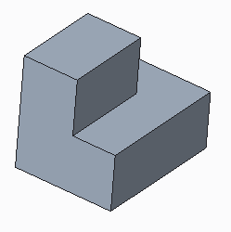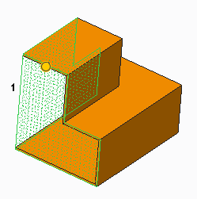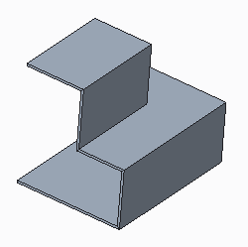

Example: Sheet Metal Convert Operation

# Chapter 11 – Flexible Modelling

**Flexible Modeling**

* + Flexible Modelling is a geometry-based set of editing tools and does not support the creation of new geometry.
  + All operations are purely geometry-based and do not leverage existing feature-based model information.
  + Feature or component references to existing geometry are automatically redirected to the modified geometry.

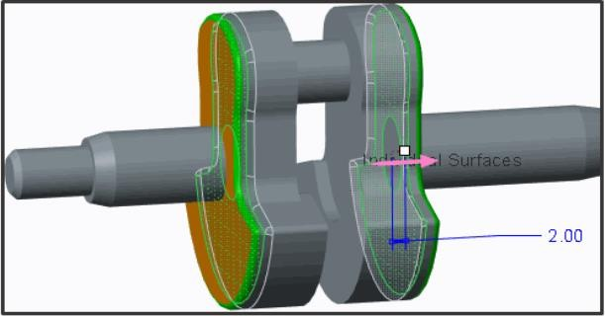

# Flexible Modeling UI

* + Flexible Modeling is integrated directly into Creo Parametric, all the basic Creo
  + Parametric UL items and functionality remain intact within the Flexible Modeling environment. This includes:
    - Graphics window and display style options.
    - Model tree and Folder Browser.
    - Quick Access toolbar, File menu and ribbon.
    - Dashboards and In Graphics toolbar.
    - Status bar and message log.
    - File management.
    - Basic 3-D orientation.

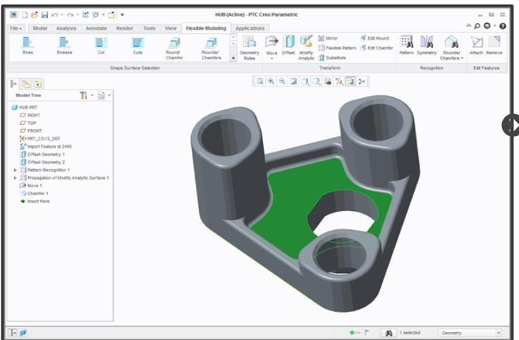

# Flexible Modeling Process

* + Select the initial Surface.
  + Create the required Surface Set.
  + Apply Operations
  + Transform
  + Recognition
  + Feature Edit etc.

# Shape Surface Selection

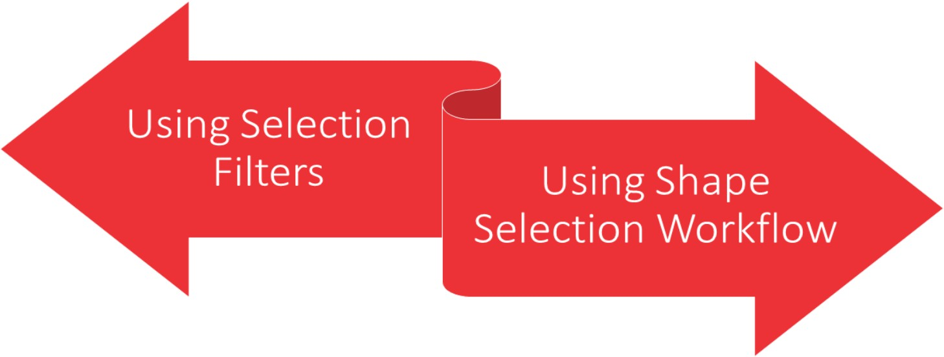

**Selection using Selection Filter**

* + Use selection filter to select appropriate reference.

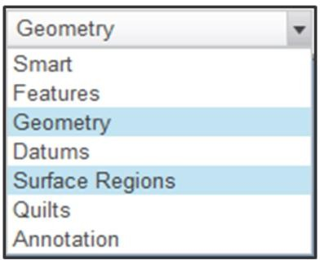

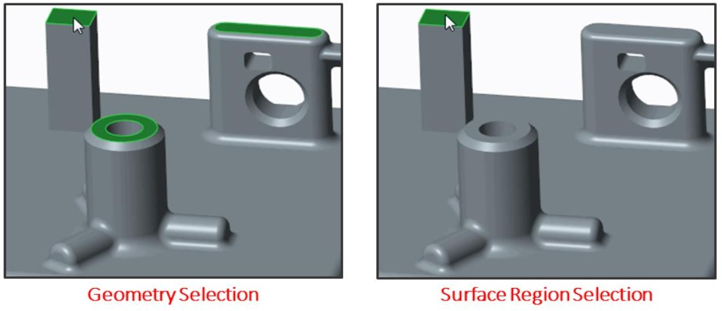

# Selection using Shape Selection Workflow

* + The shape selection tools help you to quickly select the desired surface geometry.
  + Flexible Modeling operations can use either the action-object workflow or object-action workflow.
  + You can either select the surface geometry first and start the Flexible Modeling operation, or you can start the Flexible Modeling operation and then select the surface geometry.

The following are shape selection tools available in the Shape Surface Selection group:

* + - Boss
    - Bosses
    - Cut
    - Cuts
    - Round/Chamfer
    - Rounds/Chamfers

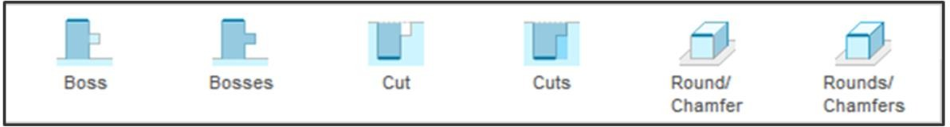

# Flexible Move

There are three different methods available for moving geometry using Flexible Modeling:

* + - * Move using Dragger
      * Move By dimesions
      * Move by Constraints

# Move using Dragger

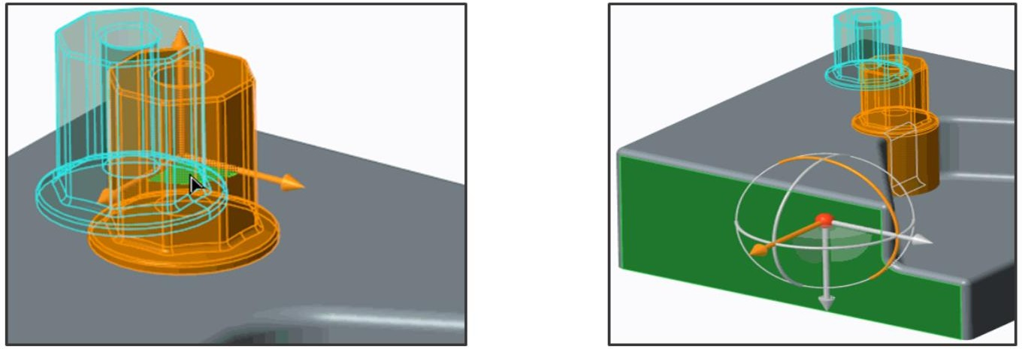

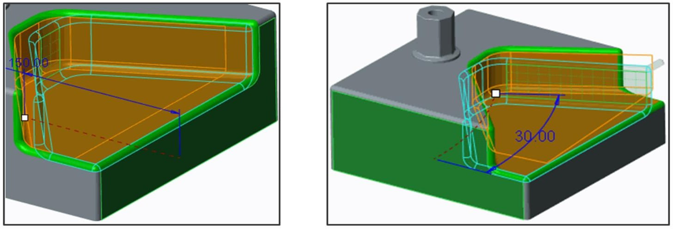**Move by Dimensions**

# Move by Constraints

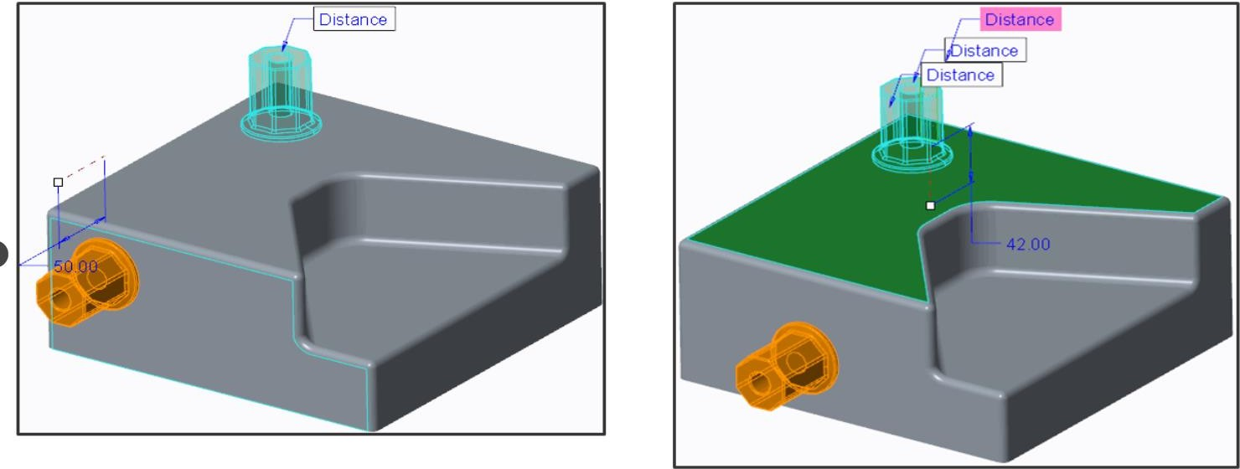

**Pattern Recognition:**

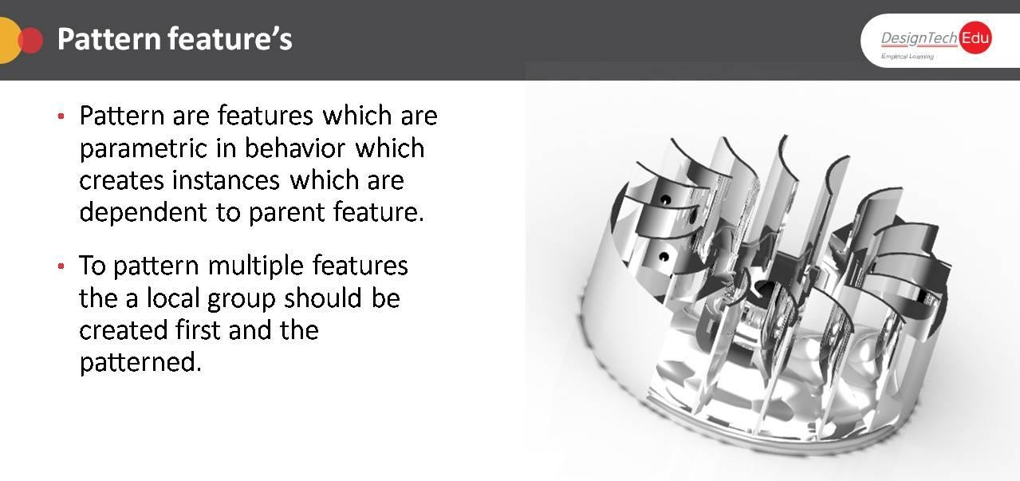

The **Pattern Recognition** tab consists of commands, tabs, and shortcut menus. Select the pattern leader geometry and click **Flexible Modeling** >  **Pattern Recognition** to open the **Pattern Recognition** tab.

**Shortcut Menus**

Right-click the graphics window to access shortcut menu commands.

* **Pattern leader surfaces**—Activates collection of the surfaces that define the leader of the geometry pattern to be recognized.
* **Pattern leader curves and datums**—Activates collection of the curves and datums that define the leader of the geometry pattern to be recognized. Datum coordinate systems cannot be selected.
* **Allow Edit** check box—Edits the number of pattern members and the spacing between pattern members for direction or axis patterns. Removes the existing pattern surfaces, and recreates the pattern using only the surfaces that are recognized as part of the pattern.
* **Transform selected attachment rounds/chamfers**—Includes in the pattern recognition the selected rounds and chamfers that attach the pattern leader geometry to the model. If not checked, the selected attaching rounds and chamfers are removed and optionally recreated.

**Commands**

* Pattern type menu—Sets the geometry pattern recognition in relation to the geometry selected as the pattern leader.
  + **Identical**—Recognizes patterns whose members have identical surfaces, and the intersection edges between the pattern members and the surrounding geometry are identical.
  + **Similar**—Recognizes patterns whose members have identical surfaces, but their intersection edges with the surrounding geometry can vary.
* Recognized geometry menu—Selects which geometry pattern is the recognized pattern. The following pattern types are available:

**Direction pattern**

* **1**—Shows either the  translation or  rotation pattern creation method in the first direction.
  + **Instances**—Sets the number of recognized pattern members in the first direction for a direction pattern or in the angular direction for an axis pattern.
  + **Spacing**—Sets the distance between pattern members in the first direction in a direction pattern or the angle between members in the angular direction in an axis pattern.
* **2**—Shows either the  translation or  rotation pattern creation method in the second direction.
  + **Instances**—Sets the number of recognized pattern members in the second direction for a direction pattern or in the radial direction for an axis pattern.
  + **Spacing**—Sets the distance between pattern members in the second direction in a direction pattern or the radial distance between members in the radial direction in an axis pattern.

**Axis pattern**

* The commands available for an axis pattern are similar to those available for a direction pattern.

**Spatial pattern**

* **Computed Instances** counter—Shows the number of pattern members in the recognized geometry pattern.

**Tabs**

* **References**
  + **Leader surfaces** collector—Shows the surfaces that define the leader of the geometry pattern to be recognized.
* **Details**—Opens the **Surface Sets** dialog box.
  + **Leader curves and datums** collector—Shows curves and datums that define the leader of the geometry pattern to be recognized. Datum coordinate systems cannot be selected.
  + **Transform selected attachment rounds/chamfers** check box—Includes in the pattern recognition the selected rounds and chamfers that attach the pattern leader geometry to the model. If not checked, the selected attaching rounds and chamfers are removed and optionally recreated.
* **Options**
  + **Allow edit** check box—Edits the number of pattern members and the spacing between pattern members for direction or axis patterns. Removes the existing pattern surfaces, and recreates the pattern using only the surfaces that are recognized as part of the pattern.
  + **Restrict pattern recognition** check box—Restricts the pattern recognition to a selected region of the model.
* **Surfaces** collector—Shows the surfaces that define the desired pattern recognition region. Members of the recognized geometry pattern must intersect the selected surfaces.

Click **Details** to open the **Surface Sets** dialog box.

* **Sketch** collector—Shows the sketch that defines the desired pattern recognition region. When the sketch is extruded, members of the recognized geometry pattern must lie within the extrusion of the sketch. Click **Define** to open the **Sketch** dialog box.

**Pattern**

* **Patterns found** menu—Selects which geometry pattern is the recognized pattern. The pattern types available are **Direction**, **Axis**, or **Spatial**.
* **Computed properties**—Shows the computed properties of the selected recognized pattern.
  + **Direction**—Shows pattern type, number of members, and spacing between members for the first and second directions.
  + **Axis**—Shows the number of members and spacing between members for the angular and radial directions
  + **Spatial**—Shows the number of members.
  + **Attachment**—Available when **Allow edit** is selected on the **Options** tab.
    - **Attach pattern members** check box—Attaches all pattern members to the model geometry.
    - **Create rounds/chamfers** check box—Attaches all pattern members to the model geometry with rounds or chamfers of the same type and dimensions as the pattern leader.
* **Properties**—Shows the name of the feature. Click  to display information in the browser.

Example: Identical Geometry and Similar Geometry in Pattern Recognition

In identical geometry, the surfaces of the pattern members are identical to the pattern leader, and the edges where the pattern members intersect the surrounding geometry are identical. The following pattern consists of geometry that is identical to the pattern leader:

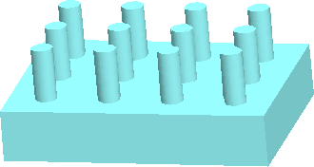

In similar geometry, the surfaces of the pattern members are identical to the pattern leader, but the edges where the pattern members intersect the surrounding geometry are not identical. The following pattern consists of geometry that is similar to the pattern leader:

